UNITED STATES

SECURITIES AND EXCHANGE COMMISSION

Washington, D.C. 20549

FORM 8-K

CURRENT REPORT

Pursuant to Section 13 or 15(d) of the

Securities Exchange Act of 1934

Date of Report (Date of earliest event reported): May 14, 2013

BRADY CORPORATION

(Exact name of registrant as specified in its charter)

Commission File Number 1-14959

Wisconsin

39-0971239

(State of
Incorporation)

(IRS Employer
Identification No.)

6555 West Good Hope Road

Milwaukee, Wisconsin 53223

(Address of Principal Executive Offices and Zip Code)

(414) 358-6600

(Registrant’s Telephone Number)

Check the appropriate box below if the Form 8-K filing is intended to simultaneously satisfy the filing obligation of the registrant under any of the following provisions:

- Written communications pursuant to Rule 425 under the Securities Act (17 CFR 230.425)

- Soliciting material pursuant to Rule 14a-12 under the Exchange Act (17 CFR 240.14a-12)

- Pre-commencement communications pursuant to Rule 14d-2(b) under the Exchange Act (17 CFR 240.14d-2(b))

- Pre-commencement communications pursuant to Rule 13e-4(c) under the Exchange Act (17 CFR 240.13e-4(c))

Item 2.02 RESULTS OF OPERATIONS AND FINANCIAL CONDITION

On May 16, 2013, Brady Corporation (the "Company") issued a press release announcing its fiscal 2013 third quarter financial results. A copy of the press release announcing the third quarter financial results is being furnished to the Securities and Exchange Commission as Exhibit 99.1 attached hereto and is incorporated herein by reference.

Item 2.06 MATERIAL IMPAIRMENTS

On May 15, 2013, the Company concluded that under generally accepted accounting principles a material impairment charge of approximately $16 million will be recorded in the Company's third fiscal quarter ended April 30, 2013. The impairment charge relates to the Company's plan to divest the Company's Asia-based Die-Cut business, as announced by the Company on May 16, 2013. In conjunction with this plan of sale, the Company is reporting the financial results of the Die-Cut business, as well as the financial results of the three businesses disposed of within the last year, Etimark, Varitronics, and Brady Medical, as discontinued operations on the condensed consolidated statements of income for the third quarter ended April 30, 2013.

The assets of the Asia-based Die-Cut business are located within several countries in North and South Asia, and include property, plant and equipment, accounts receivable, inventory and intangible assets. Liabilities of the business include normal trade payables and accrued expenses. The Company took this action to focus on its core Identifications Solutions and Workplace Safety businesses. Under generally accepted accounting principles, the plan of divestiture requires the Company to report the Asia-based Die-Cut business as a disposal group held for sale at approximate fair value less cost to sell, which results in a non-cash write-down on the carrying value of the assets of approximately $16 million, recorded in the Company's third quarter ended April 30, 2013. Future cash expenditures related to the disposal actions are expected to be immaterial.

The press releases issued by the Company relating to third quarter fiscal 2013 financial results and the plan to divest the Asia-based Die Cut business are furnished to the Securities and Exchange Commission as Exhibits 99.1 and 99.3, respectively, attached hereto and are incorporated herein by reference.

Item 5.02 DEPARTURE OF DIRECTORS OR CERTAIN OFFICERS; ELECTION OF DIRECTORS; APPOINTMENT OF

CERTAIN OFFICERS; COMPENSATORY ARRANGEMENTS OF CERTAIN OFFICERS

On May 14, 2013, the Management Development and Compensation Committee of the Board of Directors of the Company approved the following modifications to the compensation arrangement with Scott Hoffman in connection with his recently announced appointment as President - Workplace Safety: (i) increase in annual base salary to $300,000, with eligibility for an annual bonus at 70% of base salary; and (ii) authorization to enter into an amended Change of Control Agreement with Mr. Hoffman providing for the payment of two years of base salary and bonus.

Item 9.01 FINANCIAL STATEMENTS AND EXHIBITS

- Exhibits.

The following are filed as Exhibits to this Report.

Exhibit No. |  | Description of Exhibit
99.1 |  | Press Release of Brady Corporation, dated May 16, 2013, relating to third quarter fiscal 2013 financial results.
99.2 |  | Informational slides provided by Brady Corporation, dated May 16, 2013, relating to third quarter fiscal 2013 financial results.
99.3 |  | Press Release of Brady Corporation, dated May 16, 2013, relating to plan to divest Asia-based Die-Cut business.

SIGNATURE

Pursuant to the requirements of the Securities Exchange Act of 1934, the Registrant has duly caused this report to be signed on its behalf by the undersigned hereunto duly authorized.

BRADY CORPORATION

Date: May 16, 2013

/s/ Thomas J. Felmer

Thomas J. Felmer

Senior Vice President &

Chief Financial Officer

 |  | EXHIBIT INDEX
EXHIBIT
NUMBER |  | DESCRIPTION
99.1 |  | Press Release of Brady Corporation, dated May 16, 2013, relating to third quarter fiscal 2013 financial results.
99.2 |  | Informational slides provided by Brady Corporation, dated May 16, 2013, relating to third quarter fiscal 2013 financial results.
99.3 |  | Press Release of Brady Corporation, dated May 16, 2013, relating to plan to divest Asia-based Die-Cut business.

EXHIBIT 99.1

For More Information:

Investor contact: Aaron Pearce 414-438-6895
Media contact: Carole Herbstreit 414-438-6882

For Immediate Release

Brady Corporation Reports Fiscal 2013 Third Quarter Results

MILWAUKEE (May 16, 2013)--Brady Corporation (NYSE: BRC) (“Brady”), a world leader in identification solutions, today reported its financial results for the fiscal 2013 third quarter ended April 30, 2013.

Quarter Ended April 30, 2013 Financial Results:

The company continued its portfolio realignment process by announcing plans to sell its Asia-based Die-Cut business which was outlined in a separate press release on May 16, 2013. Accordingly, the company has recast its financial statements to report the financial results of the Die-Cut business on one line item in the accompanying condensed consolidated statements of income.

Sales from continuing operations for the fiscal 2013 third quarter were up 11.0 percent to $305.7 million compared to $275.4 million in the third quarter of fiscal 2012. Organic sales were down 4.7 percent, acquisitions added 16.8 percent, and the impact of foreign currency translation decreased sales by 1.1 percent. By segment, organic sales decreased 2.9 percent in the Americas, 4.8 percent in EMEA and 11.6 percent in the Asia-Pacific region.

Net earnings from continuing operations in the fiscal 2013 third quarter were $21.8 million compared to $28.0 million in the same quarter last year. Non-GAAP net earnings from continuing operations* were $28.7 million in the third quarter of fiscal 2013, compared to $29.9 million in the third quarter of fiscal 2012.

Earnings from continuing operations per diluted Class A Nonvoting Common Share were $0.42 in the third quarter of fiscal 2013 compared to $0.53 in the same quarter last year. Non-GAAP earnings from continuing operations per diluted Class A Nonvoting Common Share* were $0.55 in the third quarter of fiscal 2013, compared to $0.56 in the same quarter of fiscal 2012.

Nine Months Ended April 30, 2013 Financial Results:

Sales for the nine-month period ended April 30, 2013 were up 5.3 percent to $856.4 million compared to $813.6 million in the same period last year. Organic sales were down 2.7 percent, acquisitions added 9.3 percent to sales and the impact of foreign currency translation decreased sales by 1.3 percent. By segment, organic sales decreased 0.7 percent in the Americas, 4.2 percent in EMEA and 6.8 percent in the Asia-Pacific region.

Net earnings from continuing operations for the nine-month period ended April 30, 2013 were $37.7 million compared to $84.3 million in the same period in fiscal 2012. Non-GAAP net earnings from continuing operations* were $75.1 million in the nine-month period ended April 30, 2013 compared to $86.1 million in the same period of fiscal 2012.

Earnings from continuing operations per diluted Class A Nonvoting Common Share were $0.73 for the nine-month period ended April 30, 2013 compared to $1.59 in the same period of fiscal 2012. Non-GAAP earnings from

continuing operations per diluted Class A Nonvoting Common Share* were $1.45 for the nine-month period ended April 30, 2013, compared to $1.62 in the same period of fiscal 2012.

Commentary and Guidance:

“In the face of a challenging economy, we continue to position Brady for long-term success by optimizing our portfolio of businesses, aligning our organization with growth opportunities and reducing our infrastructure costs. This morning we announced our intention to sell our Die-Cut business which will continue the process of portfolio realignment as we have already divested three businesses and acquired Precision Dynamics Corporation, a business serving the healthcare space. These portfolio adjustments will allow us to focus more on our continuing businesses of Identification Solutions and Workplace Safety,” stated Brady's President and Chief Executive Officer, Frank M. Jaehnert. “As part of our previously announced strategy to improve organic growth and profitability, effective May 1, 2013, we are changing our organizational structure from geographically-based to an organization structured around global business platforms. We are also targeting expansion in faster-growing geographies such as Central Europe, the Middle East, Africa and selected markets in Asia; and focusing on industries such as food and beverage, chemical, oil, and gas and healthcare.

“In addition to improving organic growth, we believe that our reorganization around global business platforms will yield approximately $25 million to $30 million of annual pre-tax savings, approximately half of which will be reinvested into growth initiatives. We also continue to review our facility footprint and believe that we have further opportunities for rationalization as we move forward with our business reorganization and simplification.”

Brady's Chief Financial Officer, Thomas J. Felmer said, “Our balance sheet remains strong. Having repaid much of the debt incurred to finance the PDC acquisition, Brady is in a solid financial position to fund future organic and inorganic growth opportunities. We expect earnings from continuing operations per diluted Class A Nonvoting Common Share to range from between $0.45 and $0.55, exclusive of restructuring charges and certain other items during our fiscal 2013 fourth quarter ending July 31, 2013.”

A webcast regarding Brady's fiscal 2013 third quarter financial results will be available at www.bradycorp.com beginning at 9:30 a.m. Central Time

today.

Brady Corporation is an international manufacturer and marketer of complete solutions that identify and protect premises, products and people. Brady's products help customers increase safety, security, productivity and performance and include high-performance labels, signs, safety devices, printing systems and software, and precision die-cut materials. Founded in 1914, the company has millions of customers in electronics, telecommunications, manufacturing, electrical, construction, education, medical and a variety of other industries. Brady is headquartered in Milwaukee, Wisconsin and as of January 31, 2013 employed approximately 8,200 people at operations in the Americas, EMEA and Asia-Pacific. Brady's fiscal 2012 sales were approximately $1.32 billion. Brady stock trades on the New York Stock Exchange under the symbol BRC. More information is available on the Internet at www.bradycorp.com.

* See accompanying notes for Non-GAAP measures.

###

Brady believes that certain statements in this news release are “forward-looking statements” within the meaning of the Private Securities Litigation Reform Act of 1995. All statements related to future, not past, events included in this news release, including, without limitation, statements regarding Brady's future financial position, business strategy, targets, projected sales, costs, earnings, capital expenditures, debt levels and cash flows, and plans and objectives of management for future operations are forward-looking statements. When used in this news release, words such as “may,” “will,” “expect,” “intend,” “estimate,” “anticipate,” “believe,” “should,” “project” or “plan” or similar terminology are generally intended to identify forward-looking statements. These forward-looking statements by their nature address matters that are, to different degrees, uncertain and are subject to risks, assumptions and other factors, some of which are beyond Brady's control, that could cause actual results to differ materially from those expressed or implied by such forward-looking statements. For Brady, uncertainties arise from the length or severity of the current worldwide economic downturn or timing or strength of a subsequent recovery; future financial performance of major markets Brady serves, which include, without limitation, telecommunications, manufacturing, electrical, construction, laboratory, education, governmental, public utility, computer, transportation; difficulties in making and integrating acquisitions; risks associated with newly acquired businesses; Brady's ability to develop and successfully market new products; changes in the supply of, or price for, parts and components; increased price pressure from suppliers and customers; fluctuations in currency rates versus the US dollar; unforeseen tax consequences; potential write-offs of Brady's substantial intangible assets; Brady's ability to retain significant contracts and customers; risks associated with international operations; Brady's ability to maintain compliance with its debt covenants; technology changes; business interruptions due to implementing business systems; environmental, health and safety compliance costs and liabilities; future competition; interruptions to sources of supply; Brady's ability to realize cost savings from operating initiatives; difficulties associated with exports; risks associated with restructuring plans; risks associated with obtaining governmental approvals and maintaining regulatory compliance; and numerous other matters of national, regional and global scale, including those of a political, economic, business, competitive and regulatory nature contained from time to time in Brady's U.S. Securities and Exchange Commission filings, including, but not limited to, those factors listed in the “Risk Factors” section located in Item 1A of Part I of Brady's Form 10-K for the year ended July 31, 2012. These uncertainties may cause Brady's actual future results to be materially different than those expressed in its forward-looking statements. Brady does not undertake to update its forward-looking statements.

BRADY CORPORATION AND SUBSIDIARIES

CONDENSED CONSOLIDATED STATEMENTS OF INCOME

(Dollars in Thousands, Except Per Share Amounts)

 |  | (Unaudited) |  |  |  |  |  | (Unaudited)
 |  | Three Months Ended April 30, |  |  |  |  |  | Nine Months Ended April 30,
 |  | 2013 |  |  | 2012 |  |  | 2013 |  |  | 2012
Net sales | $ | 305,737 |  | $ | 275,388 |  | $ | 856,408 |  | $ | 813,573
Cost of products sold |  | 146,031 |  |  | 123,641 |  |  | 403,888 |  |  | 367,330
Gross margin |  | 159,706 |  |  | 151,747 |  |  | 452,520 |  |  | 446,243
Operating expenses:
Research and development |  | 8,062 |  |  | 8,200 |  |  | 24,162 |  |  | 25,657
Selling, general and administrative |  | 112,148 |  |  | 98,614 |  |  | 321,909 |  |  | 293,518
Restructuring charges |  | 8,540 |  |  | 1,977 |  |  | 10,487 |  |  | 1,977
Total operating expenses |  | 128,750 |  |  | 108,791 |  |  | 356,558 |  |  | 321,152
Operating income |  | 30,956 |  |  | 42,956 |  |  | 95,962 |  |  | 125,091
Other income and (expense):
Investment and other income |  | 1,131 |  |  | 1,108 |  |  | 2,427 |  |  | 1,719
Interest expense |  | (4,185) |  |  | (4,735) |  |  | (12,755) |  |  | (14,715)
Earnings from continuing operations before income taxes |  | 27,902 |  |  | 39,329 |  |  | 85,634 |  |  | 112,095
Income taxes |  | 6,064 |  |  | 11,290 |  |  | 47,965 |  |  | 27,767
Net earnings from continuing operations | $ | 21,838 |  | $ | 28,039 |  | $ | 37,669 |  | $ | 84,328
(Loss) from discontinued operations, net of income tax |  | (17,605) |  |  | (387) |  |  | (14,933) |  |  | (113,898)
Net earnings (loss) | $ | 4,233 |  | $ | 27,652 |  | $ | 22,736 |  | $ | (29,570)
Earnings from continuing operations per Class A Nonvoting Common
Share:
Basic | $ | 0.42 |  | $ | 0.53 |  | $ | 0.73 |  | $ | 1.60
Diluted | $ | 0.42 |  | $ | 0.53 |  | $ | 0.73 |  | $ | 1.59
Earnings from continuing operations per Class B Voting Common Share:
Basic | $ | 0.42 |  | $ | 0.53 |  | $ | 0.72 |  | $ | 1.59
Diluted | $ | 0.42 |  | $ | 0.53 |  | $ | 0.71 |  | $ | 1.57
(Loss) from discontinued operations per Class A Nonvoting Common
Share:
Basic | $ | (0.34) |  | $ | — |  | $ | (0.29) |  | $ | (2.17)
Diluted | $ | (0.34) |  | $ | (0.01) |  | $ | (0.29) |  | $ | (2.16)
(Loss) from discontinued operations per Class B Voting Common Share:
Basic | $ | (0.34) |  | $ | — |  | $ | (0.30) |  | $ | (2.17)
Diluted | $ | (0.34) |  | $ | (0.01) |  | $ | (0.29) |  | $ | (2.15)
Earnings per Class A Nonvoting Common Share:
Basic | $ | 0.08 |  | $ | 0.53 |  | $ | 0.44 |  | $ | (0.57)
Diluted | $ | 0.08 |  | $ | 0.52 |  | $ | 0.44 |  | $ | (0.57)
Dividends | $ | 0.19 |  | $ | 0.185 |  | $ | 0.57 |  | $ | 0.555
Earnings per Class B Voting Common Share:
Basic | $ | 0.08 |  | $ | 0.53 |  | $ | 0.42 |  | $ | (0.58)
Diluted | $ | 0.08 |  | $ | 0.52 |  | $ | 0.42 |  | $ | (0.58)
Dividends | $ | 0.19 |  | $ | 0.185 |  | $ | 0.553 |  | $ | 0.538
Weighted average common shares outstanding (in thousands):
Basic |  | 51,415 |  |  | 52,513 |  |  | 51,210 |  |  | 52,539
Diluted |  | 52,041 |  |  | 53,003 |  |  | 51,685 |  |  | 52,946

BRADY CORPORATION AND SUBSIDIARIES

CONDENSED CONSOLIDATED BALANCE SHEETS

(Dollars in Thousands)

 |  |  |  |  |  | (Unaudited)
 |  |  |  |  |  | April 30, 2013 |  |  | July 31, 2012
 |  | ASSETS
Current assets:
Cash and cash equivalents |  |  |  |  | $ | 77,034 |  | $ | 305,900
Accounts receivable—net |  |  |  |  |  | 177,343 |  |  | 199,006
Inventories:
Finished products |  |  |  |  |  | 62,995 |  |  | 64,740
Work-in-process |  |  |  |  |  | 14,908 |  |  | 15,377
Raw materials and supplies |  |  |  |  |  | 21,703 |  |  | 25,407
Total inventories |  |  |  |  |  | 99,606 |  |  | 105,524
Assets held for sale |  |  |  |  |  | 108,623 |  |  | —
Prepaid expenses and other current assets |  |  |  |  |  | 41,461 |  |  | 40,424
Total current assets |  |  |  |  |  | 504,067 |  |  | 650,854
Other assets:
Goodwill |  |  |  |  |  | 841,449 |  |  | 676,791
Other intangible assets |  |  |  |  |  | 174,583 |  |  | 84,119
Deferred income taxes |  |  |  |  |  | 6,305 |  |  | 45,356
Other |  |  |  |  |  | 20,915 |  |  | 20,584
Property, plant and equipment:
Cost:
Land |  |  |  |  |  | 9,081 |  |  | 8,651
Buildings and improvements |  |  |  |  |  | 100,504 |  |  | 101,962
Machinery and equipment |  |  |  |  |  | 278,233 |  |  | 292,130
Construction in progress |  |  |  |  |  | 9,358 |  |  | 10,417
 |  |  |  |  |  | 397,176 |  |  | 413,160
Less accumulated depreciation |  |  |  |  |  | 263,527 |  |  | 283,145
Property, plant and equipment—net |  |  |  |  |  | 133,649 |  |  | 130,015
Total |  |  |  |  | $ | 1,680,968 |  | $ | 1,607,719
LIABILITIES AND STOCKHOLDERS’ INVESTMENT
Current liabilities:
Notes payable |  |  |  |  | $ | 58,658 |  | $ | —
Accounts payable |  |  |  |  |  | 75,204 |  |  | 86,646
Wages and amounts withheld from employees |  |  |  |  |  | 36,840 |  |  | 54,629
Liabilities held for sale |  |  |  |  |  | 34,684 |  |  | —
Taxes, other than income taxes |  |  |  |  |  | 7,603 |  |  | 9,307
Accrued income taxes |  |  |  |  |  | 10,650 |  |  | 14,357
Other current liabilities |  |  |  |  |  | 34,396 |  |  | 40,815
Current maturities on long-term debt |  |  |  |  |  | 61,265 |  |  | 61,264
Total current liabilities |  |  |  |  |  | 319,300 |  |  | 267,018
Long-term obligations, less current maturities |  |  |  |  |  | 218,378 |  |  | 254,944
Other liabilities |  |  |  |  |  | 109,635 |  |  | 76,404
Total liabilities |  |  |  |  |  | 647,313 |  |  | 598,366
Stockholders’ investment:
Common stock:
Class A nonvoting common stock—Issued 51,261,487 and 51,261,487 shares, respectively and
outstanding 47,972,270 and 47,630,926 shares, respectively |  |  |  |  |  | 513 |  |  | 513
Class B voting common stock—Issued and outstanding, 3,538,628 shares |  |  |  |  |  | 35 |  |  | 35
Additional paid-in capital |  |  |  |  |  | 312,905 |  |  | 313,008
Earnings retained in the business |  |  |  |  |  | 725,682 |  |  | 732,290
Treasury stock—2,974,218 and 3,245,561 shares, respectively of Class A nonvoting common stock,
at cost |  |  |  |  |  | (79,996) |  |  | (92,600)
Accumulated other comprehensive income |  |  |  |  |  | 76,439 |  |  | 59,411
Other |  |  |  |  |  | (1,923) |  |  | (3,304)
Total stockholders’ investment |  |  |  |  |  | 1,033,655 |  |  | 1,009,353
Total |  |  |  |  | $ | 1,680,968 |  | $ | 1,607,719

BRADY CORPORATION AND SUBSIDIARIES

CONDENSED CONSOLIDATED STATEMENTS OF CASH FLOWS

(Dollars in Thousands)

(Unaudited)

Nine Months Ended April 30,

 |  | 2013 |  |  | 2012
Operating activities:
Net income (loss) | $ | 22,736 |  | $ | (29,570)
Adjustments to reconcile net income to net cash provided by operating activities:
Depreciation and amortization |  | 36,037 |  |  | 32,921
Non-cash portion of restructuring charges |  | 3,701 |  |  | 458
Non-cash portion of stock-based compensation expense |  | 6,964 |  |  | 7,592
Impairment charge |  | — |  |  | 115,688
Loss on write-down of assets held for sale |  | 15,658 |  |  | —
Loss (gain) on sales of businesses |  | 3,138 |  |  | —
Deferred income taxes |  | 33,780 |  |  | (3,192)
Changes in operating assets and liabilities (net of effects of business acquisitions/divestitures):
Accounts receivable |  | (6,410) |  |  | 11,050
Inventories |  | (91) |  |  | (5,595)
Prepaid expenses and other assets |  | 541 |  |  | (4,386)
Accounts payable and accrued liabilities |  | (22,226) |  |  | (39,472)
Income taxes |  | (4,198) |  |  | 15,101
Net cash provided by operating activities |  | 89,630 |  |  | 100,595
Investing activities:
Purchases of property, plant and equipment |  | (26,082) |  |  | (14,498)
Payments of contingent consideration |  | — |  |  | (2,580)
Settlement of net investment hedges |  | — |  |  | (797)
Acquisition of business, net of cash acquired |  | (301,157) |  |  | (3,039)
Sales of businesses, net of cash retained |  | 10,178 |  |  | —
Other |  | (1,245) |  |  | (1,536)
Net cash used in investing activities |  | (318,306) |  |  | (22,450)
Financing activities:
Payment of dividends |  | (29,344) |  |  | (29,235)
Proceeds from issuance of common stock |  | 10,246 |  |  | 3,624
Purchase of treasury stock |  | (5,121) |  |  | (12,309)
Proceeds from borrowings on notes payable |  | 220,000 |  |  | —
Repayment of borrowings on notes payable |  | (173,000) |  |  | —
Proceeds from borrowings on line of credit |  | 11,491 |  |  | —
Principal payments on debt |  | (42,514) |  |  | (42,514)
Debt issuance costs |  | — |  |  | (961)
Income tax benefit from the exercise of stock options and deferred compensation distributions, and
other |  | 1,794 |  |  | 754
Net cash provided by (used in) financing activities |  | (6,448) |  |  | (80,641)
Effect of exchange rate changes on cash |  | 6,258 |  |  | (13,050)
Net decrease in cash and cash equivalents |  | (228,866) |  |  | (15,546)
Cash and cash equivalents, beginning of period |  | 305,900 |  |  | 389,971
Cash and cash equivalents, end of period | $ | 77,034 |  | $ | 374,425
Supplemental disclosures:
Cash paid during the period for:
Interest, net of capitalized interest | $ | 13,194 |  | $ | 15,746
Income taxes, net of refunds |  | 26,786 |  |  | 19,959
Acquisitions:
Fair value of assets acquired, net of cash | $ | 168,675 |  | $ | 2,395
Liabilities assumed |  | (57,860) |  |  | (583)
Goodwill |  | 190,342 |  |  | 1,227
Net cash paid for acquisitions | $ | 301,157 |  | $ | 3,039

Information by regional segment for the three and nine months ended April 30, 2013 and 2012 is as follows:

 |  |  |  |  |  |  |  |  | Corporate and
(Dollars in Thousands) |  | Americas |  | EMEA |  | Asia-Pacific |  | Total Region | Eliminations |  | Total
SALES TO EXTERNAL CUSTOMERS
Three months ended:
April 30, 2013 | $ | 178,559 | $ | 94,044 | $ | 33,134 | $ | 305,737 | — | $ | 305,737
April 30, 2012 | $ | 143,083 | $ | 94,136 | $ | 38,169 | $ | 275,388 | — | $ | 275,388
Nine months ended:
April 30, 2013 | $ | 470,418 | $ | 279,420 | $ | 106,570 | $ | 856,408 | — | $ | 856,408
April 30, 2012 | $ | 419,862 | $ | 279,506 | $ | 114,205 | $ | 813,573 | — | $ | 813,573

SALES INFORMATION

Three months ended April 30, 2013:

Organic |  | (2.9)% |  | (4.8)% |  |  | (11.6)% |  |  |  | (4.7)% |  |  |  | —% |  |  | (4.7)%
Currency |  | (0.7)% |  | (1.3)% |  |  | (1.6)% |  |  |  | (1.1)% |  |  |  | —% |  |  | (1.1)%
Acquisitions |  | 28.4 % |  | 6.0 % |  |  | 0.0 % |  |  |  | 16.8 % |  |  |  | —% |  |  | 16.8 %
Total |  | 24.8 % |  | (0.1)% |  |  | (13.2)% |  |  |  | 11.0 % |  |  |  | —% |  |  | 11.0 %
Nine months ended April 30, 2013:
Organic |  | (0.7)% |  | (4.2)% |  |  | (6.8)% |  |  |  | (2.7)% |  |  |  | —% |  |  | (2.7)%
Currency |  | (0.8)% |  | (2.5)% |  |  | 0.1 % |  |  |  | (1.3)% |  |  |  | —% |  |  | (1.3)%
Acquisitions |  | 13.5 % |  | 6.7 % |  |  | 0.0 % |  |  |  | 9.3 % |  |  |  | —% |  |  | 9.3 %
Total |  | 12.0 % |  |  | — % |  | (6.7)% |  |  |  | 5.3 % |  |  |  | —% |  |  | 5.3 %
SEGMENT PROFIT
Three months ended:
April 30, 2013 | $ | 42,942 | $ | 22,993 |  | $ | 5,485 |  |  | $ | 71,420 |  |  | $ | (1,282) |  | $ | 70,138
April 30, 2012 | $ | 39,181 | $ | 25,566 |  | $ | 6,080 |  |  | $ | 70,827 |  |  | $ | (388) |  | $ | 70,439
Percentage change |  | 9.6 % |  | (10.1)% |  |  | (9.8)% |  |  |  | 0.8 % |  |  |  |  |  |  | (0.4)%
Nine months ended:
April 30, 2013 | $ | 119,179 | $ | 70,568 |  | $ | 15,793 |  |  | $ | 205,540 |  |  | $ | (5,049) |  | $ | 200,491
April 30, 2012 | $ | 118,871 | $ | 78,432 |  | $ | 18,411 |  |  | $ | 215,714 |  |  | $ | (6,010) |  | $ | 209,704
Percentage change |  | 0.3 % |  | (10.0)% |  |  | (14.2)% |  |  |  | (4.7)% |  |  |  |  |  |  | (4.4)%
 |  | NET INCOME RECONCILIATION (in thousands)
 |  |  |  |  | Three Months Ended April 30, |  |  |  |  |  |  |  |  | Nine Months Ended April 30,
 |  |  |  |  |  | 2013 |  |  |  |  | 2012 |  |  |  | 2013 |  |  | 2012
Total profit for reportable segments |  |  |  | $ |  |  | 71,420 |  | $ |  | 70,827 |  | $ |  | 205,540 |  | $ | 215,714
Corporate and eliminations |  |  |  |  |  |  | (1,282) |  |  |  | (388) |  |  |  | (5,049) |  |  | (6,010)
Unallocated amounts:
Administrative costs |  |  |  |  |  |  | (30,642) |  |  |  | (25,506) |  |  |  | (94,042) |  |  | (82,636)
Restructuring charges |  |  |  |  |  |  | (8,540) |  |  |  | (1,977) |  |  |  | (10,487) |  |  | (1,977)
Investment and other income |  |  |  |  |  |  | 1,131 |  |  |  | 1,108 |  |  |  | 2,427 |  |  | 1,719
Interest expense |  |  |  |  |  |  | (4,185) |  |  |  | (4,735) |  |  |  | (12,755) |  |  | (14,715)
Earnings from continuing operations before income taxes |  |  |  |  |  |  | 27,902 |  |  |  | 39,329 |  |  |  | 85,634 |  |  | 112,095
Income taxes |  |  |  |  |  |  | 6,064 |  |  |  | 11,290 |  |  |  | 47,965 |  |  | 27,767
Net earnings from continuing operations |  |  |  |  |  |  | 21,838 |  |  |  | 28,039 |  |  |  | 37,669 |  |  | 84,328
(Loss) from discontinued operations, net of tax |  |  |  |  |  |  | (17,605) |  |  |  | (387) |  |  |  | (14,933) |  |  | (113,898)
Net earnings (loss) |  |  |  |  | $ |  | 4,233 |  | $ |  | 27,652 |  | $ |  | 22,736 |  | $ | (29,570)

GAAP TO NON-GAAP MEASURES

(Dollars in Thousands, Except Per Share Amounts)

In accordance with the U.S. Securities and Exchange Commission’s Regulation G, the following provides definitions of the non-GAAP measures used in the earnings release and the reconciliation to the most closely related GAAP measure.

EBITDA:

Brady is presenting EBITDA because it is used by many of our investors and lenders, and is presented as a convenience to them. EBITDA represents net income before interest expense, income taxes, depreciation and amortization. EBITDA is not a calculation based on generally accepted accounting principles ("GAAP"). The amounts included in the EBITDA calculation, however, are derived from amounts included in the Condensed Consolidated Statements of Income data. EBITDA should not be considered as an alternative to net income or operating income as an indicator of the Company's operating performance, or as an alternative to net cash provided by operating activities as a measure of liquidity. The EBITDA measure presented may not always be comparable to similarly titled measures reported by other companies due to differences in the components of the calculation.

 |  |  |  |  |  |  |  | Fiscal 2013
 |  | Q1 |  |  | Q2 |  |  | Q3 |  |  | Q4 |  |  | Total
EBITDA:
Net income (loss) | $ | 27,188 |  | $ | (8,684) |  | $ | 4,233 |  |  |  |  | $ | 22,737
Interest expense |  | 4,163 |  |  | 4,406 |  |  | 4,185 |  |  |  |  |  | 12,754
Income taxes |  | 13,482 |  |  | 30,625 |  |  | 7,595 |  |  |  |  |  | 51,702
Depreciation and amortization |  | 10,675 |  |  | 11,371 |  |  | 13,991 |  |  |  |  |  | 36,037
Intangible asset write-down in restructuring charges |  | — |  |  | — |  |  | 3,207 |  |  |  |  |  | 3,207
Loss on write-down of assets held for sale |  | — |  |  | — |  |  | 15,658 |  |  |  |  |  | 15,658
EBITDA (non-GAAP measure) | $ | 55,508 |  | $ | 37,718 |  | $ | 48,869 |  |  |  |  | $ | 142,095
 |  |  |  |  |  |  |  | Fiscal 2012
 |  | Q1 |  |  | Q2 |  |  | Q3 |  |  | Q4 |  |  | Total
EBITDA:
Net income (loss) | $ | 32,732 |  | $ | (89,954) |  | $ | 27,652 |  | $ | 11,659 |  | $ | (17,911)
Interest expense |  | 5,047 |  |  | 4,933 |  |  | 4,735 |  |  | 4,375 |  |  | 19,090
Income taxes |  | 11,109 |  |  | 8,635 |  |  | 9,676 |  |  | 11,241 |  |  | 40,661
Depreciation and amortization |  | 11,241 |  |  | 10,935 |  |  | 10,745 |  |  | 11,066 |  |  | 43,987
Impairment charge |  | — |  |  | 115,688 |  |  | — |  |  | — |  |  | 115,688
EBITDA (non-GAAP measure) | $ | 60,129 |  | $ | 50,237 |  | $ | 52,808 |  | $ | 38,341 |  | $ | 201,515

GAAP TO NON-GAAP MEASURES

(Dollars in Thousands, Except Per Share Amounts)

Earnings from Continuing Operations Before Income Taxes Excluding Certain Items:

Brady is presenting the Non-GAAP measure "Earnings from Continuing Operations Before Income Taxes Excluding Certain Items." This is not a calculation based upon GAAP. The amounts included in this Non-GAAP measure are derived from amounts included in the Condensed Consolidated Statements of Income data. We do not view these items to be part of our sustainable results. We believe this profit measure provides an important perspective of underlying business trends and results and provides a more comparable measure from year to year. The table below provides a reconciliation of Earnings from Continuing Operations Before Income Taxes to Earnings from Continuing Operations Before Income Taxes Excluding Certain Items":

 | Three Months Ended April 30, |  |  |  |  |  |  | Nine Months Ended April 30,
 |  | 2013 |  |  | 2012 |  |  | 2013 |  |  | 2012
Earnings from Continuing Operations Before Income Taxes (GAAP measure) | $ | 27,902 |  | $ | 39,329 |  | $ | 85,634 |  | $ | 112,095
Cost of goods sold
Purchase accounting expense related to inventory |  | — |  |  | — |  |  | 1,530 |  |  | —
Selling, general and administrative
PDC acquisition-related expenses |  | — |  |  | — |  |  | 3,600 |  |  | —
Restructuring charges |  | 8,540 |  |  | 1,977 |  |  | 10,487 |  |  | 1,977
Non-cash income tax charge |  | — |  |  | — |  |  | — |  |  | —
Earnings from Continuing Operations Before Income Taxes
Excluding Certain Items (non-GAAP measure) | $ | 36,442 |  | $ | 41,306 |  | $ | 101,251 |  | $ | 114,072

Income Taxes on Continuing Operations Excluding Certain Items:

Brady is presenting the Non-GAAP measure "Income Taxes on Continuing Operations Excluding Certain Items." This is not a calculation based upon GAAP. The amounts included in this Non-GAAP measure are derived from amounts included in the Condensed Consolidated Statements of Income data. We do not view these items to be part of our sustainable results. We believe this measure provides an important perspective of underlying business trends and results and provides a more comparable measure from year to year. The table below provides a reconciliation of Income Taxes on Continuing Operations to Income Taxes on Continuing Operations Excluding Certain Items:

 |  | Three Months Ended April 30, |  |  |  |  |  | Nine Months Ended April 30,
 |  | 2013 |  |  | 2012 |  |  | 2013 |  |  | 2012
Income Taxes on Continuing Operations (GAAP measure) | $ | 6,064 |  | $ | 11,290 |  | $ | 47,965 |  | $ | 27,767
Cost of goods sold
Purchase accounting expense related to inventory |  | — |  |  | — |  |  | 581 |  |  | —
Selling, general and administrative
PDC acquisition-related expenses |  | — |  |  | — |  |  | 641 |  |  | —
Restructuring charges |  | 1,691 |  |  | 162 |  |  | 2,003 |  |  | 162
Non-cash income tax charge |  | — |  |  | — |  |  | (25,000) |  |  | —
Income Taxes on Continuing Operations Excluding Certain Items
(non-GAAP measure) | $ | 7,755 |  | $ | 11,452 |  | $ | 26,190 |  | $ | 27,929

GAAP TO NON-GAAP MEASURES

(Dollars in Thousands, Except Per Share Amounts)

Net Earnings from Continuing Operations Excluding Certain Items:

Brady is presenting the Non-GAAP measure "Net Earnings from Continuing Operations Excluding Certain Items." This is not a calculation based upon GAAP. The amounts included in this Non-GAAP measure are derived from amounts included in the Condensed Consolidated Statements of Income data. We do not view these items to be part of our sustainable results. We believe this measure provides an important perspective of underlying business trends and results and provides a more comparable measure from year to year. The table below provides a reconciliation of Net Earnings from Continuing Operations to Net Earnings from Continuing Operations Excluding Certain Items:

 |  | Three Months Ended April 30, |  |  |  |  |  | Nine Months Ended April 30,
 |  | 2013 |  |  | 2012 |  |  | 2013 |  |  | 2012
Net Earnings from Continuing Operations (GAAP measure) | $ | 21,838 |  | $ | 28,039 |  | $ | 37,669 |  | $ | 84,328
Cost of goods sold
Purchase accounting expense related to inventory |  | — |  |  | — |  |  | 949 |  |  | —
Selling, general and administrative
PDC acquisition-related expenses |  | — |  |  | — |  |  | 2,959 |  |  | —
Restructuring charges |  | 6,849 |  |  | 1,815 |  |  | 8,484 |  |  | 1,815
Non-cash income tax charge |  | — |  |  | — |  |  | 25,000 |  |  | —
Net Earnings from Continuing Operations Excluding Certain Items
(non-GAAP measure) | $ | 28,687 |  | $ | 29,854 |  | $ | 75,061 |  | $ | 86,143

Net Earnings from Continuing Operations Per Diluted Class A Nonvoting Common Share Excluding Certain Items:

Brady is presenting the Non-GAAP measure "Net Earnings from Continuing Operations Per Diluted Class A Nonvoting Common Share Excluding Certain Items." This is not a calculation based upon GAAP. The amounts included in this Non-GAAP measure are derived from amounts included in the Condensed Consolidated Statements of Income data. We do not view these items to be part of our sustainable results. We believe this measure provides an important perspective of underlying business trends and results and provides a more comparable measure from year to year. The table below provides a reconciliation of Net Earnings from Continuing Operations Per Diluted Class A Nonvoting Common Share to Net Earnings from Continuing Operations Per Diluted Class A Nonvoting Common Share Excluding Certain Items:

 | Three Months Ended April 30, |  |  |  |  |  |  | Nine Months Ended April 30,
 | 2013 |  |  |  | 2012 |  |  | 2013 |  |  | 2012
Net Earnings from Continuing Operations Per Diluted Class A | $ | 0.42 |  | $ | 0.53 |  | $ | 0.73 |  | $ | 1.59
Nonvoting Share (GAAP measure)
Cost of goods sold
Purchase accounting expense related to inventory |  | — |  |  | — |  |  | 0.02 |  |  | —
Selling, general and administrative
PDC acquisition-related expenses |  | — |  |  | — |  |  | 0.06 |  |  | —
Restructuring charges |  | 0.13 |  |  | 0.03 |  |  | 0.16 |  |  | 0.03
Non-cash income tax charge |  | — |  |  | — |  |  | 0.49 |  |  | —
Net Earnings from Continuing Operations Per Diluted Class A
Nonvoting Share Excluding Certain Items (non-GAAP measure) | $ | 0.55 |  | $ | 0.56 |  | $ | 1.45 |  | $ | 1.62

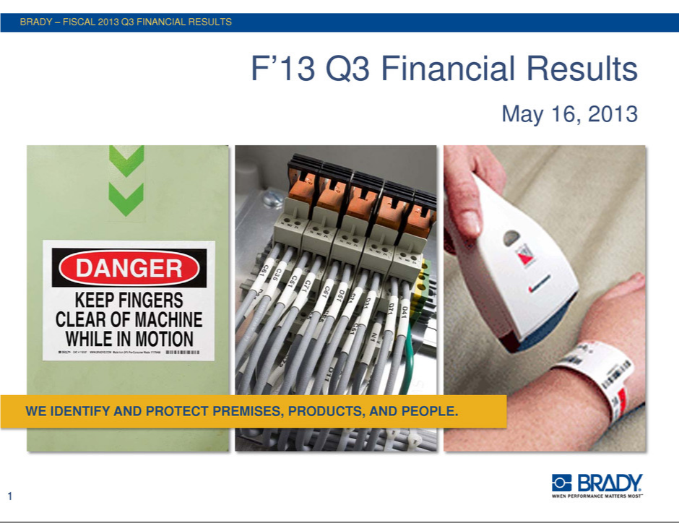

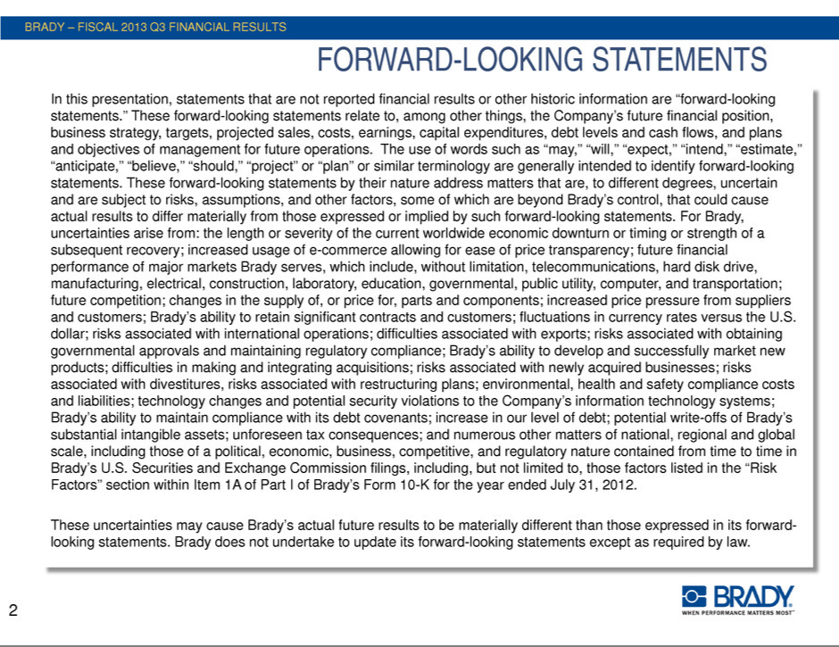

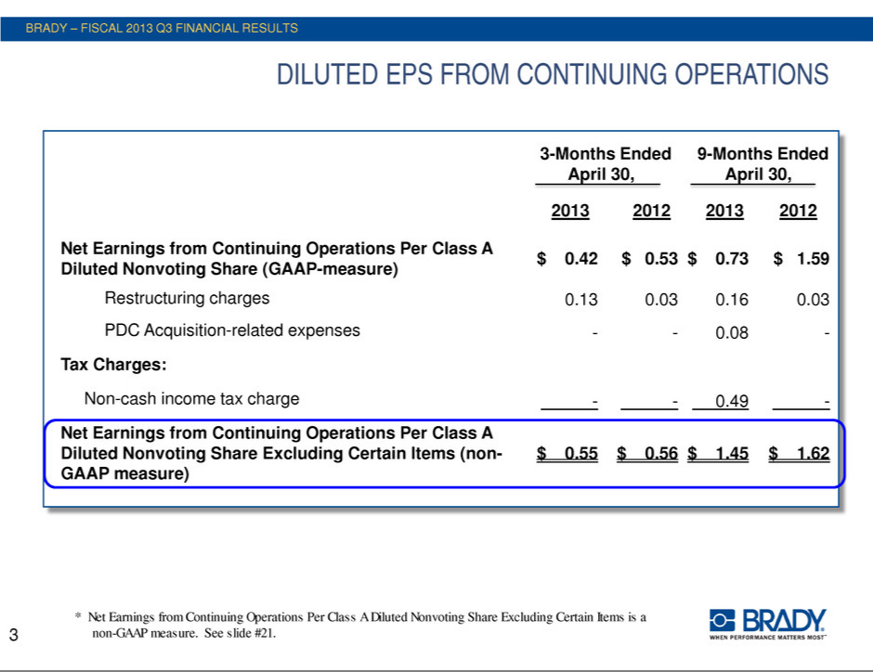

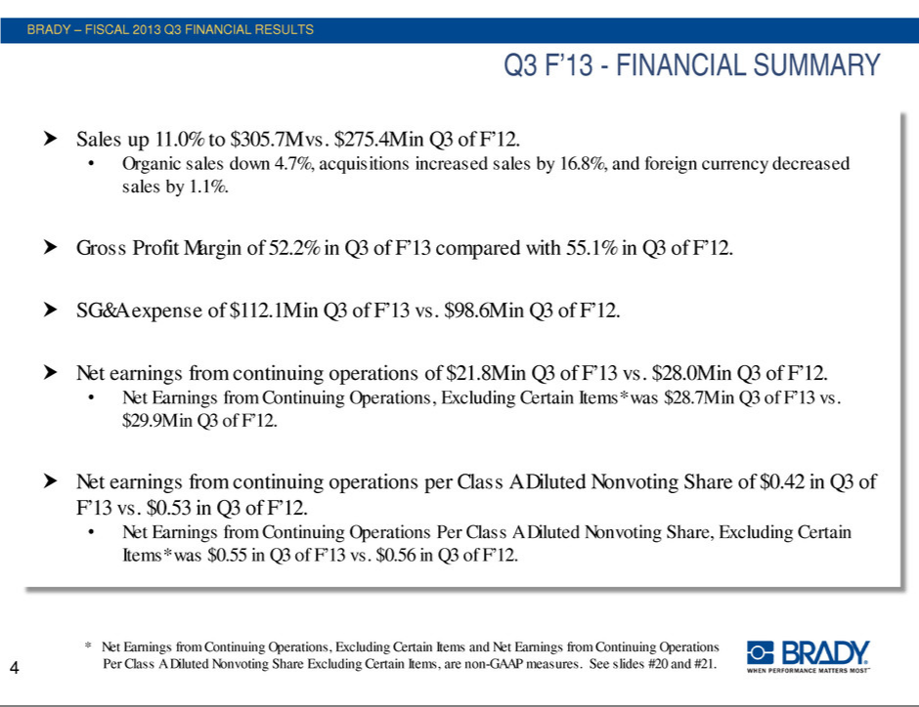

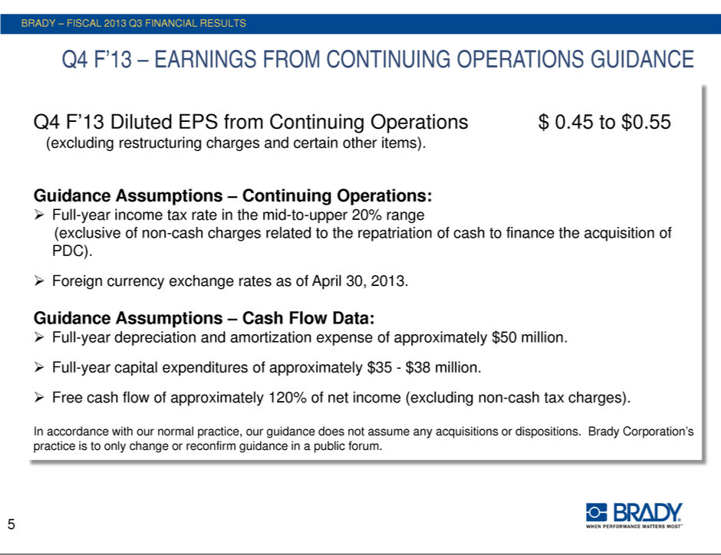

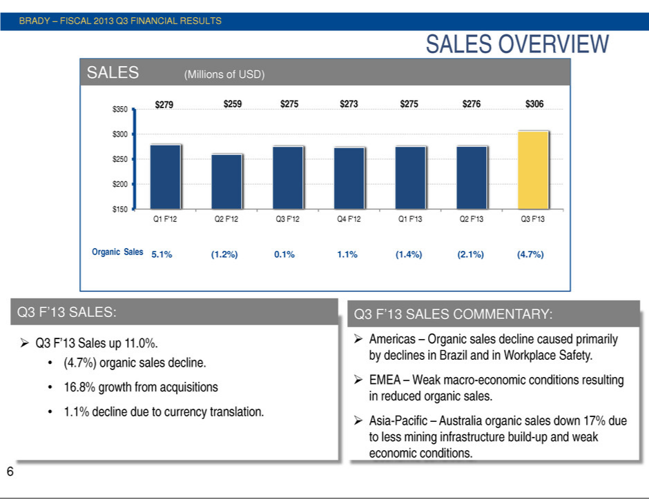

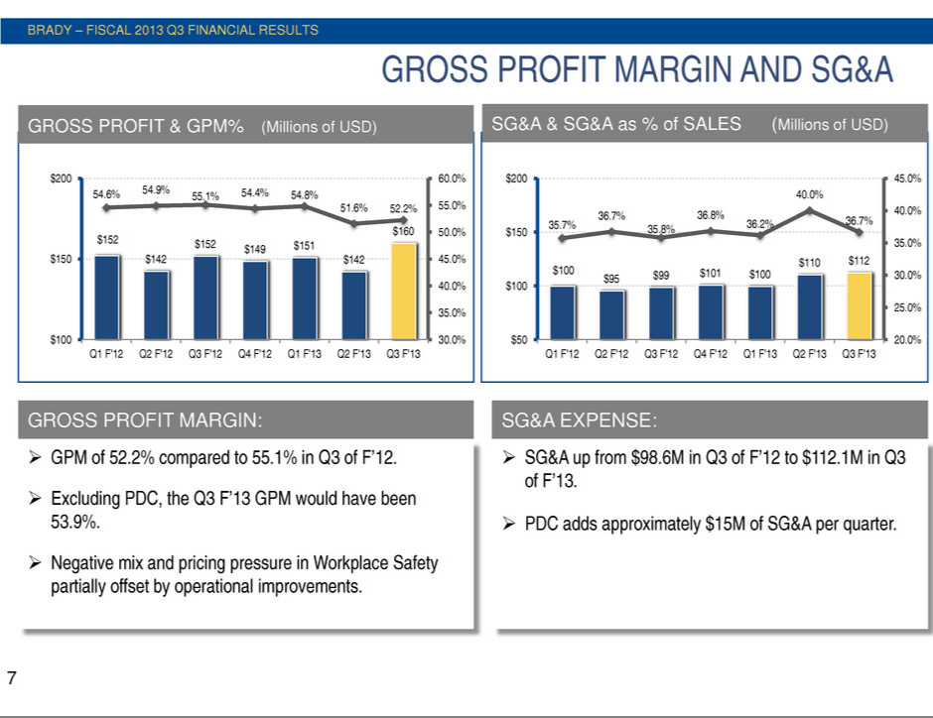

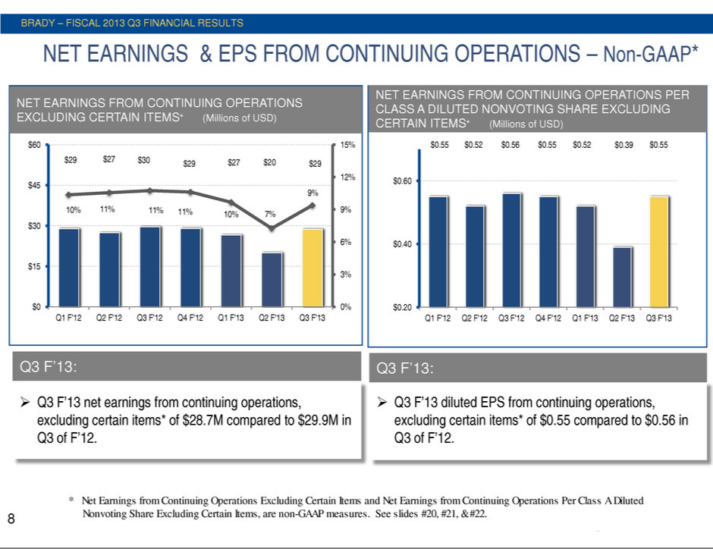

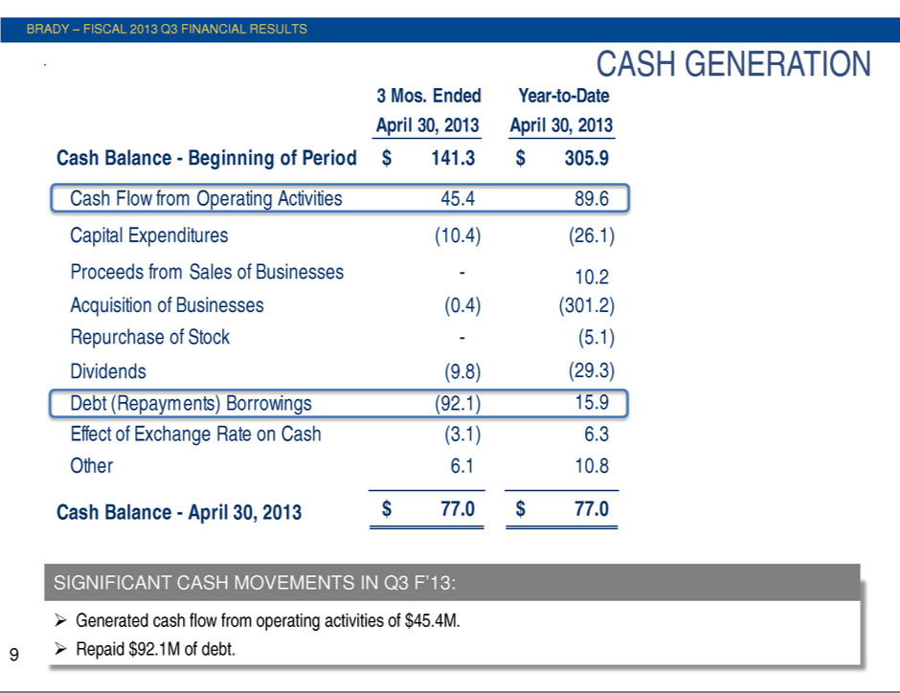

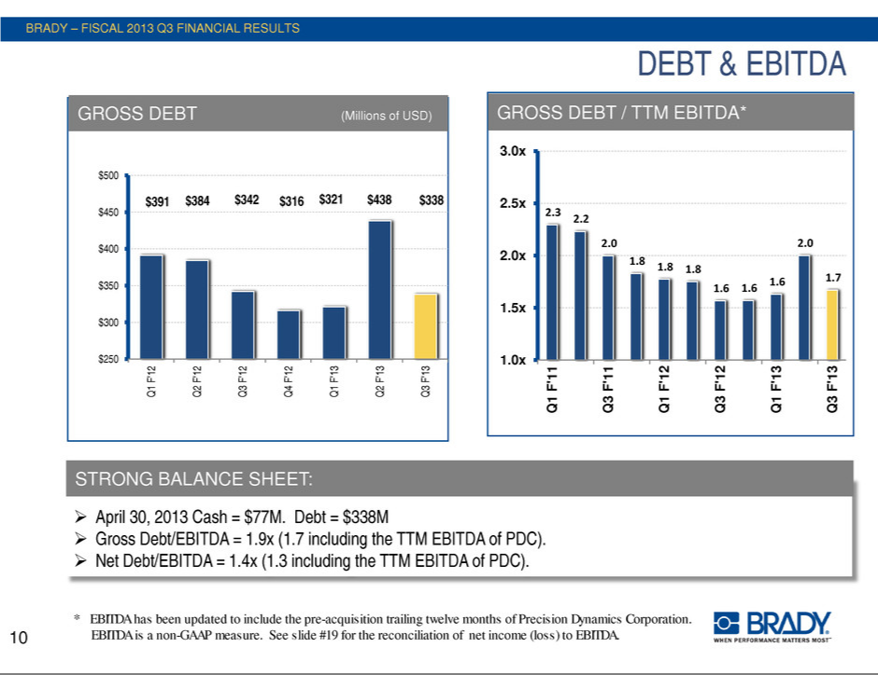

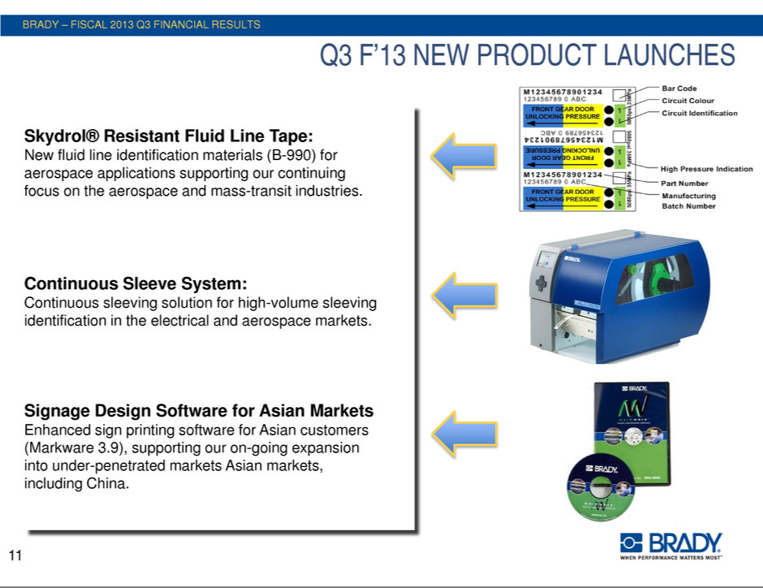

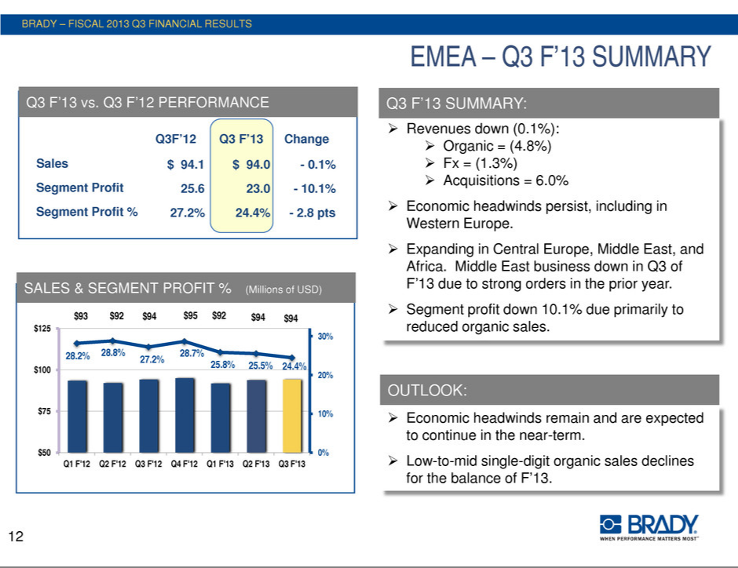

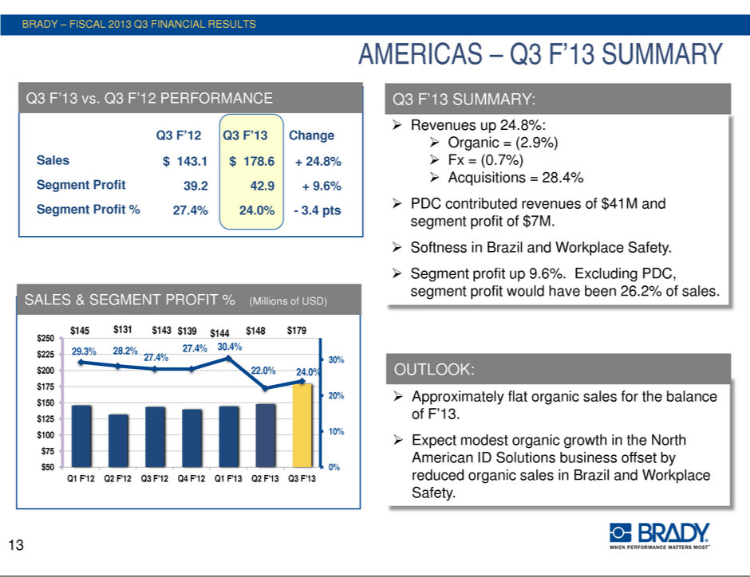

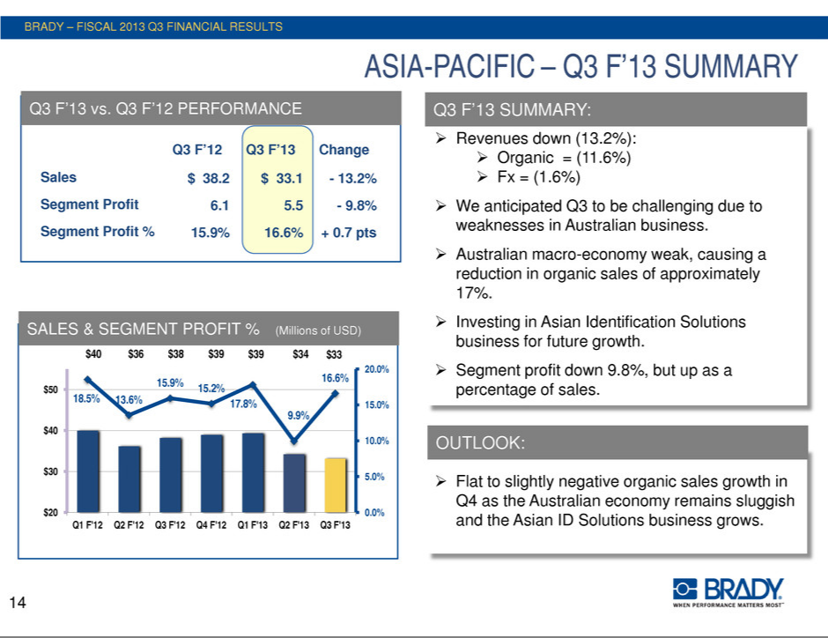

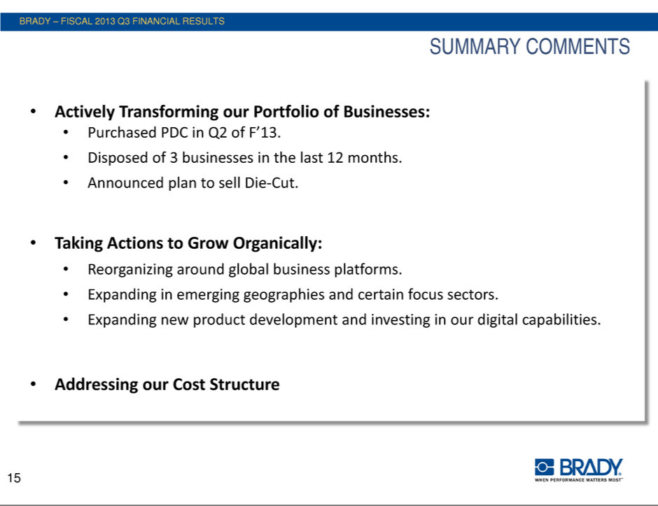



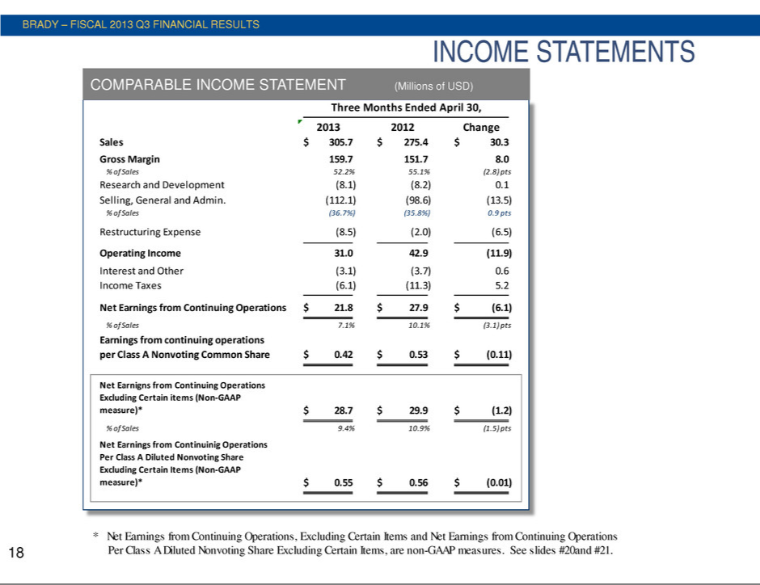

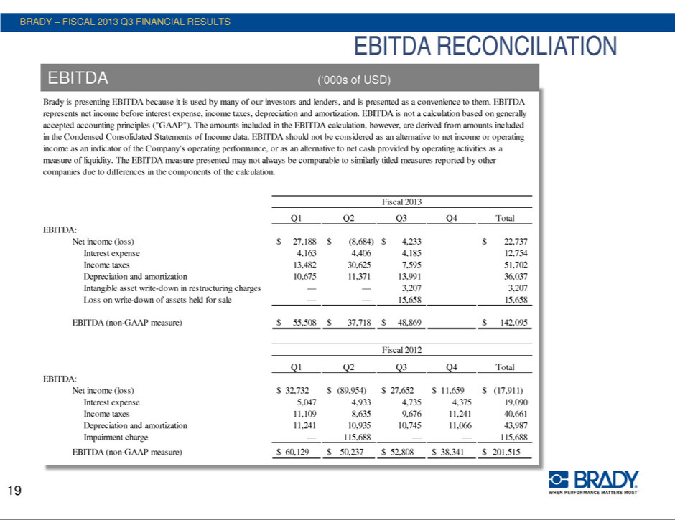

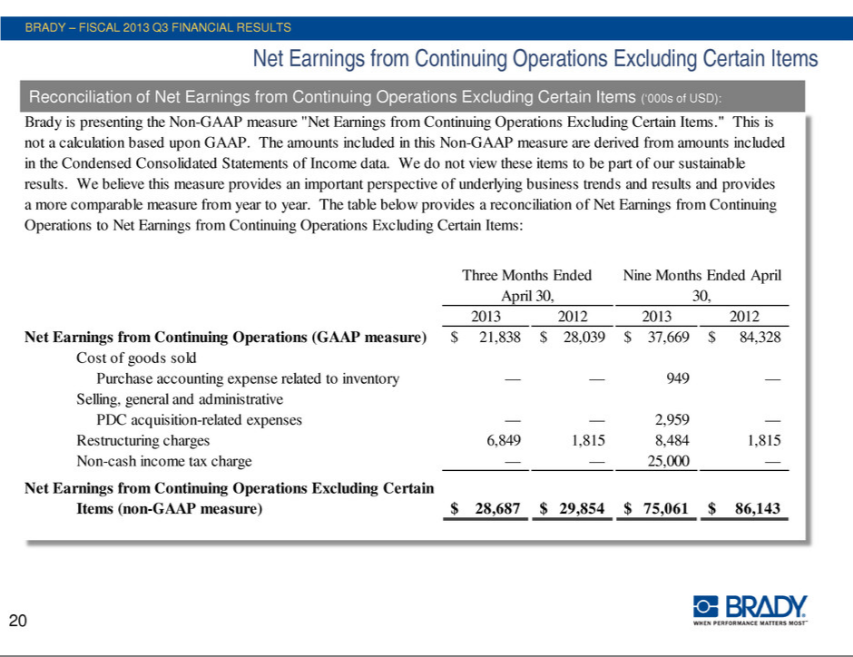

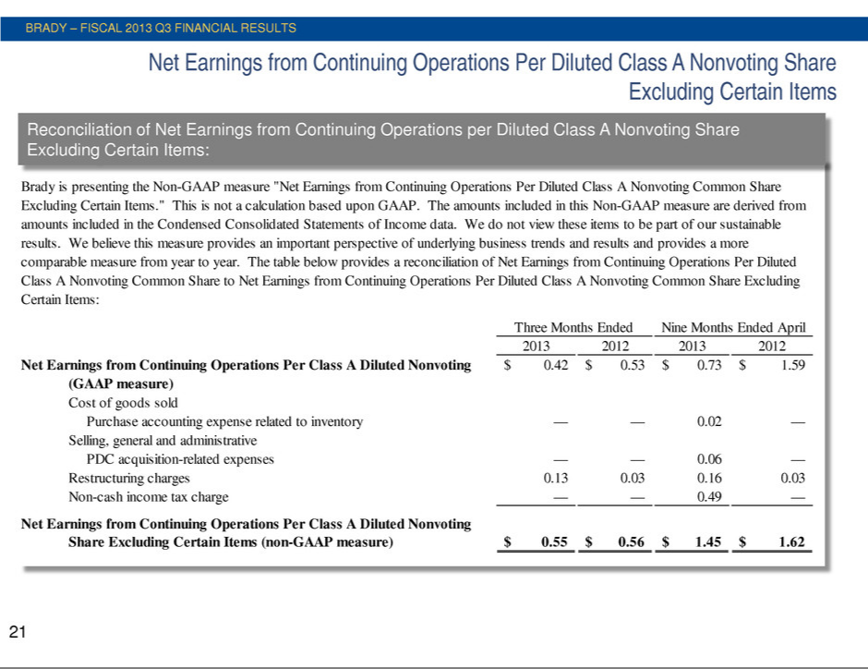

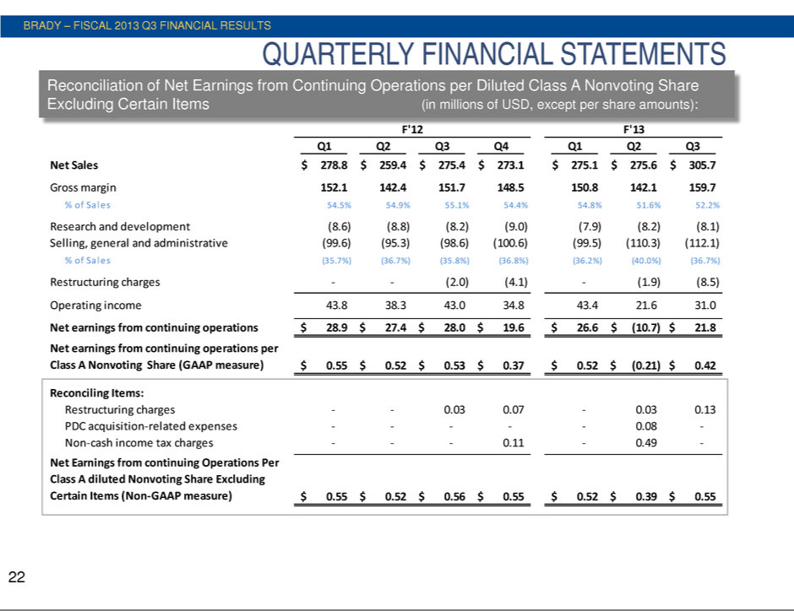

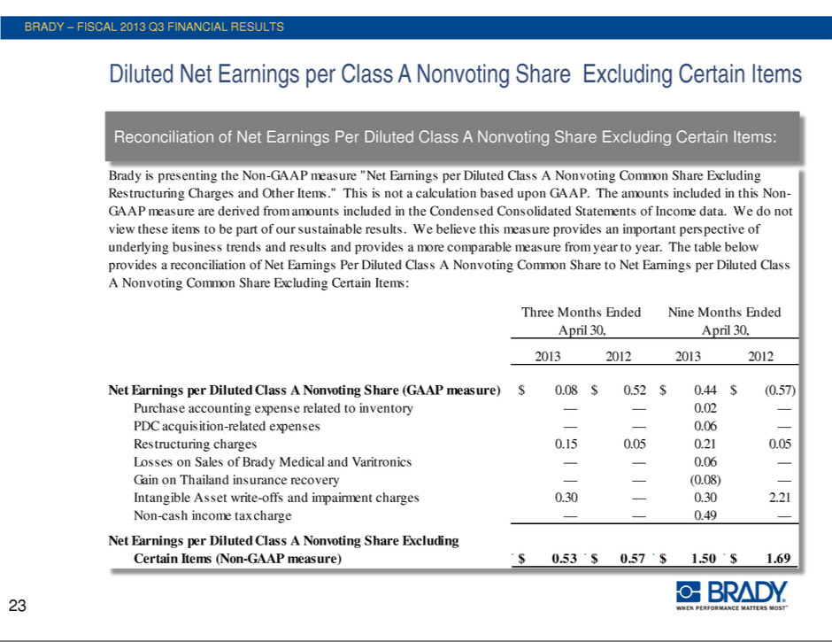

EXHIBIT 99.3

For More Information:

Investor contact: Aaron Pearce 414-438-6895
Media contact: Carole Herbstreit 414-438-6882

For Immediate Release

Brady Corporation Announces Plan to Sell its Asia-based Die-Cut Business

MILWAUKEE (May 16, 2013)--Brady Corporation (NYSE: BRC) (“Brady”), a world leader in identification solutions, today reported that it plans to sell its Asia-based Die-Cut business. This business, with sales of $179 million during the year ended July 31, 2012, consists of the manufacture and sale of high-performance products such as gaskets, meshes, heat dissipation materials, antennae, dampers, filters, and similar products sold primarily into the electronics industry with a concentration in the mobile-handset and hard-disk drive industries.

Brady's Board of Directors adopted a plan of sale for the Asia-based Die-Cut business in order to focus on its Identification Solutions and Workplace Safety businesses. Brady will continue to operate the business as a going concern and execute its improvement plans while engaged in the divestiture process.

“Our Die-Cut business has shown many signs of improvement and has recently secured several meaningful new orders,” stated Brady's President and Chief Executive Officer, Frank M. Jaehnert. “However, we no longer consider this business core to our strategy and believe that our Die-Cut customers and our employees will be better served by being with a company where Die-Cut is a core product offering.”

Brady Corporation is an international manufacturer and marketer of complete solutions that identify and protect premises, products and people. Brady's products help customers increase safety, security, productivity and performance and include high-performance labels, signs, safety devices, printing systems and software, and precision die-cut materials. Founded in 1914, the company has millions of customers in electronics, telecommunications, manufacturing, electrical, construction, education, medical and a variety of other industries. Brady is headquartered in Milwaukee, Wisconsin and as of January 31, 2013 employed approximately 8,200 people at operations in the Americas, EMEA and Asia-Pacific. Brady's fiscal 2012 sales were approximately $1.32 billion. Brady stock trades on the New York Stock Exchange under the symbol BRC. More information is available on the Internet at www.bradycorp.com.

###

Brady believes that certain statements in this news release are “forward-looking statements” within the meaning of the Private Securities Litigation Reform Act of 1995. All statements related to future, not past, events included in this news release, including, without limitation, statements regarding Brady's future financial position, business strategy, targets, projected sales, costs, earnings, capital expenditures, debt levels and cash flows, and plans and objectives of management for future operations are forward-looking statements. When used in this news release, words such as “may,” “will,” “expect,” “intend,” “estimate,” “anticipate,” “believe,” “should,” “project” or “plan” or similar terminology are generally intended to identify forward-looking statements. These forward-looking statements by their nature address matters that are, to different degrees, uncertain and are subject to risks, assumptions and other factors, some of which are beyond Brady's control, that could cause actual results to differ materially from those expressed or implied by such forward-looking statements. For Brady, uncertainties arise from the length or severity of the current worldwide economic downturn or timing or strength of a subsequent recovery; future financial performance of major markets Brady serves, which include, without limitation, telecommunications, manufacturing, electrical, construction, laboratory, education, governmental, public utility, computer, transportation; difficulties in making and integrating acquisitions; risks associated with newly acquired businesses; Brady's ability to develop and successfully market new products; changes in the supply of, or price for, parts and components; increased price pressure from suppliers and customers; fluctuations in currency rates versus the US dollar; unforeseen tax consequences; potential write-offs of Brady's substantial intangible assets; Brady's ability to retain significant contracts and customers; risks associated with international operations; Brady's ability to maintain compliance with its debt covenants; technology changes; business interruptions due to implementing business systems; environmental, health and safety compliance costs and liabilities; future competition; interruptions to sources of supply; Brady's ability to realize cost savings from operating initiatives; difficulties associated with exports; risks associated with restructuring plans; risks associated with obtaining governmental approvals and maintaining regulatory compliance; and numerous other matters of national, regional and global scale, including those of a political, economic, business, competitive and regulatory nature contained from time to time in Brady's U.S. Securities and Exchange Commission filings, including, but not limited to, those factors listed in the “Risk Factors” section located in Item 1A of Part I of Brady's Form 10-K for the year ended July 31, 2012. These uncertainties may cause Brady's actual future results to be materially different than those expressed in its forward-looking statements. Brady does not undertake to update its forward-looking statements.

