- --------------------------------------------------------------------------------

- --------------------------------------------------------------------------------

UNITED STATES SECURITIES AND EXCHANGE COMMISSION

WASHINGTON, DC 20549

---------------------

FORM 10-K

ANNUAL REPORT PURSUANT TO SECTION 13 OR 15(d) OF THE

SECURITIES EXCHANGE ACT OF 1934

FOR THE FISCAL YEAR ENDED JULY 31, 2003

COMMISSION FILE NUMBER 1-14959

---------------------

BRADY CORPORATION

(Exact name of registrant as specified in charter)

WISCONSIN

(State of Incorporation)

39-0178960

(IRS Employer Identification No.)

6555 WEST GOOD HOPE ROAD

MILWAUKEE, WI 53223

(Address of Principal Executive Offices and Zip Code)

- 358-6600

(Registrant's Telephone Number)

SECURITIES REGISTERED PURSUANT TO SECTION 12(b) OF THE ACT:

CLASS A NONVOTING COMMON STOCK, PAR VALUE $.01 PER SHARE, NEW YORK STOCK

EXCHANGE

SECURITIES REGISTERED PURSUANT TO SECTION 12(g) OF THE ACT:

NONE

Indicate by check mark whether the registrant (1) has filed all reports required to be filed by Section 13 or 15(d) of the Securities Exchange Act of 1934 during the preceding 12 months (or for such shorter period that the registrant was required to file such reports), and (2) has been subject to such filing requirements for the past 90 days. Yes [X] No [ ]

Indicate by check mark if disclosure of delinquent filers pursuant to Item 405 of Regulation S-K is not contained herein, and will not be contained, to the best of the registrant's knowledge, in definitive proxy or information statements incorporated by reference in Part III of this Form 10-K or any amendment to this Form 10-K. [ ]

Indicate by check mark whether the registrant is an accelerated filer (as defined in Rule 12b-2 of the Act). Yes [X] No [ ]

The aggregate market value of the non-voting common stock held by

non-affiliates of the entity as of January 31, 2003 was approximately

$471,233,549, (based on closing sale price of $26.56 per share on that date as

reported for the New York Stock Exchange). As of September 15, 2003, there were

outstanding 21,636,682 shares of Class A Nonvoting Common Stock (the "Class A

Common Stock"), and 1,769,314 shares of Class B Common Stock. The Class B Common

Stock, all of which is held by affiliates of the registrant, is the only voting

stock.

DOCUMENTS INCORPORATED BY REFERENCE

BRADY CORPORATION 2003 ANNUAL REPORT TO SHAREHOLDERS, INCORPORATED INTO PART II

  - IV

- --------------------------------------------------------------------------------

- --------------------------------------------------------------------------------

 | INDEX
PAGE | ------ PART I Item 1.
Business....................................................
I-1 General Development of
Business............................. | I-1 Financial
Information About Industry Segments............... |  | I-1
Narrative Description of Business:
Overview..................................................
 | I-1 Business
Strategy......................................... |  | I-1 Key
Initiatives........................................... |  | I-2
Products..................................................
 | I-3 Marketing and
Sales....................................... |  | I-5
Manufacturing Process and Raw Materials...................
I-6 Technology and Product
Development........................ | I-6 International
Operations.................................. |  | I-7
Competition...............................................
 | I-7
Backlog...................................................

 | Operations and Export
Sales............................................ | I-7
Information Available on the
Internet....................... | I-8 Item 2.
Properties..................................................
 | I-8 Item 3. Legal
Proceedings........................................... | I-8
Item 4. Submission of Matters to a Vote of Security
Holders......... | I-8 PART II Item 5. Market for the
Registrant's Common Equity and Related Stockholder
Matters......................................... | II-1 Item
 | 6. Selected Financial
Data..................................... | II-1 Item 7.
Management's Discussion and Analysis of Financial Condition
 | and Results of
Operations................................... | II-1 Item 7A.

Quantitative and Qualitative Disclosures About Market

Risk........................................................

II-10 Item 8. Financial Statements and Supplementary

Data................. II-11 Item 9. Changes In and

Disagreements With Accountants on Accounting and Financial

Disclosure.................................... II-37 Item

9A. Controls and

Procedures..................................... II-37

1

PAGE ------ PART III Item 10. Directors and Executive Officers of the

Registrant.......... III-1 Item 11. Executive

Compensation...................................... III-4 Summary

Compensation Table................................ III-4 Stock

Options............................................. III-5 Common

Stock Price Performance Graph...................... III-7

Compensation of Directors................................. III-8

Termination of Employment and Change in Control

Arrangements.............................................. III-8

Restricted Stock.......................................... III-9

Compensation Committee Interlocks and Insider

Participation............................................. III-9

Funded Retirement and 401(k) Plans........................ III-9

Deferred Compensation Arrangements........................ III-10

Compensation Committee Report on Executive Compensation... III-10

Item 12. Security Ownership of Certain Beneficial Owners and

Management and Related Stockholder Matters.................. III-13

Item 13. Certain Relationships and Related Transactions..............

III-15 PART IV Item 14. Exhibits, Financial Statement Schedule and

Reports on Form 8-

K......................................................... IV-1

Signatures............................................................

IV-5

2

PART I

Brady Corporation and Subsidiaries are referred to herein as the "Company", "Brady" or "we".

ITEM 1. BUSINESS

(A) GENERAL DEVELOPMENT OF BUSINESS

The Company, a Wisconsin corporation founded in 1914, currently operates 28 manufacturing facilities worldwide. Nine are located in the United States, three each in Australia, Brazil and China, two each in France and Germany and one each in Belgium, Canada, England, Italy, Malaysia and Singapore. The Company sells through subsidiaries or sales offices in Australia, Belgium, Brazil, Canada, China, England, France, Germany, Hong Kong, Hungary, Italy, Japan, Korea, Malaysia, Mexico, the Philippines, Singapore, Sweden, Taiwan and the United States. The Company's corporate headquarters are located at 6555 West Good Hope Road, Milwaukee, Wisconsin 53223, and the telephone number is (414) 358-6600. The Company's Internet address is http://www.bradycorp.com.

(B) FINANCIAL INFORMATION ABOUT INDUSTRY SEGMENTS

The information required by this Item is provided in Note 7 of the Notes to Consolidated Financial Statements contained in Item 8 -- Financial Statements and Supplementary Data.

- NARRATIVE DESCRIPTION OF BUSINESS OVERVIEW

Brady is an international manufacturer and marketer of identification solutions and specialty materials which help customers increase safety, security, productivity and performance. Its products include high-performance labels and signs, printing systems and software, label-application and data-collection systems, safety devices and precision die-cut materials. Founded in 1914, the Company serves more than 300,000 customers in electronics, telecommunications, manufacturing, electrical, construction, education and a variety of other industries. Brady's reputation for innovation, commitment to quality and service, and dedicated employees have made it a world leader in its markets.

Brady's major product categories include: identification solutions and specialty tapes and graphics and workplace solutions. The Company's products are sold in a variety of markets, including electrical, electronic, telecommunication, governmental, public utility, computer, construction, general manufacturing, laboratory, transportation equipment and education. The need for the Company's products is driven by specification of customer engineering departments, by regulatory compliance requirements imposed by agencies such as the Occupational Safety & Health Administration (OSHA) and the Environmental Protection Agency (EPA), or by the need to identify and track assets, or to direct, warn, inform, train and protect people. The Company manufactures and sells products domestically and internationally through multiple channels including direct sales, distributor sales, mail-order catalogs, telemarketing and electronic access through the Internet. The Company has a broad customer base, which in fiscal 2003 consisted of more than 300,000 companies, with the largest customer representing just over 5% of net sales. Sales from international operations represented 52.3%, 48.5% and 44.0% of sales in fiscal 2003, 2002, and 2001, respectively.

BUSINESS STRATEGY

Brady's mission is to be the world leader in identification and material solutions that help companies improve productivity, performance, safety and security. The Company's goal is to accomplish this objective by offering a broad range of high-quality, innovative products to a widely diversified customer base in a prompt and responsive manner. Underlying the Company's business strategy is a Company-wide commitment to enhancing shareholder value. The Company's long-term focus on activities that will create sustainable value for shareholders drives decision making at all levels of the Company. The Company's employees participate in an incentive plan that has a component focused upon growth and profitability. This incentive plan serves to

I-1

motivate employees, foster a team-oriented work environment and maximize the utilization of assets. Key elements of the Company's business strategy include:

Product innovation. The Company continually seeks to improve existing products and to develop innovative products to satisfy customers' requirements and expectations. Brady's commitment to product innovation is reflected in research and development efforts that include approximately 175 employees primarily dedicated to research and development activities in the United States, Canada, Belgium, France and Singapore.

Breadth of product line. The Company's products include over 50,000 stock as well as custom items. The number of products offered allows Brady to serve as a one-stop shopping network for customers. Additionally, management believes that the Company provides a broader range of identification solutions than many of its competitors.

Focus on customers. The Company seeks to provide "seamless" customer service and to offer rapid response to customer orders and inquiries. To meet this goal, the Company has streamlined its manufacturing processes to shorten lead-times and has increased investment in telecommunications and management information systems worldwide.

Niche markets. The Company strives to be a major player in niche markets that allow the Company to leverage its capabilities in specialty materials, die-cut parts and printing systems. By focusing on specific markets and value-added product applications, the Company has established leading positions in the electrical and safety markets with certain products such as wire markers, pipe markers, safety signs and printing systems. It also is a leader in high performance work-in-process labels, precision die-cut materials and bar-code-label-generation software.

KEY INITIATIVES

The Company's key initiatives include:

Customer-driven growth. The Company seeks to increase market penetration in existing domestic and international markets through existing distribution channels and strong sales and marketing efforts. To achieve this objective, the Company is aligning more closely with distributors, combining its current sales force and pursuing additional channels and expanding its geographic reach. Sales from Brady's international operations have increased from $50,707,000 or 26.5% of net sales in fiscal 1990 to $290,068,000 or 52.3% of net sales in fiscal 2003. The Company believes that international markets continue to represent a significant growth opportunity. Accordingly, the Company is actively seeking to increase penetration in established markets in Europe, Asia/Pacific and Canada and to enter new emerging markets elsewhere in Eastern Europe, the Pacific Rim and Latin America.

Proprietary products. The Company, through strong product innovation and development activities, seeks to continually introduce new products and explore additional applications for products in existing and new markets. Through its market planning process, the Company seeks to fully understand the broad needs of each of its major market segments and determine a strategy to meet those needs in each segment.

Acquisitions. While the Company intends to continue pursuing internal growth through the above strategies, it also intends, where practical, to fill product lines or market sectors, open new geographic markets, acquire new technology, and strengthen product offerings through the pursuit of strategic acquisitions and joint ventures.

Process improvement. Process improvement will also support the Company as it grows. Brady has been working over the last four years on its Earning Customer Loyalty through Integrated Processes and Systems Everywhere (Eclipse) initiative, a global project creating one Brady enterprise with common and shared processes supported by a single integrated system (SAP). This will allow Brady to better anticipate and serve the future needs of its customers while making improvements in working capital measures and selling, general and administrative (SG&A) expense. As of July 31, 2003, approximately 70% of Brady's global operations were operating on this system, as measured by sales volume.

I-2

Leadership. The Company highlights leadership as an important initiative to its values and growth strategy. Its leadership principles include: customer focus, high-performance expectations, boldness, decisiveness and accountability.

PRODUCTS

The Company's products consist of over 50,000 stock as well as custom items and complete identification systems that are used by the Company's customers to create a safer work environment for employees, improve production and operating efficiencies and increase the utilization of assets through tracking and inventory process controls. Major product categories include: identification solutions and specialty tapes products, including wire and cable markers, high-performance labels, laboratory identification products, stand-alone printing systems, bar-code and other software, automatic identification and data collection systems and specialty tapes and precision die-cut solutions; and graphics and workplace solutions products, including signs, pipe and valve markers, storage markers, asset identification tags, lockout/tagout products, traffic-control products, printing systems, software and graphics products.

Many of the Company's stock products were originally designed, developed and manufactured as custom products for a specific purchaser. However, such products have frequently developed wide industry acceptance and become stock items offered by the Company through mail-order and distributor sales. The Company's most significant types of products are described below.

IDENTIFICATION SOLUTIONS AND SPECIALTY TAPES PRODUCTS

WIRE AND CABLE MARKERS

Brady manufactures a broad range of wire- and cable-marking products. These products help mark and identify wires, cables and their termination points. Such products may be used in virtually every industrial, power and communication market to specify the origination and/or destination of wiring and to facilitate repair or maintenance of equipment and data communication and electrical wiring systems.

HIGH PERFORMANCE LABELS

Brady produces a complete line of label materials to meet customers' needs for identification that performs under harsh or sensitive conditions. Brady prints stock and custom labels and also sells unprinted materials to enable customers to print their own labels on site, on demand, using thermal-transfer, laser, dot matrix and inkjet printers. Brady labels are manufactured out of a variety of films, predominantly coated by Brady, for applications in the following markets: electronic, industrial, electrical, laboratory and security.

SOFTWARE AND PRINTING SYSTEMS

The Company designs and produces various computer software packages, industrial thermal-transfer and dot matrix printers and other electromechanical devices to serve the growing and specialized needs of customers in a wide variety of markets. Industrial labeling systems, software, tapes, ribbons and label stocks provide customers with the resources and flexibility to produce signs and labels on demand at their site.

AUTOMATIC IDENTIFICATION AND DATA-COLLECTION SYSTEMS

Brady's automatic identification and data collection solutions include bar-code-label-generating software and bar-code tags and labels to enable accurate tracking of manufacturing, warehousing, receiving and shipping data. The Company's software applications, fixed station terminals, high-speed printers and associated customized consumable products allow its customers, in a wide variety of markets, to have a higher degree of knowledge and control over production, asset management and all phases of inventory control, including receiving, warehousing, work-in-process, finished goods and shipping.

I-3

SPECIALTY TAPES

Brady manufactures specialty tapes and related products that are used in a variety of audio, video and computer applications. These specialty tape products are characterized by high-performance adhesives, most of which are formulated by the Company, to meet high-tolerance requirements of the industries in which they are used. Its data-storage products include audio and videocassette splicing tapes.

PRECISION DIE-CUT SOLUTIONS

The Company develops customized precision die-cut solutions that are used to seal, insulate, protect, shield or provide other mechanical performance properties in the assembly of electronic, telecommunications and other equipment, including cellular phones, personal data assistants, computer hard drives, computers and other devices. Solutions not only include the materials and converting, but also automatic placement and other value-added services.

GRAPHICS AND WORKPLACE SOLUTIONS PRODUCTS

SIGNS

The Company manufactures safety and informational signs for use in a broad range of industrial, commercial, governmental and institutional applications. These signs are either self-adhesive or mechanically mounted, are designed for both indoor and outdoor use and are manufactured to meet standards issued by the National Safety Council, OSHA and a variety of industry associations in the United States and abroad. The Company's sign products are categorized by type of message to be conveyed, including admittance, directional and exit signs; electrical hazard warnings; energy conservation messages; fire protection and fire equipment signs; hazardous waste labels; hazardous and toxic material warning signs; personal hazard warnings; housekeeping and operational warnings; pictograms; radiation and laser signs; safety practices signs and regulatory markings. The Company also offers architectural signage products including sign systems, nameplates, Braille signs and desk plates.

PIPE AND VALVE MARKERS

The Company manufactures both self-adhesive and mechanically applied stock and custom-designed pipe markers, and plastic and metal valve tags for the identification of pipes and control valves in the mechanical contractor and process industry markets. These products are designed to help identify and provide information as to the contents, direction of flow and special hazardous properties of materials contained in piping systems, and to facilitate repair or maintenance of the systems.

WAREHOUSE PRODUCTS

The Company produces signs, self-adhesive and self-aligning die-cut numbers and letters, labels, signs and tags used to mark warehouse locations and identify inventory. Warehouse products are primarily used by industrial companies in storage facilities such as warehouses, factories, stockrooms and other facilities.

ASSET IDENTIFICATION MARKERS

Brady offers a wide range of asset-identification products that are an important part of an effective asset management program in a wide variety of markets. These include self-adhesive or mechanically mounted labels or tags made of aluminum, brass, stainless steel, polycarbonate, vinyl, polyester, mylar and paper. These products are also offered in tamper-evident varieties.

LOCKOUT/TAGOUT PRODUCTS

Brady offers a wide variety of lockout/tagout products. Under OSHA regulations, all energy sources must be "locked out" while machines are being serviced or maintained to prevent accidental engagement and injury. The Company's products allow its customers to comply with these regulations and to ensure worker safety for a wide variety of energy- and fluid-transmission systems and operating machinery.

I-4

SECURITY CONTROL PRODUCTS

The Company offers identification and security products including a variety of self-expiring badges, security seals, parking permits and wristbands designed for visitor control in financial, governmental, educational and commercial facilities including meeting and convention sites. Some of these products make use of migratory ink technology, which, upon activation, starts a timed process resulting in an altered message, color or design to indicate expiration.

TRAFFIC CONTROL PRODUCTS

The Company offers a wide variety of traffic control devices including traffic signs, directional and warning signs, parking tags and permits, barriers, cones and other devices.

GRAPHICS PRODUCTS

Brady serves the identification and information needs of various non-industrial markets with a variety of easy-to-use printing systems and consumable supplies. It provides lettering and labeling systems, poster printers, laminators and supplies to education and training markets.

OTHER

The Company also offers sign-making kits, barricading products, visual warning systems, floor-marking products, safety badges, photo-identification kits, and first aid cabinets/kits, among others.

OTHER PRODUCTS

The Company also sells a variety of other products, none of which currently individually accounts for a material portion of its sales, including: hospital and clinical labels, packing and shipping goods, name plates, and quality and production control products, among others.

MARKETING AND SALES

The Company's products are sold in a wide variety of markets including electrical, electronic, telecommunications, governmental, public utility, commercial office, computer, construction, general manufacturing, laboratory, transportation equipment and education. Brady has a diverse customer base that consisted of over 300,000 customers in fiscal 2003. No material part of the Company's business is dependent upon a single customer or group of customers, and the loss of a particular customer would not have a material adverse effect upon the Company's business. In fiscal 2003, Brady's largest customer accounted for just over 5% of the Company's net sales.

Brady seeks to offer the right product with rapid response times and superior service so that it can provide solutions to the customer that are better, faster and more economical than those available from the Company's competitors. The Company markets and sells its products domestically and internationally through multiple channels including direct sales, distributor sales, mail-order-catalog marketing and electronic access through the Internet. The Company currently has over 4,000 established relationships with a broad range of electrical, safety, industrial and other domestic and international distributors. The Company's sales force seeks to establish and foster ongoing relationships with the end-users and distributors by providing technical support and product-application advice.

The Company direct markets certain products and those of other manufacturers by catalog sales in both domestic and international markets. Such products include industrial and facility identification products, safety and regulatory-compliance products and original equipment manufacturer component products, among others. Catalog operations are conducted through offices in the U.S., Australia, Brazil, Canada, England, France, Germany and Italy, and include foreign-language catalogs.

I-5

MANUFACTURING PROCESS AND RAW MATERIALS

The Company manufactures the majority of the products it sells, while purchasing certain items from other manufacturers. Products manufactured by the Company generally require a high degree of precision and the application of adhesives with chemical and physical properties suited for specific uses. The Company's manufacturing processes include compounding, coating, converting, software development and printer design and assembly. The compounding process involves the mixing of chemical batches for primers, top coatings and adhesives, in solvent- or water-based materials. The coatings and adhesives are applied to a wide variety of materials including polyester, polyimide, cloth, paper, metal and metal foil. The converting process may include embossing, perforating, laminating, die cutting, slitting, and printing or marking the materials as required.

The Company seeks to optimize the performance, quality and durability of its products, while continually improving manufacturing processes, shortening lead times and lowering manufacturing costs. The Company produces the majority of the adhesive stocks and top-coated materials through an integrated manufacturing process. These integrated manufacturing processes permit greater flexibility in product design and manufacture, and an improved ability to provide specialized products designed to meet the needs of specific applications. Brady's "cellular" manufacturing processes and "just-in-time" inventory control are designed to attain profitability in small orders by emphasizing flexibility and the maximization of assets through quick turnaround and delivery. A growing part of the Company's manufacturing is done through a Web-to-Workbench(TM) process. In this process, orders received for items such as signs and asset identification labels are sent directly from the customer's order on the Internet to the manufacturing floor. Most of the Company's manufacturing facilities have received ISO 9001 or 9002 certification.

The materials used in the products manufactured by the Company consist primarily of plastic sheets and films (primarily polyesters, vinyls and polycarbonates), paper, metal and metal foil, cloth, fiberglass, inks, dyes, adhesives, pigments, natural and synthetic rubber, organic chemicals, polymers and solvents. The Company purchases its raw materials from many suppliers and is not dependent upon any single supplier for any of its critical base materials.

TECHNOLOGY AND PRODUCT DEVELOPMENT

The Company focuses its research and development efforts on material development, systems design and software development. Material development involves the application of surface chemistry concepts to coatings and adhesives applied to a variety of base materials. Systems design integrates materials, custom firmware and a variety of printing technologies to form a complete solution for customer applications or the Company's own production requirements.

The Company possesses patents covering various aspects of adhesive chemistry, electronic circuitry, computer-generated wire markers, systems for aligning letters and patterns, and visually changing paper. Although the Company believes that its patents are a significant factor in maintaining market position for certain products, technology in the areas covered by many of the patents is evolving rapidly and may limit the value of such patents. The Company's business is not dependent on any single patent or group of patents.

The Company conducts much of its technology and development activities at

the Frederic S. Tobey Research and Innovation Center (approximately 39,600 sq.

ft.) in Milwaukee, Wisconsin. The Company spent approximately $18,900,000,

$17,300,000, and $20,300,000 in fiscal 2003, 2002, and 2001, respectively, on

its research and development activities. In fiscal 2003, approximately 175

employees were engaged in research and development activities for the Company.

Additional research projects were conducted under contract with universities,

other institutions and consultants.

The Company's name and its registered trademarks are important to each of its business segments. In addition, the Company owns other important trademarks applicable to only certain of its products.

I-6

INTERNATIONAL OPERATIONS

In fiscal 2003, 2002, and 2001, sales from international operations accounted for 52.3%, 48.5% and 44.0%, respectively, of the Company's sales. The Company's global infrastructure includes subsidiaries in Australia, Belgium, Brazil, Canada, China, England, France, Germany, Hungary, Italy, Japan, Malaysia, Mexico, Singapore, and Sweden and sales offices in Hong Kong, Korea, the Philippines, and Taiwan. Several of these locations manufacture or have the capability to manufacture certain of the products they sell. The Company acquired or opened new operations in Australia, China, England, Germany and Malaysia in the last three years. The Company expects to continue to expand its international operations as appropriate.

COMPETITION

The markets for most of the Company's products are competitive. The Company believes that it is one of the leading domestic producers of self-adhesive wire markers, safety signs, pipe markers, precision die-cut materials and bar-code-label-generating software. The Company competes for business principally on the basis of product quality, performance, service, range of products offered and to a lesser extent, on price. Product quality is determined by factors such as suitability of component materials for various applications, adhesive properties, graphics quality, durability, product consistency and workmanship. Competition in many of the Company's product markets is highly fragmented, ranging from smaller companies offering only one or a few types of products, to some of the world's major adhesive and electrical product companies offering some competing products as part of their product lines. A number of the Company's competitors are larger than the Company and have greater resources. Notwithstanding the resources of these competitors, management believes that the Company provides a broader range of identification solutions than any of its competitors.

BACKLOG

As of July 31, 2003, the amount of the Company's backlog orders believed to

be firm was approximately $16,300,000. This compares with approximately

$22,300,000 and $22,100,000 of backlog orders as of July 31, 2002 and 2001,

respectively. Average delivery time for the Company's orders varies from one day

to one month, depending on the type of product, and whether the product is stock

or custom designed and manufactured.

ENVIRONMENT

At present, the manufacturing processes for the Company's adhesive-based products utilize certain evaporative solvents, which, unless controlled, would be vented into the atmosphere. Emissions of these substances are regulated at the federal, state and local levels. The Company has implemented a number of procedures to reduce atmospheric emissions and/or to recover solvents. Management believes the Company is substantially in compliance with all environmental regulations.

EMPLOYEES

As of July 31, 2003, the Company employed approximately 3,300 individuals. The Company has never experienced a material work stoppage due to a labor dispute, is not a party to any negotiated labor contracts, and considers its relations with employees to be excellent.

ACQUISITIONS

Information about the Company's acquisitions is provided in Note 2 of the Notes to Consolidated Financial Statements contained in Item 8 -- Financial Statements and Supplementary Data.

(D) FINANCIAL INFORMATION ABOUT FOREIGN AND DOMESTIC OPERATIONS AND EXPORT SALES

The information required by this Item is provided in Note 7 of the Notes to Consolidated Financial Statements contained in Item 8 -- Financial Statements and Supplementary Data.

I-7

(E) INFORMATION AVAILABLE ON THE INTERNET

The Company's Internet address is http://www.bradycorp.com. The Company makes available, and has made available since June 2003, free of charge, on or through its Internet website copies of its Annual Report on Form 10-K, Quarterly Reports on Form 10-Q, Current Reports on Form 8-K, Section 16 reports filed by the Company's insiders, and amendments to all such reports as soon as reasonably practicable after such reports are electronically filed with or furnished to the SEC.

ITEM 2. PROPERTIES

The Company currently operates 28 manufacturing facilities. Nine are located in the United States, three each in Australia, Brazil and China, two each in France and Germany and one each in Belgium, Canada, England, Italy, Malaysia and Singapore. The Company's present operating facilities contain a total of approximately 1,545,000 square feet of space, of which approximately 709,000 square feet is leased. The Company believes that its equipment and facilities are modern, well maintained and adequate for present needs.

ITEM 3. LEGAL PROCEEDINGS

The Company is, and may in the future be, party to litigation arising in the course of business. The Company is not currently a party to any material pending legal proceedings.

ITEM 4. SUBMISSION OF MATTERS TO A VOTE OF SECURITY HOLDERS

On July 22, 2003, by written consent, the affirmative vote of 100% of the 1,769,314 shares of Class B Common Voting Stock approved the Brady Corporation 2003 Omnibus Incentive Stock Plan.

I-8

PART II

ITEM 5. MARKET FOR THE REGISTRANT'S COMMON EQUITY AND RELATED STOCKHOLDER MATTERS

(a) Market Information

Brady Corporation Class A Nonvoting Common Stock trades on the New York Stock Exchange under the symbol BRC and on the Berlin Stock Exchange under the number 900104. There is no trading market for the Company's Class B Voting Common Stock.

Stock price disclosure required by this Item is incorporated by reference to Page 10 of the Brady Corporation 2003 Annual Report to Shareholders.

(b) Holders

The number of holders of record of the Company's Class A and Class B Common Stock as of September 5, 2003, was 332 and 3, respectively.

(c) Dividends

The Company has followed a practice of paying quarterly dividends on outstanding common stock. Before any dividend may be paid on the Class B Common Stock, holders of the Class A Common Stock are entitled to receive an annual, noncumulative cash dividend of $.0333 per share (subject to adjustment in the event of future stock splits, stock dividends or similar events involving shares of Class A Common Stock). Thereafter, any further dividend in that fiscal year must be paid on all shares of Class A Common Stock and Class B Common Stock on an equal basis. The Company's revolving credit agreement requires that it maintain a specified level of consolidated net worth, which could restrict the Company's ability to pay dividends. At July 31, 2003, the required consolidated net worth was approximately $264,000,000 and the Company's actual consolidated net worth was approximately $339,000,000.

During its two most recent fiscal years and for the first quarter of the current year, the Company declared the following dividends per share on its Class A and Class B Common Stock for the years ended July 31:

YEAR ENDING

2002 2003 2004

---------------

---------------

------- -------

---------------

---------------

------- 1ST QTR

2ND QTR 3RD QTR

4TH QTR 1ST QTR

2ND QTR 3RD QTR

4TH QTR 1ST QTR

------- -------

------- -------

------- -------

------- -------

------- Class

A..............

$.19 $.19 $.19

$.19 $.20 $.20

$.20 $.20 $.21

Class

B..............

.16 .19 .19 .19

.17 .20 .20 .20

.18

ITEM 6. SELECTED FINANCIAL DATA

The information required by this Item is incorporated by reference to Pages 8 and 9 of the Brady Corporation 2003 Annual Report to Shareholders.

ITEM 7. MANAGEMENT'S DISCUSSION AND ANALYSIS OF FINANCIAL CONDITION AND RESULTS OF OPERATIONS

OVERVIEW

In fiscal 2003, a difficult economic environment and shifting global marketplace continued to challenge the Company. Nonetheless, the Company had modest sales gains. However, reported net income dropped primarily due to charges for restructuring the organization in response to a prolonged weak economy and changes in the Company's global markets.

With no sign of a material economic rebound, getting the Company's cost structure back in line became a top priority. The Company continued with its long-term strategic initiatives and began to take significant steps to transform the way it operates in order to return to higher levels of sales, long-term profitability and growth. With a renewed focus on its customers, the Company took action to simplify and streamline its organization.

II-1

Management believes this transformation is essential to ensure Brady's future competitiveness and build shareholder value.

Sales for fiscal 2003 were $554.9 million, up 7.3 percent from fiscal 2002 sales of $517.0 million. The impact of foreign-currency translations was a positive 5.1 percent. Sales from core businesses were down 0.7 percent, while acquisitions contributed 2.9 percent to annual sales. Sales in the Graphics and Workplace Solutions Group increased 10.2 percent, while the Identification Solutions and Specialty Tapes Group sales increased 3.6 percent. Regionally, sales in the U.S. declined slightly, while Europe showed modest improvement in local currencies. Asian and Latin American sales experienced more significant growth despite economic weakness in those regions.

As net income remained weak throughout the year, the Company initiated a major restructuring of its global operations that includes the consolidation of certain facilities in the U.S. and abroad, and a workforce reduction of approximately 10 percent. This was not a downsizing in the traditional sense due solely to a slowdown in work activities, but rather part of a comprehensive re-design of the Company's operations intended to increase efficiency and productivity in both the short and long term. After-tax net charges of $6.3 million were recorded in the fourth quarter, bringing the Company's reported net income for fiscal 2003 to $21.4 million or $0.91 per diluted Class A Common Share, compared with reported net income of $28.3 million or $1.20 per share in fiscal 2002. As the Company's reorganization continues into fiscal 2004, Brady expects to incur an additional $2 to $3 million in pre-tax restructuring charges, and realize total after-tax savings of $7 to $9 million annually.

Despite the challenges of fiscal 2003, Brady remains a strong and vital company. The Company finished the year with more than $76 million in cash and little debt on its balance sheet, and increased its dividend payments to investors for the 18th straight year.

YEAR ENDED JULY 31, 2003, COMPARED TO YEAR ENDED JULY 31, 2002

Sales for fiscal 2003 increased by $37,904,000 or 7.3% from fiscal 2002. Sales of the Company's international operations increased 16.2% in U.S. dollars. The acquisitions of Safety Signs Service in November 2001, Cleere Advantage in February 2003 and Etimark GmbH in April 2003 increased international sales by 2.3% in fiscal 2003. International base business increased by 3.3% in local currencies. These increases were aided by changes in the exchange rates used to translate financial results into U.S. currency, which increased international sales by 10.6%. Sales of the Company's U.S. operations decreased 1.0%, with a base business decline of 4.4%, partially offset by the acquisitions of Strandware, Inc. in November 2001, Temtec, Inc in April 2002 and TISCOR, Inc. in January 2003. In total, acquisitions added 3.4% to sales.

The cost of products sold as a percentage of sales decreased from 49.6% to 49.5% in fiscal 2003. The decrease was due to the net effect of higher initial production costs of the Company's Globalmark and Visimate products and the temporary disruption of customer service levels in our North American Direct Marketing operations as the Company implemented a new business system during the year. These factors were more than offset by higher relative growth within the higher margin Graphics and Workplace Solutions Group and savings from restructuring activities performed in fiscal 2002 and 2003.

Research and development investment as a percentage of sales was 3.4%, up from 3.3% in fiscal 2002.

Selling, general and administrative expenses as a percentage of sales increased to 39.6% in fiscal 2003 from 38.5%. The increase was due to higher administrative expenses from recent acquisitions, higher expenses associated with a system implementation in the Company's direct marketing operations in North America, additional spending in European direct marketing businesses and general cost increases, including pay and benefit cost increases, offset by cost reductions from restructuring activities.

Fiscal 2003 expenses included a net restructuring charge of $9,589,000,

which included a $10,215,000 charge relating primarily to consolidation of sales

and marketing resources in North America and Europe, consolidating operating

facilities in the United States and Europe, and a workforce reduction. The

$10,215,000 charge was offset by a $626,000 adjustment to the fiscal 2002 and

2001 restructuring accruals related to favorable settlement of leases upon

termination. Through attrition and position eliminations, the fiscal 2003

II-2

and 2004 restructuring actions will result in a workforce reduction of approximately 10 percent. The Company expects to incur pre-tax restructuring charges in fiscal 2004 of $2 to $3 million. Total annual pre-tax savings from these activities are expected to approximate $10 to $13 million.

Fiscal 2002 expenses included a net restructuring charge of $2,720,000, consisting of a $3,030,000 charge relating primarily to consolidation of facilities in Asia/Pacific, United States and Europe and a workforce reduction of approximately 3 percent, offset by a $310,000 adjustment to the fiscal 2001 severance accrual.

Operating income decreased $9,354,000 to $32,149,000 in fiscal 2003. The majority of the decrease was due to an increase in net charges associated with restructuring activities from fiscal 2002 to fiscal 2003 of $6,869,000. The remaining decrease was a result of higher selling, general and administrative expenses as discussed above.

Investment and other income decreased $1,287,000 from the prior year primarily due to the net effect of foreign exchange rates, primarily on intercompany transactions.

Income before income taxes was $32,455,000, a decrease of 24.8% from fiscal 2002. The higher expenses associated with restructuring activities in fiscal 2003 versus fiscal 2002 accounted for 15.9% of the decrease.

The Company's effective tax rate decreased from 34.5% for fiscal 2002 to 34.0% for fiscal 2003.

Net income was $21,420,000 for fiscal 2003, compared to $28,253,000 for fiscal 2002. Net income included after-tax net restructuring charges of $6,329,000 in fiscal 2003 and a $1,782,000 charge in fiscal 2002.

YEAR ENDED JULY 31, 2002, COMPARED TO YEAR ENDED JULY 31, 2001

Sales for fiscal 2002 decreased by $28,982,000 or 5.3% from fiscal 2001. Sales of the Company's international operations increased 4.7% in U.S. dollars. The acquisition of Balkhausen GmbH in March 2001, Eset in July 2001 and Safety Signs Service in November 2001 increased international sales by 4.4% in fiscal 2002. International base business increased by 0.8% in local currencies. These increases were partially offset by the negative effect of fluctuations in the exchange rates used to translate financial results into U.S. currency, which reduced international sales by 0.5%. Sales of the Company's U.S. operations decreased 13.0%, with a base business decline of 14.3% partially offset by the acquisitions of Strandware, Inc. in November 2001 and Temtec, Inc in April 2002, which added 1.3% to sales.

The cost of products sold as a percentage of sales increased from 47.1% to 49.6%. The increase was due to higher unabsorbed manufacturing overhead costs, changes in product mix and the impact of a full year of Balkhausen's operations compared to four months in fiscal 2001; Balkhausen operations have lower margins than the company average due to a high portion of pass through items in their sales mix.

Research and development investment as a percentage of sales was 3.3%, down from 3.7% in fiscal 2001.

Selling, general and administrative expenses as a percentage of sales decreased to 38.5% in fiscal 2002, from 39.2% in fiscal 2001. Fiscal 2001 expenses included goodwill amortization of $6,119,000, which ceased on August 1, 2001. The remaining decrease of $8,819,000 was due primarily to fixed administrative expenses spread over a lower sales base.

Fiscal 2002 expenses included a net restructuring charge of $2,720,000 which consisted of a $3,030,000 charge relating primarily to consolidation of facilities in Asia/Pacific, United States and Europe and a workforce reduction of approximately 3 percent, offset by a $310,000 adjustment to the fiscal 2001 severance accrual. Fiscal 2001 expenses included a restructuring charge of $9,560,000, primarily related to facilities consolidation and a workforce reduction of approximately 5 percent.

Operating income decreased $3,019,000 to $41,503,000 in fiscal 2002. Lower expenses from restructuring and goodwill amortization when compared to fiscal 2001 were more than offset by reduced gross margin from lower sales volume, resulting in the reduction in operating income.

II-3

Investment and other income increased $1,028,000 from the prior year primarily due to the net effect of foreign exchange rates, primarily on intercompany transactions, improving over the prior year by approximately $2,000,000. Reductions in interest income of $800,000 partially offset the foreign exchange improvement.

Income before income taxes was $43,135,000, a decrease of 3.7% compared to fiscal 2001's $44,790,000, due to the factors cited above.

The Company's effective tax rate decreased from 38.5% for fiscal 2001 to 34.5% for fiscal 2002. The large decrease in the effective rate was due to the effect of ceasing goodwill amortization on August 1, 2001.

Net income was $28,253,000 for fiscal 2002, compared to $27,546,000 for fiscal 2001. Net income included after-tax net restructuring charges of $1,782,000 in fiscal 2002 and $5,879,000 in fiscal 2001 and goodwill amortization in fiscal 2001 of $5,939,000 after-tax, which ceased on August 1, 2001.

BUSINESS SEGMENT OPERATING RESULTS

IDENTIFICATION SOLUTIONS & SPECIALTY TAPES (ISST) GROUP

ISST sales increased 3.6% in fiscal 2003 from fiscal 2002, following a decrease of 12.9% in fiscal 2002 versus 2001. Base-business sales in fiscal 2003 were down 2.6% from fiscal 2002. The base business decline within the group was most significant in North America, where a weak manufacturing economy impacted our industrial base of customers. This was more than offset by the impact of foreign currency translation, which added 4.1% to the group's sales and the acquisitions of Strandware, Inc. in November 2001 and Etimark GmbH in April 2003, which added 2.1% to the group's sales.

Segment profit as a percentage of sales remained constant at 13.5% in both 2003 and 2002. Comparing fiscal 2002 to 2001, segment profit as a percentage of sales decreased from 19.7% to 13.5% as a result of sales decline and unabsorbed cost increases.

GRAPHICS & WORKPLACE SOLUTIONS GROUP

Graphics & Workplace Solutions' sales increased 10.2% in fiscal 2003 from fiscal 2002. Foreign currency translation increased the group's sales by 5.9% from fiscal 2002 to 2003. The acquisitions of Safety Signs Service in November 2001, Temtec, Inc. in April 2002, TISCOR, Inc. in January 2003 and Cleere Advantage in February 2003 added 3.4% to the group's sales. Base business increased 0.9% in fiscal 2003. Graphics & Workplace Solutions' sales increased 1.4% in fiscal 2002 from fiscal 2001. The acquisitions of Safety Signs Service in November 2001 and Temtec, Inc. in April 2002 added 1.2% to the group's sales. Foreign currency did not have an impact on the group's sales in fiscal 2002 compared to fiscal 2001.

Segment profit as a percentage of sales in the group declined to 22.7% in fiscal 2003 from 24.8% in fiscal 2002 due to higher costs and depressed sales in our North American direct marketing operations as a result of a temporary disruption of customer service levels related to a business system implementation mid-way through fiscal 2003. Segment profit as a percentage of sales in the group declined to 24.8% in fiscal 2002 from 25.7% in fiscal 2001 due to a decline in gross margin. This decline was driven by lower sales volume in North America and production costs for a new product introduction.

LIQUIDITY

The Company's liquidity remains strong. Cash and cash equivalents were $76,088,000 at July 31, 2003, compared to $75,969,000 at July 31, 2002 and $62,811,000 at July 31, 2001. Working capital decreased $11,886,000 during fiscal 2003 to $123,878,000 at July 31, 2003. Accounts receivable balances increased $3,916,000 from July 31, 2002 to July 31, 2003. These increases were due to foreign currency translation and accounts receivable balances added from acquisitions completed during the fiscal year partially offset by a decrease attributable to better management of receivables. Inventory remained essentially flat from July 31, 2002 to July 31, 2003 as reduced unit volume offset increases from foreign currency translation and acquisitions. Current liabilities increased $17,017,000 due to the timing of income tax payments, increased operating liabilities associated with acquisitions completed during fiscal 2003 and a larger accrual for restructuring charges at July 31, 2003 when compared to July 31, 2002.

II-4

The Company has maintained significant cash balances due in large part to its strong operating cash flow, which totaled $55,249,000 for fiscal 2003, $54,251,000 for fiscal 2002 and $53,228,000 for fiscal 2001.

Capital expenditures were $14,438,000 in fiscal 2003, $13,095,000 in fiscal 2002 and $20,770,000 in fiscal 2001. Fiscal 2003's capital expenditures included further investment in software related to our Eclipse initiative, plant additions/expansions in Asia and tooling for additional new products. Fiscal 2002's capital expenditures included tooling for two new products, continued investment in software related to our Eclipse initiative, computers and building improvements in Europe. Fiscal 2001's capital expenditures included a new manufacturing location in Brazil, new software, computers and manufacturing equipment in Europe.

Financing activities required $16,833,000 in fiscal 2003, $13,385,000 in fiscal 2002 and $22,676,000 in fiscal 2001. Cash used for dividends to shareholders was $17,936,000 in fiscal 2003, $17,358,000 in fiscal 2002 and $16,229,000 in fiscal 2001. The Company also redeemed all of the outstanding preferred stock during fiscal 2003 for $3,026,000, including a required $171,000 premium paid for the redemption.

On September 23, 1999, the Company entered into a $150,000,000 multicurrency revolving loan agreement with a group of six banks, which expires on September 23, 2004. On January 31, 2000, the multicurrency revolving loan was amended, increasing the amount available to $200,000,000. On October 31, 2001, the multicurrency revolving loan was amended to modify a financial covenant to restrict the amount of line of credit available to a multiple of domestic earnings. On April 18, 2003, the multicurrency revolving loan was amended at the Company's request, decreasing the amount available to $100,000,000. Under the agreement, the Company has the option to have interest rates determined based upon the prime rate at PNC Bank N.A. plus margin or a LIBOR rate plus margin. A commitment fee is payable on the unused amount of credit. The agreement requires the Company to maintain certain financial covenants. The Company is in compliance with the covenants of the agreement. At July 31, 2003, approximately $58,000,000 of the line of credit was available to the Company under the formulas contained in the agreement. The agreement requires that the Company maintain a specified level of consolidated net worth, which could restrict the Company's ability to pay dividends. At July 31, 2003, the required consolidated net worth was approximately $264,000,000 and the Company's actual consolidated net worth was approximately $339,000,000. There were no borrowings under this line of credit during the years ended July 31, 2003 and 2002.

Long-term obligations as a percentage of long-term obligations plus stockholders' investment were 0.2% at July 31, 2003 and 1.1% at July 31, 2002. In November 2002, the Company successfully exited a capital lease of a domestic facility. This capital lease represented approximately $3 million of the long-term debt balance at July 31, 2002.

The Company continues to seek opportunities to invest in new products, new markets and strategic acquisitions that fit its growth strategy. Management believes the Company's cash and cash equivalents, the cash flow it generates from operating activities and the Company's available line of credit are adequate to meet the Company's current investing and financing needs.

The Company believes that its strong liquidity and continued strong cash flows will enable it to execute its long-term strategic plan. This strategic plan includes investments, which expand our current market share, open new markets and geographies, develop new products and distribution channels and continue to improve our processes. This strategic plan also includes executing key acquisitions. Even in uncertain economic times, the Company's strong liquidity allows it to continue with investments for the Company's future. Should the Company remain in an unleveraged position during expansionary times, the Company may experience a less rapid rate of growth compared to some of its competitors.

OFF-BALANCE SHEET ARRANGEMENTS

The Company does not have material off-balance sheet arrangements or related party transactions. The Company is not aware of factors that are reasonably likely to adversely affect liquidity trends, other than the risk factors presented in other Company filings. However, the following additional information is provided to assist financial statement users.

II-5

Operating Leases -- These leases generally are entered into only for non-strategic investments (e.g., warehouses, office buildings, computer equipment) for which the economic profile is favorable.

Purchase Commitments -- The Company has purchase commitments for materials, supplies, services, and property, plant and equipment as part of the ordinary conduct of business. Such commitments are not in excess of current market prices. Due to the proprietary nature of many of the Company's materials and processes, certain supply contracts contain penalty provisions for early termination. The Company does not believe a material amount of penalties will be incurred under these contracts based upon historical experience and current expectations.

Other Contractual Obligations -- The Company does not have material financial guarantees or other contractual commitments that are reasonably likely to adversely affect liquidity.

Related Party Transactions -- The Company does not have any related party transactions that affect the results of operations, cash flow or financial condition.

PAYMENTS DUE UNDER CONTRACTUAL OBLIGATIONS

The Company's future commitments at July 31, 2003 for long-term debt and operating lease obligations are as follows (dollars in thousands):

YEAR ENDING JULY 31, LONG-TERM DEBT OPERATING

LEASES TOTAL - -------------------- ---------

----- ---------------- -------

2004..........................................

$ 930 $10,358 $11,288

2005..........................................

161 7,681 7,842

2006..........................................

127 2,688 2,815

2007..........................................

109 2,503 2,612

2008..........................................

91 1,757 1,848

Thereafter....................................

80 2,671 2,751 ------ ------- -------

Total.......................................

$1,498 $27,658 $29,156 ====== ======= =======

INFLATION

Essentially all of the Company's revenue is derived from the sale of its products in competitive markets. Because prices are influenced by market conditions, it is not always possible to fully recover cost increases through pricing. Changes in product mix from year to year and timing differences in instituting price changes make it virtually impossible to accurately define the impact of inflation on profit margins.

CRITICAL ACCOUNTING POLICIES

REVENUE RECOGNITION

The Company recognizes revenue when title and risk of loss have transferred, there is evidence of an arrangement and collection of the sales proceeds is reasonably assured, all of which generally occur upon shipment of goods to customers. The vast majority of the Company's revenue relates to sale of inventory to customers, and revenue is recognized when title and the risks and rewards of ownership pass to the customer. Given the nature of the Company's business and the applicable rules guiding revenue recognition, the Company's revenue recognition practices do not contain estimates that materially affect results of operations.

RESTRUCTURING

Restructuring charges relate to the restructuring activities in fiscal 2003, 2002 and 2001. The Company provides forward-looking information about the restructuring activities, including estimated costs and savings. Such disclosures represent management's best estimate, but do require significant estimates that may change over time. However, the specific reserves recorded in each year under the restructuring activities are not considered highly uncertain, as discussed in more detail in Note 10 to the Consolidated Financial Statements.

II-6

INCOME TAXES

The Company accounts for income taxes in accordance with Statement of Financial Accounting Standards ("SFAS") No. 109, "Accounting for Income Taxes," which requires an asset and liability approach to financial accounting and reporting for income taxes. Deferred income tax assets and liabilities are computed annually for differences between the financial statement and tax bases of assets and liabilities that will result in taxable or deductible amounts in the future based on enacted tax laws and rates applicable to the periods in which the differences are expected to affect taxable income. Valuation allowances are established when necessary to reduce deferred tax assets to the amount expected to be realized. Income tax expense is the tax payable or refundable for the period plus or minus the change during the period in deferred tax assets and liabilities. Changes in existing regulatory tax laws and rates may affect the Company's ability to successfully manage regulatory matters around the world, and future business results may affect the amount of deferred tax liabilities or the valuation of deferred tax assets over time. The Company's accounting for deferred tax consequences represents management's best estimate of future events that can be appropriately reflected in the accounting estimates. Although certain changes cannot be reasonably assumed in the Company's current estimates, management does not believe such changes would result in a material period-to-period impact on the results of operations or financial condition.

GOODWILL AND INTANGIBLE ASSETS

The allocation of purchase price for business combinations requires management estimates and judgment as to expectations for future cash flows of the acquired business and allocation of those cash flows to identifiable intangible assets in determining the estimated fair value for purchase price allocation purposes. If the actual results differ from the estimates and judgments used in these estimates, the amounts recorded in the financial statements could result in a possible impairment of the intangible assets and goodwill or require acceleration in the amortization expense of finite lived intangible assets. In addition, SFAS No. 142, "Goodwill and Other Intangible Assets," requires that goodwill and other indefinite lived intangible assets be tested annually for impairment. Changes in management estimates or judgments could result in an impairment charge, and such a charge could have an adverse effect on the Company's financial condition and results of operations.

RESERVES AND ALLOWANCES

The Company has recorded reserves or allowances for inventory obsolescence, credit memos, allowance for doubtful accounts, incurred but not reported medical claims, compensated absences, incentive compensation and income tax contingencies. These reserves require the use of estimates and judgment. The Company bases its estimates on historical experience and on various other assumptions that are believed to be reasonable under the circumstances. The Company believes that such estimates are made with consistent and appropriate methods. Actual results may differ from these estimates under different assumptions or conditions.

NEW ACCOUNTING STANDARDS

In December 2002, the Financial Accounting Standards Board ("FASB") issued SFAS No. 148, "Accounting for Stock-Based Compensation -- Transition and Disclosure." This pronouncement provides alternative methods of transition for a voluntary change to the fair value based method of accounting for stock-based employee compensation. In addition, this Statement amends the disclosure requirements of SFAS No. 123, "Accounting for Stock-based Compensation," to require prominent disclosures in both annual and interim financial statements about the method of accounting for stock-based employee compensation and the effect of the method used on reported results. This pronouncement did not have an effect on the Company's financial results. The Company adopted the disclosure provisions of SFAS No. 148 during fiscal 2003.

In May 2003, the FASB issued SFAS No. 150, "Accounting for Certain Financial Instruments with Characteristics of Both Liabilities and Equity." This pronouncement establishes standards for how an issuer classifies and measures certain financial instruments with characteristics of both liabilities and equity. It requires that an issuer classify a financial instrument that is within its scope as a liability (or an asset in some

II-7

circumstances). Many of those instruments were previously classified as equity. This Statement is effective for financial instruments entered into or modified after May 31, 2003. This pronouncement does not impact the accounting of any of the Company's financial instruments existing at July 31, 2003.

FORWARD-LOOKING STATEMENTS

Except for historical information, the Company's reports to the Securities and Exchange Commission on Form 10-K and Form 10-Q and periodic press releases, as well as other public documents and statements, may contain "forward-looking statements," as defined in the Private Securities Litigation Reform Act of 1995. These forward-looking statements are often identified by words such as "intend," "anticipate," "assume," "believe," "estimate," "expect," "plan," "project," "will," and other expressions, which refer to future events and trends.

The ability of the Company to attain management's goals and objectives is materially dependent on numerous factors, including those set forth herein.

ECONOMIC CONDITIONS

Operating results are significantly influenced by general economic conditions and growth or contraction of the principal economies in which we operate, including the United States, Canada, Europe, Latin America and the Asia-Pacific region. This is especially true with respect to growth or contraction of the industrial and technology sectors of those economies. All economies in which we operate are cyclical and the rates of growth or contraction can vary substantially. Because we have few long-term contracts, we generally ship products within a short period of time from receiving orders and thus maintain only a small backlog. The extent to which we can rapidly adjust our cost structure and output to changing economic conditions may have a significant effect on our future profitability.

CURRENCY FLUCTUATIONS

Approximately half of our sales are in foreign currencies, which fluctuate in relationship to one another and to the United States dollar. Fluctuations in currencies can cause transaction, translation and other losses. These fluctuations can have an adverse effect on our reported sales and earnings.

COST OF RAW MATERIALS

As a manufacturer, our sales and profitability are also dependent upon availability and cost of raw materials and the ability to control or pass on costs of raw materials and labor. Inflationary and other increases in the costs of raw materials and labor have occurred in the past and are expected to recur. Our ability to reflect these costs in increased selling prices for our products, increasing our productivity, and focusing on higher profit businesses, will significantly influence our ability to maintain our margins. Past performance may or may not be replicable in the future.

RELIANCE ON SUPPLIERS

Our manufacturing operations depend on our suppliers' ability to deliver quality components and products in time for us to meet critical manufacturing and distribution schedules. If shortages or delays occur, our operating results could suffer until other sources can be developed.

NEW PRODUCTS

A significant portion of the revenues in each of our recent fiscal years has been represented by sales of products we have introduced within three years prior to the period. Our ability to develop and successfully market new products and to develop, acquire and retain necessary intellectual property rights is therefore essential to maintaining our growth, which ability cannot be assured.

II-8

ACQUISITIONS, STRATEGIC ALLIANCES, JOINT VENTURES AND DIVESTITURES

Part of our historic growth has come through acquisitions. We may also engage in strategic alliances, joint ventures and divestitures. Our ability to effectively evaluate potential acquisition, strategic alliance, joint venture or divestiture transactions and to effectuate such transactions at a reasonable price can affect our profitability. In addition, acquisitions, strategic alliances and joint ventures may require us to integrate with a different company culture, management team and business infrastructure. We may also have to develop, manufacture and market products with our products in a way that enhances the performance of the combined business or product line. Depending on the size and complexity of an acquisition, our successful integration of the entity depends on a variety of factors, including:

- The hiring and retention of key employees,

- Management of facilities and employees in separate geographic areas,

- The integration or coordination of different research and development and product manufacturing facilities, and

- Systems integration and implementation.

All of these efforts require varying levels of management resources, which may divert our attention from other business operations.

INTELLECTUAL PROPERTY

We generally rely upon patent, copyright, trademark and trade secret laws in the U.S. and in certain other countries, and agreements with our employees and customers to establish and maintain our property rights in our technology and products. However, any of our intellectual property rights could be challenged, invalidated or circumvented. Third parties may claim that we are infringing their intellectual property. Even if we do not believe that our products are infringing third parties' intellectual property rights, the claims can be time-consuming and costly to defend and divert management's attention and resources away from our business. Claims of intellectual property infringement might also require us to enter into costly royalty or license agreements. If we cannot or do not license the infringed technology or substitute similar technology from another source, our business could suffer.

ENVIRONMENTAL

Some of our operations use substances regulated under various federal, state and foreign laws governing the environment. It is our policy to apply strict standards for environmental protection to sites inside and outside the U.S., even when not subject to local government regulations. However, a failure to comply with applicable standards or the accidental emission of or exposure to hazardous materials could give rise to significant monetary liability. Also, the imposition of new governmental standards or requirements could materially increase our cost of operation.

EFFECT OF INTERNATIONAL POLITICAL CONSIDERATIONS

Our international operations may be significantly influenced by political, economic and regulatory conditions (including tariffs) in the countries in which we conduct our operations.

OTHER

Other factors include costs and other effects of computer viruses, availability of electricity, natural gas and other sources of power, interest rate increases; legal and administrative cases and proceedings, settlements, judgments and investigations, claims, and changes in those items; adoption of new, or revised accounting policies and practices and the application of such policies and practices; the successful implementation of a new enterprise-resource-planning system; business reorganizations or combinations; loss of significant contracts or customers; the ability and willingness of purchasers to substitute other products for the products that

II-9

we distribute; and pricing, purchasing, financing and promotional decisions by intermediaries in the distribution channel.

The factors identified in this statement are believed to be important factors (but not necessarily all of the important factors) that could cause actual results to be materially different from those that may be expressed or implied in any forward-looking statement made by, or on behalf of, the Company. Other factors not discussed in this statement could also have material adverse effects concerning forward-looking objectives or estimates. The Company assumes no obligation to update the information included in this statement.

ITEM 7A. QUANTITATIVE AND QUALITATIVE DISCLOSURES ABOUT MARKET RISK

The Company's business operations give rise to market risk exposure due to changes in foreign exchange rates. To manage that risk effectively, the Company enters into hedging transactions, according to established guidelines and policies, that enable it to mitigate the adverse effects of this financial market risk.

The global nature of the Company's business requires active participation in the foreign exchange markets. As a result of investments, production facilities and other operations on a global scale, the Company has assets, liabilities and cash flows in currencies other than the U.S. Dollar. The primary objective of the Company's foreign-exchange risk management is to minimize the impact of currency movements on intercompany transactions and foreign raw-material imports. To achieve this objective, the Company hedges a portion of known exposures using forward contracts. Main exposures are related to transactions denominated in the British Pound, the Euro, Canadian Dollar, Japanese Yen and Australian Dollar. The risk of these hedging instruments is not material.

The Company could be exposed to interest rate risk through its corporate borrowing activities. The objective of the Company's interest rate risk management activities is to manage the levels of the Company's fixed and floating interest rate exposure to be consistent with the Company's preferred mix. The interest rate risk management program consists of entering into approved interest rate derivatives when there is a desire to modify the Company's exposure to interest rates. As of July 31, 2003, the Company has not entered into any interest rate derivatives.

II-10

ITEM 8. FINANCIAL STATEMENTS AND SUPPLEMENTARY DATA

BRADY CORPORATION

INDEX TO FINANCIAL STATEMENTS

PAGE ----- Independent Auditors'

Report................................ II-12 Financial

Statements: Consolidated Balance Sheets -- July 31,

2003 and 2002..... II-13 Consolidated Statements of

Income -- Years Ended July 31, 2003, 2002 and

2001.................................... II-14

Consolidated Statements of Stockholders' Investment --

Years Ended July 31, 2003, 2002 and

2001...................................................

II-15 Consolidated Statements of Cash Flows -- Years

Ended July 31, 2003, 2002 and

2001................................ II-16 Notes to

Consolidated Financial Statements -- Years Ended July

31, 2003, 2002 and 2001........................... II-

17

II-11

INDEPENDENT AUDITORS' REPORT

To the Board of Directors and Stockholders

of Brady Corporation:

Milwaukee, Wisconsin

We have audited the accompanying consolidated balance sheets of Brady Corporation and subsidiaries (the "Company") as of July 31, 2003 and 2002, and the related consolidated statements of income, stockholders' investment and cash flows for each of the three years in the period ended July 31, 2003. Our audits also included the financial statement schedule listed in Item 14. These financial statements and financial statement schedule are the responsibility of the Company's management. Our responsibility is to express an opinion on these financial statements and financial statement schedule based on our audits.

We conducted our audits in accordance with auditing standards generally accepted in the United States of America. Those standards require that we plan and perform the audit to obtain reasonable assurance about whether the financial statements are free of material misstatement. An audit includes examining, on a test basis, evidence supporting the amounts and disclosures in the financial statements. An audit also includes assessing the accounting principles used and significant estimates made by management, as well as evaluating the overall financial statement presentation. We believe that our audits provide a reasonable basis for our opinion.

In our opinion, such consolidated financial statements present fairly, in all material respects, the financial position of the Company at July 31, 2003 and 2002, and the results of its operations and its cash flows for each of the three years in the period ended July 31, 2003 in conformity with accounting principles generally accepted in the United States of America. Also, in our opinion, such financial statement schedule, when considered in relation to the basic consolidated financial statements taken as a whole, presents fairly in all material respects the information set forth therein.

As discussed in Note 1 to the consolidated financial statements, the Company ceased its amortization of goodwill as of August 1, 2001 in accordance with Statement of Financial Accounting Standards No. 142 "Goodwill and Other Intangible Assets."

/s/ DELOITTE & TOUCHE LLP

September 8, 2003

Milwaukee, Wisconsin

II-12

BRADY CORPORATION AND SUBSIDIARIES
 | CONSOLIDATED BALANCE SHEETS
 | JULY 31, 2003 AND 2002
2003 2002 ---------- ---------- | (DOLLARS IN THOUSANDS)
ASSETS Current Assets: Cash and cash equivalents (Note
1)........................ | $ 76,088 $ 75,969 Accounts
receivable, less allowance for losses ($3,166 and 3,206,
respectively)................................... | 80,162
76,246 Inventories (Note 1): Finished
products...................................... | 18,780
19,130 Work-in-
process........................................ | 5,356 5,135
Raw materials and supplies.............................
12,428 12,453 -------- | -------- Total
inventories.................................... | 36,564

36,718 Prepaid expenses and other current assets (Notes 1,

 | 3 and
4).....................................................
22,343 21,093 -------- | -------- Total current
assets................................. | 215,157 210,026 ---
----- -------- | Other Assets: Goodwill (Note
1)......................................... | 130,667 | 108,053
Other (Notes 1 and 4).....................................
24,455 21,555 Property, plant and equipment (Notes 1 and
 | 5): Cost:
Land...................................................
5,172 5,612 Buildings and
improvements............................. | 51,471 50,122
Machinery and equipment................................
139,007 127,955 Construction in
progress............................... | 3,245 3,062 -------
- -------- 198,895 186,751 Less accumulated
depreciation............................. | 119,655 105,860 -
------- -------- | Net property, plant and
equipment.................... | 79,240 80,891 -------- ------
 | --
Total.......................................................

$449,519 $420,525 ======== ======== LIABILITIES AND

STOCKHOLDERS' INVESTMENT Current Liabilities: Accounts

payable.......................................... $ 28,470

$ 26,294 Wages and amounts withheld from

employees................. 30,619 26,251 Taxes, other than

income taxes............................ 2,492 2,396

Accrued income taxes......................................

11,449 6,312 Other current liabilities (Note

3)........................ 17,320 12,847 Short-term

borrowings and current maturities on long-term obligations

(Note 5)................................... |  | 929 162 -------
- -------- | Total current
liabilities............................ |  | 91,279 74,262 Long-
Term Obligations, less current maturities (Note 5)..... |  |  | 568
3,751 Other Liabilities (Note
3).................................. |  | 18,711 18,270 --------
 | -------- Total
liabilities.................................... |  | 110,558
96,283 -------- -------- | Stockholders' Investment (Notes 1
 | and 6): Preferred
Stock........................................... |  | 2,855
Common Stock: Class A Nonvoting |  | -- Issued 21,558,265 and
21,356,605 shares, respectively (aggregate liquidation
preference of $36,002 and $35,666 at July 31, 2003 and
 | 2002,
respectively)......................................... |  |  | 216
214 Class B Voting | -- Issued and outstanding 1,769,314
shares................................................ |  |  | 18
18 Additional paid-in
capital................................ |  | 47,464 41,526
Earnings retained in the business.........................
290,805 287,674 Treasury stock -- |  | 18,262 and 4,548 shares,
respectively of Class A nonvoting common stock, at
cost................ | (509) (132) Cumulative other
comprehensive income (loss).............. |  | 1,595 (7,665)
Other.....................................................
(628) (248) -------- -------- |  | Total stockholders'
investment....................... |  | 338,961 324,242 --------
 | --------
Total.......................................................
$449,519 | $420,525 ======== ========

See notes to consolidated financial statements.

II-13

BRADY CORPORATION AND SUBSIDIARIES

CONSOLIDATED STATEMENTS OF INCOME

YEARS ENDED JULY 31, 2003, 2002 AND 2001

2003 2002 2001 -------- -------- -------- (DOLLARS IN

THOUSANDS, EXCEPT PER SHARE AMOUNTS) Net Sales (Note

1).......................................... $554,866

$516,962 $545,944 Operating Expenses: Cost of products

sold..................................... 274,593

256,186 257,313 Research and

development.................................. 18,873

17,271 20,329 Selling, general and

administrative....................... 219,662 199,282

214,220 Restructuring charge -- net (Note

10)..................... 9,589 2,720 9,560 -------- ---

----- -------- Total operating

expenses............................... 522,717 475,459

501,422 -------- -------- -------- Operating

Income............................................

32,149 41,503 44,522 Other Income and (Expense):

Investment and other income --

net........................ 427 1,714 686 Interest

expense.......................................... (121)

(82) (418) -------- -------- -------- Net other

income....................................... 306 1,632

268 -------- -------- -------- Income Before Income

Taxes.................................. 32,455 43,135

44,790 Income Taxes (Notes 1 and

4)................................ 11,035 14,882 17,244

-------- -------- -------- Net

Income..................................................

- 21,420 $ 28,253 $ 27,546 ======== ======== ========

Net Income Per Common Share (Notes 6 and 8): Class A

Nonvoting:

Basic..................................................

- 0.92 $ 1.22 $ 1.20 ======== ======== ========

Diluted................................................

$ 0.91 $ 1.20 $ 1.18 ======== ======== ======== Class B

Voting:

Basic..................................................

- 0.89 $ 1.19 $ 1.17 ======== ======== ========

Diluted................................................

- 0.88 $ 1.17 $ 1.15 ======== ======== ========

See notes to consolidated financial statements.

II-14

BRADY CORPORATION AND SUBSIDIARIES

CONSOLIDATED STATEMENTS OF STOCKHOLDERS' INVESTMENT

YEARS ENDED JULY 31, 2003, 2002 AND 2001

EARNINGS OTHER ADDITIONAL

RETAINED COMPREHENSIVE TOTAL

PREFERRED COMMON PAID-IN IN

THE TREASURY INCOME

COMPREHENSIVE STOCK STOCK

CAPITAL BUSINESS STOCK (LOSS)

OTHER INCOME --------- ------

---------- -------- --------

------------- ------- -------

------ (DOLLARS IN THOUSANDS,

EXCEPT PER SHARE AMOUNTS)

Balances at July 31,

2000....... |  | $2,855 $227
$31,586 | $265,462 $(132) |  | $
(7,137) |  | $(1,637) Net

income....................

27,546 $27,546 Net currency

translation

adjustment..................

(4,879) (4,879) ------- Total

comprehensive

income..................

$22,667 ======= Issuance of

183,236 shares of Class A

Common Stock under stock

option plan............... 2

3,578

Other.........................

695 Tax benefit from exercise

of stock
options............... | 642
Cash dividends on Preferred
Stock: 1979 series -- | $10 a
share.....................
(220) 6% and 1972 series --
$6 a
share.....................

(39) Cash dividends |  | on Common
Stock: Class A -- |  | $.72 a
share..... | (14,755) | Class B -
- $.69 a share..... |  | (1,215) -

- ---- ------- -------- -

  - -------- -------

Balances at July 31,

2001....... | 2,855 229 |  | 35,806
276,779 | (132) (12,016) |  | (942)
 | Net
income....................
28,253 | $28,253 Net currency
 | translation
adjustment..................
4,351 4,351 ------- |  | Total

comprehensive

income..................

$32,604 ======= Issuance of

207,054 shares of Class A

Common Stock under stock

option plan............... | 3

4,885

Other.........................

694 Tax benefit from exercise

of stock

options............... | 835
Cash dividends on Preferred
Stock: 1979 series -- | $10 a
share.....................
(220) 6% and 1972 series --
$6 a
share.....................

(39) Cash dividends |  | on Common
Stock: Class A -- |  | $.76 a
share..... | (15,807) | Class B -
- $.73 a share..... |  | (1,292) -

- ---- ------- -------- -

  - -------- -------

Balances at July 31,

2002....... | 2,855 232 |  | 41,526
287,674 (132) |  | (7,665) (248)
 | Net
income....................
21,420 | $21,420 Net currency
 | translation
adjustment..................
9,260 | 9,260 ------- |  | Total
 | comprehensive
income..................

$30,680 ======= Issuance of

201,660 shares of Class A

Common Stock under stock

option plan............... |  | 2
 | 4,660 Other (Note
6) | ................ 669 | (380)

Tax benefit from exercise of

stock options...............

609 Redemption of Preferred

Stock.......................

(2,855) (171) Purchase of

13,714 shares of Class A

Common Stock................

(377) Cash dividends on

Common Stock: Class A -- $.80

a share..... (16,762) Class B

-- $.77 a share..... (1,356)

------ ---- ------- --------

- -------- -------

Balances at July 31,

2003....... $ -- $234 $47,464

$290,805 $(509) $ 1,595 $

- ====== ==== =======

======== ===== ========

=======

See notes to consolidated financial statements.

II-15

 |  |  | BRADY CORPORATION AND SUBSIDIARIES
 |  |  | CONSOLIDATED STATEMENTS OF CASH FLOWS
 |  |  | YEARS ENDED JULY 31, 2003, 2002 AND 2001
2003 | 2002 2001 |  | ------- ------- ------- (DOLLARS IN
 |  | THOUSANDS) Operating Activities: Net
income................................................
$21,420 |  | $28,253 | $27,546 Adjustments to reconcile net

income to net cash provided by operating activities:

Depreciation and amortization...........................

17,771 16,630 22,646 Loss (gain) on sale of property,

plant and equipment.... 55 1,166 (185) Gain on sale of

securities.............................. (722) Provision

for losses on accounts receivable............. 1,523

2,467 1,537

Other...................................................

289 694 695 Restructuring charge --

net............................. 6,926 2,239 9,226

Changes in operating assets and liabilities (net of

effects of business acquisitions): Accounts

receivable................................... 4,334

(3,057) 8,299

Inventory.............................................

4,140 4,895 2,252 Prepaid expenses and other

assets..................... (1,179) (1,538) (1,749)

Accounts payable and accrued liabilities..............

(4,007) 923 (13,109) Income

taxes.......................................... 5,244 453

(2,382) Deferred income

taxes................................. (1,915) 449

(1,981) Other

liabilities..................................... 648 677

1,155 ------- ------- ------- Net cash provided by

operating activities.......... 55,249 54,251 53,228 -----

-- ------- ------- Investing Activities: Acquisitions of

businesses, net of cash acquired.......... (23,912)

(12,749) (6,699) Purchases of property, plant and

equipment................ (14,438) (13,095) (20,770)

Termination of capital

lease.............................. (791) Proceeds from

sale of property, plant and equipment....... 257 776 525

Proceeds from sale of

securities.......................... 825

Other.....................................................

68 534 (356) ------- ------- ------- Net cash used in

investing activities.............. (38,816) (24,534)

(26,475) ------- ------- ------- Financing Activities:

Payment of

dividends...................................... (17,936)

(17,358) (16,229) Proceeds from issuance of common

stock.................... 4,662 5,720 4,222 Proceeds from

borrowings.................................. 313

Principal payments on

debt................................ (327) (1,747)

(9,257) Payment for redemption of preferred

stock................. (2,855) Purchase of treasury

stock................................ (377)

Other.....................................................

(1,725) ------- ------- ------- Net cash used in

financing activities.............. (16,833) (13,385)

(22,676) ------- ------- ------- Effect of exchange rate

changes on cash..................... 519 (3,174) (2,050)

------- ------- ------- Net increase in cash and cash

equivalents................... 119 13,158 2,027 Cash and

cash equivalents, beginning of year................

75,969 62,811 60,784 ------- ------- ------- Cash and

cash equivalents, end of year......................

$76,088 $75,969 $62,811 ======= ======= =======

Supplemental Disclosure of Cash Flow Information: Cash

paid during the year for:

Interest................................................

$ 43 $ 175 $ 441 Income taxes, net of

refunds............................ 12,789 15,176 21,613

Acquisitions: Fair value of assets acquired, net of

cash.............. $14,430 $ 5,667 $ 7,859 Liabilities

assumed..................................... (8,146)

(1,789) (4,736)

Goodwill................................................

17,628 8,871 3,576 ------- ------- ------- Net cash paid

for acquisitions.......................... $23,912

$12,749 $ 6,699 ======= ======= ======= Termination of

capital lease: Disposition of capital

assets........................... (2,574) Settlement of

capital lease liability................... 3,365 -------

Net cash paid for termination of capital lease..........

$ 791 =======

See notes to consolidated financial statements.

II-16

BRADY CORPORATION AND SUBSIDIARIES

NOTES TO CONSOLIDATED FINANCIAL STATEMENTS

YEARS ENDED JULY 31, 2003, 2002 AND 2001

- SUMMARY OF SIGNIFICANT ACCOUNTING POLICIES

Principles of Consolidation -- The accompanying consolidated financial statements include the accounts of Brady Corporation and its subsidiaries (the "Company"), all of which are wholly-owned. All significant intercompany accounts and transactions have been eliminated in consolidation.

Use of Estimates -- The preparation of financial statements in conformity with accounting principles generally accepted in the United States of America requires management to make estimates and assumptions that affect the reported amounts of assets and liabilities, and disclosure of contingent assets and liabilities at the date of the financial statements and the reported amounts of revenues and expenses during the reporting period. Actual results could differ from those estimates.

Fair Value of Financial Instruments -- The Company believes the carrying amount of its financial instruments (cash and cash equivalents, accounts receivable, accounts payable and long-term debt) is a reasonable estimate of the fair value of these instruments due to their short-term nature or variable interest rate.

Cash Equivalents -- The Company considers all highly liquid investments with maturities of three months or less when acquired to be cash equivalents.

Inventories -- Inventories are stated at the lower of cost or market. Cost has been determined using the last-in, first-out ("LIFO") method for certain inventories (approximately 36% and 39% of total inventories at July 31, 2003 and 2002, respectively) and the first-in, first-out ("FIFO") method for other inventories. The carrying value of domestic inventories stated at FIFO cost exceeded the value of such inventories stated at LIFO cost by $7,494,000 and $5,874,000 at July 31, 2003 and 2002, respectively.

Depreciation -- The cost of buildings and improvements and machinery and equipment is being depreciated over their estimated useful lives using the straight-line method for financial reporting purposes. The estimated useful lives range from 3 to 33 years.

Intangible Assets -- The cost of intangible assets with determinable useful lives is amortized to reflect the pattern of economic benefits consumed, principally on a straight-line basis, over the estimated periods benefited. Goodwill is evaluated annually for impairment. Beginning in fiscal 2002, such determination of fair value is based on valuation models that incorporate expected future cash flows and profitability projections. Prior to 2002, goodwill was amortized over periods not exceeding 40 years.

Changes in the carrying amount of goodwill for the years ended July 31, 2003 and 2002, are as follows:

GRAPHICS & WORKPLACE

ISST SOLUTIONS TOTAL

----------- ---------

  - ------------

Balance as of August

1,

2001.................

$56,740,000

$39,301,000 $

96,041,000 Goodwill acquired during the period........

2,041,000 6,830,000

8,871,000 Translation

adjustments and other..........

1,103,000 2,038,000

3,141,000 -----------

----------- ---------

- Balance as of July 31,

2002..................

$59,884,000

$48,169,000

$108,053,000

===========

===========

============ Goodwill

acquired during the

period........
4,552,000 | 13,076,000

17,628,000

Translation

adjustments and

other..........
2,122,000 | 2,864,000
4,986,000 -----------

----------- ---------

- Balance as of July 31,

2003..................

$66,558,000

$64,109,000

$130,667,000

===========

===========

============

Goodwill increased by $22,614,000 during the year ended July 31, 2003, including an increase of $4,986,000 attributable to the effects of foreign currency translation and other. The acquisitions of TISCOR

II-17

BRADY CORPORATION AND SUBSIDIARIES

NOTES TO CONSOLIDATED FINANCIAL STATEMENTS -- (CONTINUED)

Inc., Cleere Advantage Ltd., Etimark GmbH and Aztech Systems resulted in $8,191,000, $2,169,000, $4,132,000 and $580,000 of additional goodwill, respectively. An additional payment of $2,000,000 related to the fiscal 2002 Temtec, Inc. acquisition was earned and paid during the period, resulting in additional goodwill of $2,000,000. Lastly, a holdback payment and a purchase accounting adjustment related to the fiscal 2002 acquisitions of Strandware, Inc. and Temtec, Inc., respectively, resulted in additional goodwill of $556,000.

Goodwill increased by $12,012,000 during the year ended July 31, 2002, including an increase of $3,141,000 attributable to the effects of foreign currency translation and other. The acquisitions of Temtec, Inc., Strandware, Inc. and Safety Signs Systems resulted in $5,397,000, $2,041,000 and $1,433,000 of additional goodwill, respectively.

Other long-term assets include patents, trademarks, non-compete agreements and other intangibles with finite lives being amortized in accordance with Statement of Financial Accounting Standards ("SFAS") No. 142, "Goodwill and Other Intangible Assets." The net book value of these assets was as follows:

JULY 31, 2003 JULY

31, 2002 WEIGHTED --

--------------------

----------------- --

--------------------

----------------

AVERAGE GROSS GROSS

AMORTIZATION

CARRYING ACCUMULATED

NET BOOK CARRYING

ACCUMULATED NET BOOK

PERIOD (YEARS)

AMOUNT AMORTIZATION

VALUE AMOUNT

AMORTIZATION VALUE -

------------- ------

-- ------------ ----

---- -------- ------

------ --------

Patents, trademarks

and

other................

16 $ 6,920,000

$(4,129,000)

$2,791,000

$6,289,000

$(3,369,000)

$2,920,000 Customer

relationships........

9 3,491,000

(205,000) | 3,286,000
-- -- -- Purchased
software | ..... 5
2,337,000 | (475,000)
1,862,000 | 236,000

(230,000) 6,000 Non-

compete

agreements...........

5 2,658,000

(1,761,000) | 897,000
2,423,000
(1,432,000) | 991,000

----------- --------

---- ---------- ----

------ ------------

----------

Total............ 11

$15,406,000

$(6,570,000)

$8,836,000

$8,948,000

$(5,031,000)

$3,917,000

===========

============

==========

==========

============

==========

The amounts related to customer relationships and software were acquired with the TISCOR, Inc. and Cleere Advantage Ltd. acquisitions during the year ended July 31, 2003. The purchase accounting related to the Etimark GmbH and Aztech Systems acquisitions is subject to change based on completion of final valuations of the assets purchased.

Amortization expense related to intangible assets for 2003 and 2002 was

$1,539,000 and $385,000, respectively. The amortization over each of the next five fiscal years will be $1,505,000, $1,385,000, $1,167,000, $1,062,000 and $723,000 for 2004, 2005, 2006, 2007 and 2008, respectively.

Impairment of Long-Lived Assets -- The Company evaluates whether events and circumstances have occurred that indicate the remaining estimated useful life of long-lived assets may warrant revision or that the remaining balance of an asset may not be recoverable. The measurement of possible impairment is based on the ability to recover the balance of assets from expected future operating cash flows on an undiscounted basis.

Impairment of Goodwill -- As of August 1, 2001, the Company adopted SFAS No. 142 which addresses the financial accounting and reporting standards for the acquisition of intangible assets outside of a business combination and for goodwill and other intangible assets subsequent to their acquisition. This accounting standard requires that goodwill be separately disclosed from other intangible assets in the consolidated balance sheet, and no longer be amortized, but tested for impairment on at least an annual basis.

The Company performed the transitional assessment of goodwill on August 1, 2001 and the annual assessments on May 1, 2002 and 2003. The assessments included comparing the carrying amount of net assets, including goodwill, of each reporting unit to their respective fair value as of the date of the assessment. Fair value was estimated based upon discounted cash flow analyses. Because the estimated fair value of each of the Company's reporting units exceeded their carrying amount, management believes that no impairment existed as of the date of the latest assessment. No indications of impairment have been identified between the date of the latest assessment and July 31, 2003.

II-18

BRADY CORPORATION AND SUBSIDIARIES

NOTES TO CONSOLIDATED FINANCIAL STATEMENTS -- (CONTINUED)

In accordance with SFAS No. 142, the Company discontinued the amortization of goodwill effective August 1, 2001. A reconciliation of previously reported net income and net income per share to the amounts adjusted for the exclusion of goodwill amortization net of the related income tax effect follows:

FISCAL 2003 FISCAL 2002 FISCAL 2001

----------- ----------- -----------

Reported net

income...........................

$21,420,000 $28,253,000 $27,546,000

Add: Goodwill amortization, net of

tax...... -- -- 5,939,000 ---------

-- ----------- ----------- Adjusted

net

income...........................

$21,420,000 $28,253,000 $33,485,000

=========== =========== ===========

Net income per Class A Nonvoting

Common Share -- Basic: Reported net

income...................... $ 0.92

- 1.22 $ 1.20 Add: Goodwill amortization, net of

Tax.................................

-- -- 0.26 ----------- -----------

----------- Adjusted net

income...................... $ 0.92

- 1.22 $ 1.46 ===========

=========== =========== Net income per Class A Nonvoting Common Share

  - Diluted: Reported net

income...................... | $ 0.91

- 1.20 $ 1.18 Add: Goodwill amortization, net of

Tax.................................

-- -- 0.26 ----------- -----------

----------- Adjusted net

income...................... $ 0.91

- 1.20 $ 1.44 ===========

=========== ===========

Catalog Costs -- Catalog costs are initially capitalized and amortized over the estimated useful lives of the publications (generally eight months). At July 31, 2003 and 2002, $8,507,000 and $8,211,000 respectively, of prepaid catalog costs were included in prepaid expenses and other current assets.

Revenue Recognition -- The Company recognizes revenue when title and risk of loss have transferred, there is evidence of an arrangement and collection of the sales proceeds is reasonably assured, all of which generally occur upon shipment of goods to customers. The vast majority of the Company's revenue relates to sale of inventory to customers, and revenue is recognized when title and the risks and rewards of ownership pass to the customer. Given the nature of the Company's business and the applicable rules guiding revenue recognition, the Company's revenue recognition practices do not contain estimates that materially affect results of operations.

Shipping and Handling Fees and Costs -- The Company accounts for Shipping and Handling Fees and Costs in accordance with Emerging Issues Task Force ("EITF") Issue No. 00-10, "Accounting for Shipping and Handling Fees and Costs." Under Issue No. 00-10 amounts billed to a customer in a sale transaction related to shipping costs are reported as net sales and the related costs incurred for shipping are reported as cost of goods sold.

Stock Based Compensation -- The Company accounts for its stock based compensation plans using the intrinsic value method in accordance with Accounting Principles Board Opinion No. 25, "Accounting for Stock Issued to Employees".

Research and Development -- Amounts expended for research and development are expensed as incurred.

Foreign Currency Translation -- Foreign currency assets and liabilities are translated into United States dollars at end of period rates of exchange, and income and expense accounts are translated at the weighted average rates of exchange for the period. Resulting translation adjustments are included in other comprehensive income.

II-19

BRADY CORPORATION AND SUBSIDIARIES

NOTES TO CONSOLIDATED FINANCIAL STATEMENTS -- (CONTINUED)

Income Taxes -- The Company accounts for income taxes in accordance with SFAS No. 109, "Accounting for Income Taxes," which requires an asset and liability approach to financial accounting and reporting for income taxes. Deferred income tax assets and liabilities are computed annually for differences between the financial statement and tax bases of assets and liabilities that will result in taxable or deductible amounts in the future based on enacted tax laws and rates applicable to the periods in which the differences are expected to affect taxable income. Valuation allowances are established when necessary to reduce deferred tax assets to the amount expected to be realized. Income tax expense is the tax payable or refundable for the period plus or minus the change during the period in deferred tax assets and liabilities.

Risk Management Activities -- The Company is exposed to market risk, such as changes in interest rates and currency exchange rates. The Company does not hold or issue derivative financial instruments for trading purposes.

Currency Rate Hedging -- The primary objectives of the foreign exchange risk management activities are to understand and mitigate the impact of potential foreign exchange fluctuations on the Company's financial results and its economic well-being. While the Company's risk management objectives and strategies will be driven from an economic perspective, the Company will attempt, where possible and practical, to ensure that the hedging strategies it engages in can be treated as "hedges" from an accounting perspective or otherwise result in accounting treatment where the earnings effect of the hedging instrument provides substantial offset (in the same period) to the earnings effect of the hedged item. Generally, these risk management transactions will involve the use of foreign currency derivatives to protect against exposure resulting from intercompany sales and identified inventory or other asset purchases.

The Company primarily utilizes forward exchange contracts with maturities of less than 12 months, which qualify as cash flow hedges. These are intended to offset the effect of exchange rate fluctuations on forecasted sales, inventory purchases and intercompany charges. The fair value of these instruments at July 31, 2003 and 2002 was not material.

Hedge effectiveness is determined by how closely the changes in the fair value of the hedging instrument offset the changes in the fair value or cash flows of the hedged item. Hedge accounting is permitted only if the hedging relationship is expected to be highly effective at the inception of the hedge and on an on-going basis. Any ineffective portions are to be recognized in earnings immediately.

No cash flow hedges were discontinued during the year ended July 31, 2003.

New Accounting Standards -- In June 2002, the Financial Accounting Standards Board ("FASB") issued SFAS No. 146, "Accounting for Costs Associated with Exit or Disposal Activities." This pronouncement is effective for exit or disposal activities that are initiated after December 31, 2002, and requires these costs to be recognized when the liability is incurred and not at project initiation. The Company recorded a restructuring charge in fiscal 2003 in accordance with the guidance of SFAS No. 146.

In December 2002, the FASB issued SFAS No. 148, "Accounting for Stock-Based Compensation -- Transition and Disclosure." This pronouncement provides alternative methods of transition for a voluntary change to the fair value based method of accounting for stock-based employee compensation. In addition, this Statement amends the disclosure requirements of SFAS No. 123, "Accounting for Stock-Based Compensation," to require prominent disclosures in both annual and interim financial statements about the method of accounting for stock-based employee compensation and the effect of the method used on reported results. This pronouncement did not have an effect on the Company's financial results. The Company adopted the disclosure requirements of SFAS No. 148 during fiscal 2003.

In May 2003, the FASB issued SFAS No. 150, "Accounting for Certain Financial Instruments with Characteristics of Both Liabilities and Equity." This pronouncement establishes standards for how an issuer classifies and measures certain financial instruments with characteristics of both liabilities and equity. It

II-20

BRADY CORPORATION AND SUBSIDIARIES

NOTES TO CONSOLIDATED FINANCIAL STATEMENTS -- (CONTINUED)

requires that an issuer classify a financial instrument that is within its scope as a liability (or an asset in some circumstances). Many of those instruments were previously classified as equity. This Statement is effective for financial instruments entered into or modified after May 31, 2003. This pronouncement does not impact the accounting of any of the Company's financial instruments existing at July 31, 2003.

Reclassifications -- Certain reclassifications have been made to the prior years' financial statements to conform to the current year presentation.

- ACQUISITIONS OF BUSINESSES

Effective March 2001, the Company acquired the assets of Balkhausen GmbH, located in Syke, Germany, a manufacturer of precision die-cut parts, specialty materials and thermal-management products for cash of approximately $6,600,000 and assumed liabilities of approximately $4,300,000. Effective July 2001, the Company acquired the assets of Eset, GmbH, located in Munich, Germany, a developer of certain software printer drivers and label design software.

In November 2001, the Company acquired Strandware, Inc., located in Eau Claire, Wisconsin, a bar-code, label-design, and data-collection software developer. Also in November 2001, the Company acquired Safety Signs Service, located in Perth, Australia, a manufacturer and supplier of safety products. In April 2002, the Company acquired Temtec, located in Suffern, New York, a printing Company that develops and markets products for security applications. The combined purchase price of these acquisitions was approximately $13,600,000. Each of the acquisitions was for cash. The agreements include provisions for contingent payments up to a maximum of $4,000,000 based on the earnings of the acquired entities in calendar years 2002 and 2003, $2,000,000 of which was paid during fiscal 2003. Approximately $8,900,000 was assigned to goodwill and approximately $2,000,000 was assigned to patents, which will be amortized over a weighted average life of nine years.

In January 2003, the Company acquired TISCOR, Inc., located in Poway, California, an innovator in mobile workforce automation solutions, and an industry leader in designing hand-held-computer software for technicians performing site and equipment inspections. The purchase price was approximately $13,500,000 in cash. The agreement includes provisions for contingent payments up to a maximum of $3,000,000 based on the earnings of the acquired entity in calendar years 2003 and 2004. The results of its operations have been included since the respective date of acquisition in the accompanying condensed consolidated financial statements. The allocation of the purchase price resulted in the allocation to intangible assets as follows: $8,191,000 to goodwill, $2,900,000 to customer relationships and $2,100,000 to software.

In February 2003, the Company acquired Cleere Advantage Ltd., a small printing system distributor, located in the United Kingdom. In April 2003, the Company acquired Etimark GmbH, located in Bad Nauheim, Germany, a leading provider of complete barcode solutions including labels, printers, applicators and software for the German Market. In July 2003, the Company acquired Aztech Systems, an industrial labeling and signmaking system distributor, located in Yorkshire, England. The combined purchase price for these acquisitions was approximately $8,100,000 in cash. Preliminary allocations of the purchase price for these acquisitions have been made based on the carrying values recorded by the acquired entities. The purchase price allocations are preliminary and pending the outcome of a valuation of some of the acquired entities, which are in progress. Approximately $6,881,000 was assigned to goodwill in the preliminary allocation of the purchase price.

In September 2003, the Company acquired Brandon International, headquartered in Baldwin Park, California, a manufacturer of die-cut products, for approximately $11 million in cash and notes payable.

These acquisitions have been accounted for using the purchase method of accounting and, accordingly, the results of operations have been included since the dates of acquisition in the accompanying consolidated

II-21

BRADY CORPORATION AND SUBSIDIARIES

NOTES TO CONSOLIDATED FINANCIAL STATEMENTS -- (CONTINUED)

financial statements. The pro forma results of operations of the above acquisitions are not significant to the consolidated financial statements.

- EMPLOYEE BENEFIT PLANS

The Company provides postretirement medical, dental and vision benefits for all regular full and part-time domestic employees (including spouses) who retire on or after attainment of age 55 with 15 years of credited service. Credited service begins accruing at the later of age 40 or date of hire. All active employees first eligible to retire after July 31, 1992, are covered by an unfunded, contributory postretirement healthcare plan where employer contributions will not exceed a Defined Dollar Benefit amount, regardless of the cost of the program. Employer contributions to the plan are based on the employee's age and service at retirement.

The Company accounts for postretirement benefits other than pensions in accordance with SFAS No. 106, "Employers' Accounting for Postretirement Benefits Other than Pensions." The Company funds benefit costs on a pay-as-you-go basis.

The following table provides a reconciliation of the changes in the Plan's accumulated benefit obligations at July 31, 2003, 2002 and 2001:

2003 2002 ---------- ---------- (DOLLARS IN

THOUSANDS) Obligation at beginning of fiscal

year...................... $11,144 $10,438 Service

cost................................................

658 628 Interest

cost...............................................

726 790 Actuarial (gain)

loss....................................... (639)

(240) Benefit

payments............................................

(476) (472) ------- ------- Obligation at end of

fiscal year............................ $11,413

$11,144 ======= =======

The following table shows the unfunded status of the Plan as of July 31, 2003 and 2002:

2003 2002 ---------- ----------

(DOLLARS IN THOUSANDS) Unfunded

status at July

31..................................

$11,413 $11,144 Unrecognized net

actuarial

gain.............................

1,848 1,391 Unrecognized prior

service

cost.............................

(197) (219) ------- -------

Accumulated postretirement benefit

obligation liability..... | $13,064
$12,316

The following table provides the components of net periodic benefit cost for the Plan for fiscal years 2003, 2002 and 2001:

YEAR ENDED JULY 31, ------------------------ 2003

2002 2001 ------ ------ ------ (DOLLARS IN THOUSANDS)

Net periodic postretirement benefit cost included the

following components: Service cost -- | benefits
attributed to service during the
period................................................
$ 658 $ 628 $ 469 Prior service
cost....................................... | 22 22 | 22

obligation............................................

726 790 726 Amortization of unrecognized

(gain)...................... (182) (30) (81) ------ -

----- ------ Periodic postretirement benefit

cost....................... $1,224 $1,410 $1,136

====== ====== ======

II-22

BRADY CORPORATION AND SUBSIDIARIES

NOTES TO CONSOLIDATED FINANCIAL STATEMENTS -- (CONTINUED)

The assumed health care cost trend rates used in measuring the accumulated postretirement benefit obligation at July 31, 2003 was 12.0% trending down 0.5% per year to 5.5% at July 31, 2017. The assumed health care cost trend rates used in measuring the accumulated postretirement benefit obligation at July 31, 2002 was 9.5% trending down 0.5% per year to 5.5% at July 31, 2011.

The weighted average discount rates used in determining the accumulated postretirement benefit obligation was 6.0% and 7.5% in 2003 and 2002, respectively.

If the health care cost trend rate assumptions were increased by 1% or

decreased by 1%, the accumulated postretirement benefit obligation as of July

31, 2003 would be increased by $214,200 and decreased by $214,200, respectively.

The effect of a 1% increase or decrease in the health care cost trend rate

assumption on the sum of the service cost and interest cost would be increased

by $53,300 and decreased by $53,300, respectively. If the health care cost trend

rate assumptions were increased by 1% or decreased by 1%, the accumulated

postretirement benefit obligation as of July 31, 2002 would be increased by

$59,200 and decreased by $59,200, respectively. The effect of this change on the

sum of the service cost and interest cost would not be material.

The Company has retirement and profit-sharing plans covering substantially all full-time domestic employees and certain of its foreign subsidiaries. Contributions to the plans are determined annually or quarterly, according to the plan, based on earnings of the respective companies and employee contributions. At July 31, 2003 and 2002, $3,497,000 and $2,503,000, respectively, of accrued profit-sharing contributions were included in other current liabilities.

The Company also has deferred compensation plans for directors, officers and key executives. At July 31, 2003 and 2002, $5,462,000 and $5,191,000, respectively, of deferred compensation was included in current and other long-term liabilities.

During fiscal 1998, the Company adopted a new deferred compensation plan that invests solely in shares of the Company's Class A Nonvoting Common Stock. Participants in the old phantom stock plan were allowed to convert their balances in the old plan to this new plan. The new plan was funded initially by the issuance of 372,728 shares of Class A Nonvoting Common Stock to a Rabbi Trust. All deferrals into the new plan result in purchases of Class A Nonvoting Common Stock by the Rabbi Trust. No deferrals are allowed into the old plan. Shares held by the Rabbi Trust are distributed to participants upon separation from the Company as defined in the plan agreement.

During fiscal 2002, the Company adopted a new deferred compensation plan that allows future contributions to be invested in shares of the Company's Class A Nonvoting Common Stock or in certain other investment vehicles. Prior deferred compensation deferrals must remain in the Company's Class A Nonvoting Common Stock. All deferrals into the new plan result in purchases of Class A Nonvoting Common Stock or certain other investment vehicles by the Rabbi Trust. Balances held by the Rabbi Trust are distributed to participants upon separation from the Company as defined in the plan agreement.

The amounts charged to income for the retirement, profit-sharing and deferred compensation plans described above were $8,506,000 in 2003, $8,918,000 in 2002 and $7,515,000 in 2001.

The Company has a voluntary employee benefit trust for the purpose of funding employee medical benefits and certain other employee benefits. At July 31, 2003 and 2002, $2,428,000, and $4,142,000, respectively, of payments to the trust to fund such benefits was included in prepaid expenses and other current assets.

II-23

BRADY CORPORATION AND SUBSIDIARIES

NOTES TO CONSOLIDATED FINANCIAL STATEMENTS -- (CONTINUED)

- INCOME TAXES

Income taxes consist of the following:

YEAR ENDED JULY 31, --------------------------- 2003

2002 2001 ------- |  |  | ------- |  | ------- (DOLLARS IN
 |  | THOUSANDS) Currently payable:
Federal | ...............................................
 |  | $ 1,556 |  | $ 408 | $ 4,977
Foreign | ...............................................
 |  | 10,329 13,421 13,242
State.................................................
1,065 605 1,006 ------- |  |  |  | ------- | ------- 12,950 14,434
19,225 ------- ------- |  |  |  | ------- | Deferred provision
 |  |  | (credit):
Federal | ...............................................
 |  | (2,004) |  | 3,290 (1,101)
Foreign | ...............................................
 |  | 851 | (3,319) |  | (569)
State.................................................
(762) | 477 (311) ------- |  |  | ------- | ------- (1,915) | 448
 |  | (1,981) ------- |  | ------- -------
Total...................................................
$11,035 |  | $14,882 $17,244 ======= ======= =======

Deferred income taxes result from temporary differences in the recognition of revenues and expenses for financial statement and income tax purposes.

Pre-tax income consists of the following:

YEAR ENDED JULY 31, --------------------------- 2003

2002 2001 ------- ------- |  |  | ------- (DOLLARS IN
 |  | THOUSANDS) United
States........................................... |  |  | $
 | 3,371 $15,269 |  | $17,957
Foreign.................................................
29,084 27,866 26,833 ------- ------- -------
Total.................................................
$32,455 | $43,135 | $44,790 ======= ======= =======
 |  |  | II-24

BRADY CORPORATION AND SUBSIDIARIES

NOTES TO CONSOLIDATED FINANCIAL STATEMENTS -- (CONTINUED)

The approximate tax effects of temporary differences are as follows:

JULY 31, 2003 ------------------------------- ASSETS

LIABILITIES TOTAL ------- ----------- ------- (DOLLARS

IN THOUSANDS)

Inventories.............................................

$ 2,906 $ 2,906 Prepaid catalog

costs................................... $(1,592)

(1,592) Employee

benefits....................................... 4,011

(675) 3,336 Allowance for doubtful

accounts......................... 236 236 Other,

net.............................................. 2,579

2,579 ------- ------- -------

Current...............................................

9,732 (2,267) 7,465 ------- ------- -------

Depreciation and

amortization........................... (3,649) (3,649)

Deferred

compensation................................... 6,906

6,906 Postretirement

benefits................................. 5,871 5,871

Currency translation

adjustment......................... 1,304 1,304 Tax

loss carryforwards..................................

6,534 6,534 Less valuation

allowance................................ (6,274)

(6,274) Other,

net.............................................. 1,382

1,382 ------- ------- -------

Noncurrent............................................

15,723 (3,649) 12,074 ------- ------- -------

Total.................................................

$25,455 $(5,916) $19,539 ======= ======= =======

JULY 31, 2002 ------------------------------- ASSETS

LIABILITIES TOTAL ------- ----------- ------- (DOLLARS

IN THOUSANDS)

Inventories.............................................

$ 2,422 $ 2,422 Prepaid catalog

costs................................... $(1,944)

(1,944) Employee

benefits....................................... 3,281

(649) 2,632 Allowance for doubtful

accounts......................... 274 274 Other,

net.............................................. 2,093

2,093 ------- ------- -------

Current...............................................

8,070 (2,593) 5,477 ------- ------- -------

Depreciation and

amortization........................... (4,700) (4,700)

Deferred

compensation................................... 7,726

7,726 Postretirement

benefits................................. 5,316 5,316

Currency translation

adjustment......................... 4,362 4,362 Tax

loss carryforwards..................................

6,447 6,447 Less valuation

allowance................................ (4,647)

(4,647) Other,

net.............................................. 583

583 ------- ------- -------

Noncurrent............................................

19,787 (4,700) 15,087 ------- ------- -------

Total.................................................

$27,857 $(7,293) $20,564 ======= ======= =======

The change in the valuation allowance was $1,627,000, $930,000 and $663,000 in fiscal 2003, 2002 and 2001, respectively.

II-25

BRADY CORPORATION AND SUBSIDIARIES

NOTES TO CONSOLIDATED FINANCIAL STATEMENTS -- (CONTINUED)

A reconciliation of the tax computed by applying the statutory U.S. Federal income tax rate to income before income taxes to the total income tax provision is as follows:

YEAR ENDED JULY 31, --------------------------- 2003

2002 2001 ------- ------- ------- (DOLLARS IN

THOUSANDS) Tax at statutory

rate................................... $11,359

$15,097 $15,676 State income taxes, net of Federal

tax benefit.......... 197 583 751 International

losses with no related tax benefits....... 992 1,447

1,071 International rate

differential......................... (1,221) (1,099)

2,127 Rate variances arising from foreign subsidiary

distributions.........................................

13 (564) (2,860) Other,

net..............................................

(305) (582) 479 ------- ------- ------- Total income

tax provision.............................. $11,035

$14,882 $17,244 ======= ======= ======= Effective tax

rate...................................... 34.0%

34.5% 38.5% ======= ======= =======

The Company's policy is to remit earnings from foreign subsidiaries only to the extent any resultant foreign income taxes are creditable in the United States. Accordingly, the Company does not currently provide for the additional United States and foreign income taxes which would become payable upon remission of undistributed earnings of foreign subsidiaries.

The cumulative undistributed earnings of such companies at July 31, 2003 amounted to approximately $62,841,000. If all such undistributed earnings were remitted, an additional provision for foreign income taxes of $2,150,000 would be required.

- LONG-TERM OBLIGATIONS

On September 23, 1999, the Company entered into a $150,000,000 multicurrency revolving loan agreement with a group of six banks, which expires on September 23, 2004. On January 31, 2000, the multicurrency revolving loan was amended, increasing the amount available to $200,000,000. On October 31, 2001, the multicurrency revolving loan was amended to modify a financial covenant to restrict the amount of line of credit available to a multiple of domestic earnings. On April 18, 2003, the multicurrency revolving loan was amended at the Company's request, decreasing the amount available to $100,000,000. Under the agreement, the Company has the option to have interest rates determined based upon the prime rate at PNC Bank N.A. plus margin or a LIBOR rate plus margin. A commitment fee is payable on the unused amount of credit. The agreement requires the Company to maintain certain financial covenants. The Company is in compliance with the covenants of the agreement. At July 31, 2003, approximately $58,000,000 of the line of credit was available to the Company under the formulas contained in the agreement. The agreement requires that the Company maintain a specified level of consolidated net worth, which could restrict the Company's ability to pay dividends. At July 31, 2003, the required consolidated net worth was approximately $264,000,000 and the Company's actual consolidated net worth was approximately $339,000,000. There were no borrowings under this line of credit during the years ended July 31, 2003 and 2002.

II-26

BRADY CORPORATION AND SUBSIDIARIES

NOTES TO CONSOLIDATED FINANCIAL STATEMENTS -- (CONTINUED)

Long-term obligations consist of the following:

JULY 31, --------------- 2003 2002 ------ ----

- (DOLLARS IN THOUSANDS) Various bank loans..........................................

$1,497 $ 903 Capital lease on building, term

7/1/00 - 6/30/15............ | -- 3,010 ------ -

- 1,497 3,913 Less current maturities.....................................

929 162 ------ | ------ $ 568 | $3,751 ======
 | ======

The carrying value of the Company's long-term obligations approximates fair value due to the variable nature of its interest rates.

Maturities on long-term debt are as follows:

YEAR ENDING JULY 31 - ------------------- (DOLLARS IN

THOUSANDS)

2004........................................................

$930

2005........................................................

161

2006........................................................

127

2007........................................................

109

2008........................................................

91

Thereafter..................................................

80

- STOCKHOLDERS' INVESTMENT

Information as to the Company's capital stock at July 31, 2003 and 2002 is as follows:

JULY 31, 2003 JULY 31, 2002 -

-----------------------------

-------- --------------------

------------------ SHARES

SHARES SHARES SHARES

AUTHORIZED ISSUED AMOUNT

AUTHORIZED ISSUED AMOUNT ----

------- ---------- ----------

- ----------- ---------- ----

------- (DOLLARS IN (DOLLARS

IN THOUSANDS) THOUSANDS)

Preferred Stock, $.01 par

value.........................

5,000,000 5,000,000

Cumulative Preferred Stock:

6%

Cumulative.................

5,000 5,000 3,984 $ 399 1972

Series...................

10,000 10,000 2,600 260 1979

Series...................

30,000 30,000 21,963 2,196 --

- $2,855 ====== Common Stock, $.01 par value: Class

A Nonvoting.............

100,000,000 21,558,265 $216

100,000,000 21,356,605 $ 214

Class B

Voting................

10,000,000 1,769,314 18

10,000,000 1,769,314 18 ----

------ $234 $ 232 ==== ======

On August 1, 2002, all Cumulative Preferred Stock was redeemed at a 6% premium for approximately $3,026,000. Each share of $100 par value Cumulative Preferred Stock was entitled to receive cumulative cash dividends and could be redeemed, under certain circumstances, by the Company at par value plus accrued

II-27

BRADY CORPORATION AND SUBSIDIARIES

NOTES TO CONSOLIDATED FINANCIAL STATEMENTS -- (CONTINUED)

dividends plus a premium of 6% of the par value. Such shares, which were held by the initial holder thereof, were subject to redemption only if the holder consented thereto.

Before any dividend may be paid on the Class B Common Stock, holders of the Class A Common Stock are entitled to receive an annual, noncumulative cash dividend of $.0333 per share. Thereafter, any further dividend in that fiscal year must be paid on each share of Class A Common Stock and Class B Common Stock on an equal basis.

Holders of the Class A Common Stock are not entitled to any vote on

corporate matters, unless, in each of the three preceding fiscal years, the

$.0333 preferential dividend described above has not been paid in full. Holders

of the Class A Common Stock are entitled to one vote per share for the entire

fiscal year immediately following the third consecutive fiscal year in which the

preferential dividend is not paid in full. Holders of Class B Common Stock are

entitled to one vote per share for the election of directors and for all other

purposes.

Upon liquidation, dissolution or winding up of the Company, and after distribution of any amounts due to holders of Cumulative Preferred Stock, holders of the Class A Common Stock are entitled to receive the sum of $1.67 per share before any payment or distribution to holders of the Class B Common Stock. Thereafter, holders of the Class B Common Stock are entitled to receive a payment or distribution of $1.67 per share. Thereafter, holders of the Class A Common Stock and Class B Common Stock share equally in all payments or distributions upon liquidation, dissolution or winding up of the Company.

The preferences in dividends and liquidation rights of the Class A Common Stock over the Class B Common Stock will terminate at any time that the voting rights of Class A Common Stock and Class B Common Stock become equal.

The following is a summary of other activity in stockholders' investment for the years ended July 31, 2001, 2002 and 2003:

UNEARNED SHARES HELD RESTRICTED

DEFERRED IN RABBI STOCK COMPENSATION

TRUST, AT COST TOTAL ---------- -----

------- -------------- -------

(DOLLARS IN THOUSANDS) Balances July

31, 2000 | .................. | $(1,637)
$12,772 | $(12,772) | $(1,637) =======

======= ======== ======= Sale of

13,608 shares of Class A Common Stock

purchased by the Rabbi Trust related

to deferred compensation

plan..................................

- 407 Purchase of 60,101 shares of Class A Common Stock purchased by the Rabbi Trust related to deferred

compensation

plan..................................

1,906 (1,906) Amortization of

restricted stock........ 695 695 ----

--- ------- -------- ------- Balances

July 31, 2001.................. $

  - $14,271 $(14,271) $ (942)

======= ======= ======== ======= Sale of 15,545 shares of Class A Common Stock purchased by the Rabbi Trust related to deferred compensation plan..................................

- 609 Purchase of 22,859 shares of Class A Common Stock purchased by the Rabbi Trust related to deferred

compensation

plan..................................

670 (670) Amortization of restricted

stock........ | 694 694 | ------- -------
-------- | ------- Balances July 31,
2002.................. |  | $ (248)
$14,332 | $(14,332) $ | (248) =======

======= ======== =======

II-28

BRADY CORPORATION AND SUBSIDIARIES

NOTES TO CONSOLIDATED FINANCIAL STATEMENTS -- (CONTINUED)

UNEARNED SHARES HELD RESTRICTED

DEFERRED IN RABBI STOCK COMPENSATION

TRUST, AT COST TOTAL ---------- -----

------- -------------- -------

(DOLLARS IN THOUSANDS) Sale of 14,213

shares of Class A Common Stock

purchased by the Rabbi Trust related

to deferred compensation

plan..................................

(430) 430 Purchase of 26,798 shares

of Class A Common Stock purchased by

the Rabbi Trust related to deferred

compensation

plan..................................

823 (823) Issuance of restricted

stock............ (670) (670)

Amortization of restricted

stock........ 290 290 ------- -------

-------- ------- Balances July 31,

2003.................. $ (628)

$14,725 $(14,725) $ (628) =======

======= ======== =======

The Company's Nonqualified Stock Option Plans allow the granting of stock options to various officers, directors and other employees of the Company at prices equal to fair market value at the date of grant. The Company has reserved 1,500,000, 2,125,000, 500,000 and 750,000 shares of Class A Nonvoting Common Stock for issuance under the 1989, 1997, 2001 and 2003 Plans, respectively. Generally, options will not be exercisable until one year after the date of grant, and will be exercisable thereafter, to the extent of one-third per year and have a maximum term of ten years.

Changes in the options are as follows:

WEIGHTED AVERAGE OPTIONS EXERCISE

OPTION PRICE OUTSTANDING PRICE --------

------- ----------- -------- Balance,

July 31, 2000..........................

$ 6.83 - $34.00 1,948,791 $24.01

=========== Options

granted.................................

28.32 - 32.88 386,633 28.92 Options

exercised...............................

6.83 - 31.38 (185,336) 19.66 Options

cancelled...............................

19.19 - 34.00 (31,016) 26.76 ----------

- Balance, July | 31,
2001.......................... | $12.17 | -
$34.00 2,119,072 $25.24 | ===========
Options

granted.................................

30.38 - 32.00 275,200 31.93 Options

exercised | ...............................
12.17 - | 34.00 (207,054) 23.61 Options
cancelled | ...............................
19.19 - 32.00 (28,236) 28.02 ----------
 | - Balance, July 31,
2002.......................... |  | $12.17 -
$34.00 | 2,158,982 | $26.21 ===========
 | Options

granted.................................

26.62 - 32.78 408,300 31.27 Options

exercised | ...............................
12.17 - | 32.88 (195,374) 23.86 |  | Options
cancelled | ...............................
28.32 - 34.00 (24,467) 29.52 ----------
 | - Balance, July 31,
2003.......................... |  |  | $12.17 -
$34.00 | 2,347,441 | $27.24 ===========
Available for grant after July 31,
 | 2003......... | 123,836

There were 1,505,092, 1,418,118, and 859,770 options exercisable with a weighted average exercise price of $25.57, $24.39, and $23.82 at July 31, 2003, 2002 and 2001, respectively.

II-29

BRADY CORPORATION AND SUBSIDIARIES

NOTES TO CONSOLIDATED FINANCIAL STATEMENTS -- (CONTINUED)

The following table summarizes information about stock options outstanding at July 31, 2003:

OPTIONS

OUTSTANDING

OPTIONS

EXERCISABLE ------

------------------

-----------------

------------------

- SHARES

WEIGHTED AVERAGE WEIGHTED SHARES WEIGHTED OUTSTANDING REMAINING AVERAGE EXERCISABLE AVERAGE RANGE OF AT JULY 31, CONTRACTUAL EXERCISE AT JULY 31, EXERCISE EXERCISE PRICES

2003 LIFE -- YEARS

PRICE 2003 PRICE -

-------------- ---

-------- ---------

------- -------- -

---------- -------

- $12.17 -

$22.99.............

430,168 3.5 $19.07

355,168 $18.80

23.00 -

29.99.............

857,214 | 5.3 |  | 25.61
675,743 |  | 25.13
30.00 -
34.00.............
1,060,059 |  |  | 7.4
31.87 | 474,181
31.25 -----------
----------- |  |  | $12.17
 | -
$34.00.............
2,347,441 |  |  | 5.9

$27.24 1,505,092

$25.57 ===========

===========

In October 1995, SFAS No. 123, "Accounting for Stock-Based Compensation," was issued. SFAS No. 123 establishes a fair value based method of accounting for stock-based compensation; however, it allows entities to continue accounting for employee stock-based compensation under the intrinsic value method prescribed by Accounting Principles Board Opinion No. 25, "Accounting for Stock Issued to Employees." SFAS No. 123 as amended by SFAS No. 148, "Accounting for Stock-Based Compensation," requires certain disclosures, including pro forma net income and net income per share as if the fair value based accounting method had been used for employee stock-based compensation cost. The Company has adopted SFAS No. 123 through disclosure with respect to employee stock-based compensation.

If the Company had elected to recognize compensation cost for the Stock Option Plans based on the fair value at the grant dates for awards under those plans, consistent with the method prescribed by SFAS No. 123, net income and net income per common share would have been changed to the pro forma amounts indicated below:

2003 2002 2001 ------- ------- ------- (DOLLARS IN

THOUSANDS) Net income: As

reported | ...........................................
$21,420 | $28,253 $27,546 Pro forma expense, net of
tax effects |  | ................. |  |  | (2,038) (2,038)
 |  | (2,153) Pro
forma.............................................
19,382 26,215 25,393 |  |  | Net income per Class A Common
 |  | Share | -- | Diluted: As
reported | ...........................................
$ 0.91 $ 1.20 |  | $ 1.18 | Pro forma expense, net of tax
effects................. |  |  |  | (0.09) (0.09) (0.09) Pro
forma.............................................
 |  | 0.82 |  | 1.11 | 1.09

The fair value of stock options used to compute pro forma net income and net income per common share disclosure is the estimated present value at grant date using the Black-Scholes option-pricing model with weighted average assumptions and the resulting estimated fair value for fiscal years 2003, 2002

and 2001 as follows:

2003 2002 2001 ---------- ---------- ----------

Risk-free interest

rate........................... 3.2% 5.4% 5.5%

Expected

volatility............................... 38.5%

37.5% 36.5% Dividend

yield.................................... 2.4%

2.3% 2.1% Expected option

life.............................. 5.0 years

4.6 years 4.6 years Weighted average estimated

fair value at grant

date............................................

$9.62 $10.37 $9.40

II-30

BRADY CORPORATION AND SUBSIDIARIES

NOTES TO CONSOLIDATED FINANCIAL STATEMENTS -- (CONTINUED)

- SEGMENT INFORMATION

Brady Corporation's reportable segments are business units that are each managed separately because they manufacture and/or distribute distinct products to differentiated markets. The Company has two reportable segments: the Identification Solutions & Specialty Tapes Group and the Graphics and Workplace Solutions Group.

The Identification Solutions & Specialty Tapes Group consists of High-Performance Identification (HPI), Power & Communications Identification (PCI), Precision Die-Cut Solutions and Brady Software & Services. HPI develops, manufactures and sells high performance identification products including labels and printing systems used in recording and transmitting data throughout the manufacturing process. PCI develops, manufactures and sells identification solutions for customers that design, build, install and manage power and communications distribution systems. Precision Die-Cut Solutions develops, manufactures and sells precision die-cut products and services for electronic, telecommunication, automotive and computer original equipment manufacturers requiring value-added engineering die-cut solutions and global support. Brady Software & Services is focused on Automatic Identification and Data Collection software development for barcode, label design and data collection applications and system integration services.

The Graphics & Workplace Solutions Group consists primarily of Safety & Facility Identification and Presentation Systems. Safety & Facility Identification is the core business of the group and involves several brands: Seton, Champion and Signals brands sell by direct marketing; Brady-Signmark(R) brand sells through a field sales force and distributors. Each of the direct marketing brands engages in direct selling to end users via direct-mail catalogs, telemarketing and the Internet. Their products include more than 50,000 items including signs, property identification tags, training programs for hazardous materials and regulatory compliance and related products, and office accessories. Signmark(R) manufactures and sells signs, labels and devices to meet government safety requirements; printers and accessories for do-it-yourself industrial signage and labels; regulatory training programs and products; and barricade tape, accident-prevention tags and other visual warning systems. Presentation Systems focuses on the education market in North America and Europe under the Varitronics brand and sells through distributors and telemarketing. Varitronics produces and markets printing systems including lettering and labeling systems, poster printers, and supplies and laminating equipment.

The Company evaluates performance and allocates resources based on profit or loss from operations before income taxes, not including administrative costs, interest, foreign exchange gain or loss and nonrecurring items. The accounting policies of the reportable segments are the same as those described in the summary of significant accounting policies.

Intersegment sales and transfers are recorded at cost plus a standard percentage markup. Intercompany profit is eliminated in consolidation. It is not practicable to disclose enterprise-wide revenue from external customers on the basis of product or service.

In April 2003, the Company announced a new regional based management structure. Throughout fiscal 2003, the Company continued to internally evaluate its fiscal 2003 results under the historical group structure described above. As a result, the Company will begin to report segment information by Americas, Europe and Asia in fiscal 2004, when those segments are fully operational.

II-31

BRADY CORPORATION AND SUBSIDIARIES

NOTES TO CONSOLIDATED FINANCIAL STATEMENTS -- (CONTINUED)

IDENTIFICATION GRAPHICS & CORPORATE

SOLUTIONS & WORKPLACE AND SPECIALTY TAPES

SOLUTIONS ELIMINATIONS TOTALS -------------

-- ---------- ------------ --------

(DOLLARS IN THOUSANDS) Year ended July 31,

2003: Revenues from external

customers............ $229,565 $325,301

$554,866 Intersegment

revenues....................... 929 935 $

(1,864) Depreciation and amortization

expense....... 9,205 5,213 3,353 17,771

Profit

(loss)...............................

31,000 73,814 (2,812) 102,002

Assets......................................

166,192 173,474 109,853 449,519

Expenditures for property, plant and

equipment................................

4,600 3,268 6,570 14,438 Year ended July

31, 2002: Revenues from external

customers............ $221,678 $295,284

$516,962 Intersegment

revenues....................... 468 1,419 $

(1,887) Depreciation and amortization

expense....... 9,058 4,626 2,946 16,630

Profit

(loss)...............................

29,819 73,143 (2,140) 100,822

Assets......................................

154,527 149,907 116,091 420,525

Expenditures for property, plant and

equipment................................

4,188 5,983 2,924 13,095 Year ended July

31, 2001: Revenues from external

customers............ |  | $254,611 $291,333
$545,944 Intersegment
revenues....................... |  |  | 2,194 1,847
$ (4,041) Depreciation and amortization
expense....... | 13,425 6,299 2,922 22,646
 | Profit
(loss)...............................
50,270 74,873 (1,917) |  |  | 123,226
Assets......................................
161,638 | 123,148 | 108,806 | 393,592

Expenditures for property, plant and

equipment................................

7,597 5,508 7,665 20,770

YEAR ENDED JULY 31 ----------------------------

-- 2003 2002 2001 -------- -------- --------

(DOLLARS IN THOUSANDS) Profit reconciliation:

Total profit or loss for reportable

segments....... | $104,814 $102,962 |  | $125,143
 | Corporate and
eliminations......................... |  |  | (2,812)
(2,140) (1,917) Unallocated amounts:
 | Administrative
costs............................ |  |  | (56,167)
 | (53,832) | (58,071)
Goodwill........................................
 | (6,119) Interest-
net.................................... |  |  | 717 665
 | 1,128 Foreign
exchange................................ |  |  | (411)
963 (1,115) Restructuring charge,
net....................... |  | (9,589) (2,720)
 | (9,560)
Other...........................................
(4,097) (2,763) | (4,699) | -------- -------- -----
--- Income before income
taxes.................... |  | $ 32,455 | $ 43,135 | $
44,790 ======== ======== ========
 |  |  | II-32

BRADY CORPORATION AND SUBSIDIARIES

NOTES TO CONSOLIDATED FINANCIAL STATEMENTS -- (CONTINUED)

REVENUES* LONG-LIVED

ASSETS** YEAR ENDED JULY

31, YEAR ENDED JULY 31, ---

---------------------------

---------------------------

    - 2003 2002 2001 2003

2002 2001 -------- --------

-------- -------- --------

-------- (DOLLARS IN THOUSANDS) Geographic information: United States...............

$303,849 $302,543 $341,379 $134,506 $129,986 $127,632 Europe......................

200,348 165,020 156,115

58,317 45,551 40,648 Other

foreign...............

92,452 85,498 84,112 17,084

13,407 13,198

Eliminations................

(41,783) (36,099) (35,662)

-------- -------- --------

-------- -------- --------

Consolidated total.......

$554,866 $516,962 $545,944 $209,907 $188,944 $181,478

======== ======== ========

======== ======== ========

- ---------------

* Revenues are attributed based on country of origin.

  - Long-lived assets consist of property, plant, and equipment and goodwill.

- NET INCOME PER COMMON SHARE

Net income per Common Share is computed by dividing net income (after deducting the applicable Preferred Stock dividends and preferential Class A Common Stock dividends) by the weighted average Common Shares outstanding of 23,177,741 for 2003, 23,023,687 for 2002 and 22,824,398 for 2001. The preferential dividend on the Class A Common Stock of $.0333 per share has been added to the net income per Class A Common Share for all years presented.

II-33

BRADY CORPORATION AND SUBSIDIARIES

NOTES TO CONSOLIDATED FINANCIAL STATEMENTS -- (CONTINUED)

Reconciliations of the numerator and denominator of the basic and diluted per share computations for the Company's Class A and Class B common stock are summarized as follows:

FISCAL 2003 FISCAL 2002 FISCAL 2001 ------------

------------ ------------ (IN THOUSANDS, EXCEPT

PER SHARE AMOUNTS) Numerator: Net

income........................................

$21,420 $28,253 $27,546 Less: Preferred stock

dividends and premium on redemption of preferred

stock.................. (171) (259) (259) -------

------- ------- Numerator for basic and diluted

Class A net income per

share......................................

21,249 27,994 27,287 Less: Preferential

dividends......................... (711) (705)

(699) Preferential dividends on dilutive stock

Options...................................... (7)

(10) (8) ------- ------- ------- Numerator for

basic and diluted Class B net income per

share......................................

$20,531 $27,279 $26,580 ======= ======= =======

share for both Class A and

B............................. 23,178 23,024

22,824 Plus: Effect of dilutive stock

options............ 199 316 283 ------- ------- -

------ Denominator for diluted net income per

share for both Class A and

B............................. 23,377 23,340

23,107 ======= ======= ======= Class A common

stock net income per share calculation:

Basic.............................................

$ 0.92 $ 1.22 $ 1.20

Diluted...........................................

- 0.91 $ 1.20 $ 1.18 Class B common stock net income per share calculation:

Basic.............................................

$ 0.89 $ 1.19 $ 1.17

Diluted...........................................

$ 0.88 $ 1.17 $ 1.15

Options to purchase 778,684, 0, and 95,050 shares of Class A common stock were not included in the computations of diluted net income per share for the fiscal years 2003, 2002 and 2001, respectively, because the option exercise prices were greater than the average market price of the common shares and, therefore, the effect would be antidilutive.

II-34

BRADY CORPORATION AND SUBSIDIARIES

NOTES TO CONSOLIDATED FINANCIAL STATEMENTS -- (CONTINUED)

- COMMITMENTS

The Company has entered into various noncancellable operating lease agreements. Rental expense charged to operations was $10,800,000 for 2003, $8,955,000 for 2002 and $8,822,000 for 2001. Future minimum lease payments required under such leases in effect at July 31, 2003, are as follows (by fiscal year):

2004........................................................ | $10,358,000
2005........................................................ | 7,681,000
2006........................................................ | 2,688,000
2007........................................................ | 2,503,000
2008........................................................ | 1,757,000
Thereafter.................................................. | 2,671,000
 | -----------

$27,658,000

===========

10. RESTRUCTURING CHARGES

The Company recorded a restructuring charge of $10,215,000 in fiscal 2003

related primarily to combining sales and marketing resources and consolidation

of facilities throughout North American and Europe resulting in a workforce

reduction of approximately 200 employees. The majority of the workforce

reduction was completed in May 2003. The $10,215,000 charge includes a provision

for severance of approximately $8,220,000 and write-off or impairment of assets

and other of $1,995,000. Total cash expenditures in connection with these

actions will approximate $9,000,000, of which, approximately $2,300,000 was paid

prior to July 31, 2003. The cost savings resulting from this began in fiscal

2003 and will continue into fiscal 2004. The $10,215,000 charge in fiscal 2003

was partially offset by a credit of $626,000 related to adjustments in lease

termination costs associated with the Company's fiscal 2002 and 2001

restructuring activities. The net restructuring charge in fiscal 2003 was

$9,589,000 ($6,329,000 after tax, $0.27 per diluted class A common share). The

total restructuring charge the Company expects to incur under this restructuring

program is $12,000,000 to $13,000,000, with the remainder to be incurred during

fiscal 2004.

The Company recorded a restructuring charge of $3,030,000 in fiscal 2002

related primarily to consolidation of facilities in Asia/Pacific, United States

and Europe and workforce reduction of approximately three percent. The

$3,030,000 charge includes a provision for severance of approximately

$1,720,000, a provision for lease cancellation costs associated with the

facilities consolidation of $940,000 and write-off or impairment of assets and

other of $370,000. The workforce reduction of approximately 100 people was

essentially completed in July 2002. Total cash expenditures in connection with

these actions will approximate $2,400,000, of which, approximately $800,000 was

paid prior to July 31, 2002. The cost savings resulting from this plan are

expected to be recognized beginning in fiscal 2003. The $3,030,000 charge in

fiscal 2002 was partially offset by a credit of $310,000 related to adjustments

in severance costs associated with the Company's fiscal 2001 restructuring

activities. The net restructuring charge in fiscal 2002 was $2,720,000

($1,782,000 after tax, $0.07 per diluted class A common share).

A reconciliation of activity with respect to the Company's 2002 restructuring is as follows:

Ending | balance, | July 31, 2002............................... | $ 2,239,000
Cash | payments | associated with severance and other......... | (1,461,000)
Non-cash asset write-offs................................. |  |  | (195,000)
Adjustment to lease accrual............................... |  |  | (453,000)
 |  |  | -----------
Ending | balance, July 31, 2003............................... |  | $ 130,000
 |  |  | ===========
 |  | II-35

BRADY CORPORATION AND SUBSIDIARIES

NOTES TO CONSOLIDATED FINANCIAL STATEMENTS -- (CONTINUED)

In July 2001, the Company recorded a restructuring charge of $9,560,000 ($5,879,000 after tax, $0.26 per share) related primarily to facilities consolidation in the United States and Europe and workforce reductions in its operations around the world. The $9,560,000 charge includes a provision for severance of approximately $5,700,000, write-off or impairment of assets (primarily buildings) of approximately $2,750,000 and $1,110,000 of other costs associated with the restructuring efforts. Other costs primarily include lease cancellation costs associated with the facilities consolidation. The workforce reduction of approximately 175 people was essentially completed in August 2001. Total cash expenditures in connection with these actions approximated $6,300,000.

A reconciliation of activity with respect to the Company's 2001 restructuring is as follows:

Ending | balance, | July 31, 2001............................... | $ 6,937,000
Cash | payments | associated with severance and other......... |  | (4,389,000)
Non-cash asset write-offs................................. |  |  |  | (490,000)
Adjustment to severance accrual........................... |  |  |  | (310,000)
 |  |  | -----------
Ending | balance, July 31, 2002............................... |  | $ 1,748,000
 |  |  | ===========
Cash | payments associated with severance and other......... |  |  | (1,535,000)
Non-cash asset write-offs................................. |  |  |  | (40,000)
Adjustment to lease accrual............................... |  |  |  | (173,000)
 |  |  | -----------
Ending | balance, July 31, 2003............................... |  | $ | --
 |  |  | ===========

11. UNAUDITED QUARTERLY FINANCIAL INFORMATION

QUARTERS --------------------

-----------------------------

- FIRST SECOND THIRD FOURTH TOTAL -------- -------- -----

  - -------- --------

(DOLLARS IN THOUSANDS, EXCEPT

PER SHARE DATA) 2003 Net

Sales.......................

$138,662 $129,565 $141,955

$144,684 $554,866 Gross

Margin....................

70,217 63,656 73,129 73,271

Income................ |  | 12,374
4,549 | 12,074 3,152* | 32,149
 | Net
Income......................

8,199 2,817 8,597 1,807*

21,420 Net Income Per Class A

Common Share:

Basic | .........................
0.35 |  | 0.12 |  | 0.37 |  | 0.08 |  | 0.92
Diluted.......................
0.35 | 0.12 |  | 0.37 |  | 0.08 |  | 0.91 |  | 2002
 |  |  |  | Net
Sales.......................
$130,001 |  |  | $120,589 |  |  |  | $130,533
$135,839 |  |  |  | $516,962 Gross
Margin....................
66,878 59,637 67,017 67,244
 | 260,776 Operating
Income................ |  |  |  |  |  |  |  | 11,668
9,386 |  | 12,716 7,733* |  |  |  |  |  | 41,503
 |  |  |  | Net

 | Common Share:
Basic.........................
0.35 | 0.26 | 0.36 | 0.24 | 1.22
Diluted.......................
0.34 | 0.26 | 0.36 | 0.24 | 1.20

- ---------------

- The fourth quarters of fiscal 2003 and 2002 include net restructuring charges of $9,589,000 ($6,329,000 after-tax, $0.27 per share) and $2,720,000 ($1,782,000 after-tax, $0.07 per share), respectively.

II-36

ITEM 9. CHANGES IN AND DISAGREEMENTS WITH ACCOUNTANTS ON ACCOUNTING AND FINANCIAL DISCLOSURE

None.

ITEM 9A. CONTROLS AND PROCEDURES

The Company maintains disclosure controls and procedures designed to ensure that the information the Company must disclose in its filings with the Securities and Exchange Commission is recorded, processed, summarized and reported on a timely basis. The Company's Chief Executive Officer and Chief Financial Officer have reviewed and evaluated the Company's disclosure controls and procedures as defined in Rules 13a-15(e) and 15d-15(e) under the Securities Exchange Act of 1934, as amended (the "Exchange Act") as of the end of the period covered by this report (the "Evaluation Date"). Based on such evaluation, such officers have concluded that, as of the Evaluation Date, the Company's disclosure controls and procedures are effective in bringing to their attention on a timely basis material information relating to the Company required to be included in the Company's periodic filings under the Exchange Act.

There have not been any changes in the Company's internal control over financial reporting (as defined in Exchange Act Rules 13a-15(f) and 15d-15(f)) that occurred during the Company's most recently completed fiscal quarter that have materially affected, or are reasonably likely to materially affect, the Company's internal control over financial reporting.

II-37

PART III

ITEM 10. DIRECTORS AND EXECUTIVE OFFICERS OF THE REGISTRANT

NAME AGE TITLE - ---

- --- ----- Frank M.

Jaehnert............

46 President, CEO

and Director Tracey

F.

Carpentier.........

40 V.P. -- Direct

Marketing Americas

David R.

Hawke...............

49 Executive Vice

President Allan J.

Klotsche............

38 V.P. -- Brady

Asia-Pacific, Global

Die Cut and

Strategic Account

Manager Michael O.

Oliver............

50 Sr. V.P., Human

Resources Donald E.

Rearic.............

63 Sr. V.P. --

Corporate Finance,

Treasurer &

Assistant Secretary

David W.

Schroeder...........

48 Sr. V.P., CFO

Peter C.

Sephton.............

44 V.P. -- Brady

Europe Matt O.

Williamson...........

47 V.P. -- Brady

Americas Conrad G.

Goodkind...........

- Secretary Katherine M.

Hudson.......... 56

Chairman, Director

Peter J.

Lettenberger........

66 Director Robert

C.

Buchanan...........

63 Director Roger D.

Peirce..............

66 Director Richard

A.

Bemis.............

62 Director Dr.

Frank W.

Harris.......... 61

Director Gary E.

Nei..................

59 Director Mary K.

Bush.................

55 Director Frank R.

Jarc................

61 Director

Frank M. Jaehnert -- Mr. Jaehnert joined the Company in 1995 as Finance Director of the Identification Solutions & Specialty Tapes Group. He served as Chief Financial Officer from November 1996 to January 2002. He served as Senior Vice President of the Company and President, Identification Solutions and Specialty Tapes Group from January 2002 to March 2003. In February 2003, he was elected to his current position, effective April 1, 2003. Before joining the Company, he held various financial and management positions for Robert Bosch GmbH from 1983 to 1995.

Tracey F. Carpentier -- Mrs. Carpentier joined the Company in 1985. She served in a variety of sales, marketing and management roles until 1997, when she was appointed V.P. and General Manager of Brady Canada. From 1999 to 2003, Mrs. Carpentier served as V.P. and General Manager of Brady's Seton division in Branford, Connecticut. She was appointed to her current position in April 2003.

David R. Hawke -- Mr. Hawke joined the Company in 1979. He served as General Manager of the Industrial Products Division from 1985 to 1991. From 1991 to February 1995, he served as Managing Director -- European Operations. From February 1995 to August 2001, he served as Vice President, Graphics Group. He served as Vice President, Graphics and Workplace Solutions from August 2001 to January 2002. He served as Senior Vice President of the Company and President, Graphics and Workplace Solutions Group from January 2002 to April 2003. In April 2003, he was appointed to his present position.

Allan J. Klotsche -- Mr. Klotsche joined the Company in 1988. He served in a variety of sales, marketing, technical, and management roles until 1998, when he was appointed V.P. and General Manager of the Precision Tapes Group. He was appointed to his current position in April 2003.

Michael O. Oliver -- Mr. Oliver joined the Company in February 1997 as Vice President -- Human Resources. He was appointed to his present position in January 2002. Before joining the Company, he held various human resource positions for Unilever from 1990 to 1997.

III-1

Donald E. Rearic -- Mr. Rearic joined the Company in 1990. He served in a variety of treasury and finance roles until 2002, when he was appointed to his current position. Before joining Brady, he served as V.P., Treasurer and Assistant Secretary at CSC Industries, Inc., Warren Ohio, the holding company for Copperweld Steel Company.

David W. Schroeder -- Mr. Schroeder joined the Company in June 1991 as General Manager of the Industrial Products Division. He served as Vice President, Identification Solutions & Specialty Tapes Group from March 1995 to January 2002. He was appointed to his present position in January 2002. Before joining the Company, he served as President and Chief Executive Officer of Uniroyal Adhesives & Sealants Co., Inc. from 1988 to May 1991.

Peter C. Sephton -- Mr. Sephton joined the Company in 1997 as Managing Director -- Seton-UK. From 2001 to 2003 he served as managing director for Brady's Identification Solutions Business in Europe. In April 2003, he was appointed to his current position. Before joining Brady, he served in a variety of managerial roles with Tate and Lyle Plc, Sutcliffe Speakman Plc and Morgan Crucible Plc.

Matt O. Williamson -- Mr. Williamson joined the Company in 1979. From 1979 to 1998 he served in a variety of sales and marketing leadership roles. From 1998 to 2001, he served as V.P. and General Manager -- Identification Solutions Division. From 2001 to 2003 he served as V.P. and General Manager of High Performance Identification Business. In April 2003, he was appointed to his current position.

Conrad G. Goodkind -- Mr. Goodkind was elected Secretary of the Company in November 1999. He is a partner of Quarles & Brady LLP, general counsel to the Company, which he joined in 1979.

Katherine M. Hudson -- Mrs. Hudson joined the Company in January 1994, as President, Chief Executive Officer and Director. Before joining Brady Corporation, she was a Vice President at Eastman Kodak Company and General Manager of its Professional, Printing and Publishing Imaging Division. Her 24 years at Eastman Kodak Company included positions in finance, communication and public affairs, information systems and the management of instant photography, printing and publishing and professional photography. She is a director of CNH Global N.V. and Charming Shoppes, Inc., and serves on the Alverno College Board of Trustees, the Medical College of Wisconsin Board of Trustees and the Board of Wisconsin United for Health Foundation.

Peter J. Lettenberger -- Mr. Lettenberger has served as a Director of the Company since January 1977. Mr. Lettenberger is a member of the Company's Finance and Corporate Governance Committees. He is a partner of Quarles & Brady LLP, general counsel to the Company, which he joined in 1964. He is also a director of Electronic Tele-Communications, Inc., Waukesha, Wisconsin.

Robert C. Buchanan -- Mr. Buchanan has been a Director of the Company since November 1987. Mr. Buchanan is a member of the Company's Finance Committee and chairs its Corporate Governance Committee. Mr. Buchanan is President and Chairman of the Board of Fox Valley Corporation in Appleton, Wisconsin, having assumed that position November 1980. He is also a trustee of The Northwestern Mutual Life Insurance Company, Milwaukee.

Roger D. Peirce -- Mr. Peirce has served as a Director of the Company since September 1988. Mr. Peirce has been a member of the Compensation Committee of the Company since September 1988, and its chairman from November 1996 to June 2003, and is a member of its Corporate Governance and Finance Committees. Mr. Peirce is a private investor and consultant and is a director of Journal Communications, Inc. He was the secretary/treasurer of The Jor-Mac Company, Inc., a metal fabricator in Grafton, Wisconsin, from 1997 through 2002. He was President and CEO of Valuation Research Corporation from April 1995 to May 1996. From September 1988 to December 1993, he was President of Super Steel Products Corp. in Milwaukee, Wisconsin. Prior to that he was a managing partner for Arthur Andersen LLP, independent certified public accountants.

Richard A. Bemis -- Mr. Bemis has been a Director of the Company since January 1990 and a member of its Compensation Committee since March 1990, and is a member of its Technology Committee. Mr. Bemis is President and CEO of Bemis Manufacturing Company, a manufacturer of molded plastic products in

III-2

Sheboygan Falls, Wisconsin. He is also a director of the Wisconsin Public Service Corporation, Green Bay, Wisconsin.

Frank W. Harris -- Dr. Harris has been a Director of the Company since November 1991, a member of its Audit Committee since May 1999, and is chair of its Technology Committee. Dr. Harris is Professor and Director of the Maurice Morton Institute of Polymer Science at the University of Akron, and has been on its faculty since 1983.

Gary E. Nei -- Mr. Nei has been a Director of the Company since November 1992. Mr. Nei is a member of the Company's Governance Committee and Chair of its Finance and Compensation Committees. Mr. Nei is Chairman of NEI-Turner Media, a publishing company in Walworth, Wisconsin, and Chairman of the Beverage Testing Institute, a publishing company in Chicago, Illinois. He also serves as a consultant to Welsh Carson Anderson and Stowe, a private investment company in New York, New York. He is also a Director of Bone Care International, Inc. a pharmaceutical company in Madison, Wisconsin.

Mary K. Bush -- Ms. Bush was elected to the Board of Directors in May 2000. Ms. Bush is president of Bush International Inc., Washington, D.C., an international financial advisory firm. She serves on the Audit Committee. Ms. Bush is also a director of Mortgage Guarantee Insurance Corp., R.J. Reynolds Tobacco Holdings, Inc., Millennium Chemicals, Inc. and the Board of Trustees of the Pioneer Funds. Former Boards include Texaco, Inc. and Nations Bank Trust Company.

Frank R. Jarc -- Mr. Jarc was elected to the Board of Directors in May 2000. Mr. Jarc is a consultant specializing in corporate development and international acquisitions. From April 1999 to March 2000 he was Senior Vice President of Corporate Development at Office Depot, an operator of office supply superstores. Between June 1996 and March 1999, he was Executive Vice President and Chief Financial Officer of Viking Office Products, a direct mail marketer of office products. Prior to that, he was Executive Vice President and Chief Financial Officer of R.R. Donnelley and Sons, a global printing company. He is chair of Brady's Audit Committee and serves on the Compensation Committee.

All directors serve until their respective successors are elected at the next annual meeting of shareholders. Officers serve at the discretion of the Board of Directors. None of the Company's directors or executive officers has any family relationship with any other director or executive officer.

AUDIT COMMITTEE FINANCIAL EXPERT

The Company's board of directors has determined that at least one audit committee financial expert is serving on its audit committee. Mr. Jarc, chair of the audit committee is a financial expert and is independent as that term is used in Item 7(d)(3)(iv) of Schedule 14A under the Exchange Act.

SECTION 16(a) BENEFICIAL OWNERSHIP REPORTING COMPLIANCE

During fiscal year 2003 with respect to the Company's Class A Common Stock:

- On February 24, 2003, the Company granted options to purchase 100,000 shares of Class A Common Stock to Frank M. Jaehnert, an officer of the Company. This transaction was reported on an amended Form 4 filed May 21, 2003.

- On July 31, 2003, Mr. Jaehnert acquired 6 shares of Class A Common Stock through the Company's dividend reinvestment program. This transaction was reported on a Form 5 filed September 18, 2003.

CODE OF ETHICS

The Company has adopted a code of ethics that applies to its chief executive officer, chief financial officer, chief accounting officer and other key financial personnel. The code of ethics can be viewed at the Company's website, www.bradycorp.com. The Company intends to satisfy the disclosure requirements under

III-3

Item 10 of Form 8-K regarding an amendment to, or a waiver from, a provision of its code of ethics by putting such information on its Internet website.

ITEM 11. EXECUTIVE COMPENSATION

The following table summarizes the compensation paid or accrued by the Company during the three fiscal years ended July 31, 2003, to those persons who, as of the end of fiscal 2003, were the Named Executive Officers.

SUMMARY COMPENSATION TABLE

LONG-TERM COMPENSATION ANNUAL

COMPENSATION AWARDS -------------------

------- --------------------------

OTHER RESTRICTED ANNUAL STOCK ALL OTHER

FISCAL SALARY BONUS COMP AWARDS

OPTIONS/SAR COMP NAME AND PRINCIPAL

POSITION YEAR ($) ($)(1) ($)(2) ($)(5)

(# OF SHARES) ($)(3) - ----------------

----------- ------ ------- ------- ----

- ---------- ------------- ---------

F.M.

Jaehnert |  | ................................
2003 345,769 |  |  |  |  | -- | -- -- | 115,000 | 32,371
President & 2002 265,384 45,000 -- --
13,000 17,312 Chief Executive Officer
2001 236,154 |  |  |  |  | -- -- -- |  | 10,000 16,893
(effective April 1, 2003) K. M.
Hudson.................................
2003 550,000 |  |  |  | -- -- |  | -- 36,300 85,473(4)
Chairman of the Board 2002 536,626
100,000 |  |  |  | -- -- |  | 35,000 58,919(4)
(effective April 1, 2003) 2001 497,231
-- -- |  |  | -- | 35,000 95,063(4) D. W.
Schroeder..............................
2003 | 337,308 |  |  | 74,200 -- -- |  |  | 15,000 35,105
Sr. V.P., Chief Financial Officer &
2002 | 321,038 |  |  | 45,000 -- -- |  |  | 13,000 19,705
President Brady Technologies 2001
289,385 |  |  | -- | -- -- |  | 13,000 21,849 D.R.
Hawke...................................
2003 | 315,673 83,170 -- |  |  |  |  |  | 334,700 | 15,000
28,744 Executive Vice President 2002
292,669 |  | 45,000 |  |  | -- | -- 13,000 18,900 2001
258,384 |  |  | -- | -- -- |  | 13,000 18,449 M.O.
Oliver..................................
2003 220,481 |  |  |  |  | 51,130 -- |  | 334,700 | 7,000
20,188 Sr. Vice President, 2002 207,227
25,000 -- |  |  |  |  | -- | 5,000 15,484 Human
Resources 2001 178,107 |  |  |  |  |  |  | -- -- -- | 45,000
 |  |  |  |  | 12,522 D.E.
Rearic..................................
2003 168,654 |  |  |  |  |  | 35,442 | -- -- 5,500
74,873(6) Sr. Vice President --
Corporate 2002 157,435 21,362 |  |  |  |  |  |  |  | -- --
4,500 67,429(6) Finance, Treasurer 2001
143,542 |  |  | 12,919 -- |  |  | -- 3,500 60,866(6)
 |  | and Assistant Secretary

- ---------------

- Reflects bonus earned during the listed fiscal year, which was paid during the next fiscal year.

- Unless otherwise noted, any prerequisites or other personal benefits received from the Company by any of the named executives were less than the reporting thresholds established by the Securities and Exchange Commission (the lesser of $50,000 or 10% of the individual's cash compensation).

- All other compensation for fiscal 2003 for Mrs. Hudson, and Messrs. Schroeder, Hawke, Jaehnert, Oliver and Rearic, respectively, includes: (i) matching contributions to the Company's Matched 401(k) Plan, Funded Retirement Plan and Restoration Plan for each named executive officer of $55,000, $30,363, $24,485, $29,329, $19,400 and $18,126 respectively and

  - the cost of group term life insurance for each named executive officer of $2,124, $4,742, $4,259, $3,042, $788 and $567, respectively.

All other compensation for fiscal 2002 for Mrs. Hudson, and Messrs. Schroeder, Hawke, Jaehnert, Oliver and Rearic, respectively, includes: (i) matching contributions to the Company's Matched 401(k) Plan, Funded Retirement Plan and Restoration Plan for each named executive officer of $25,013, $19,095, $18,331, $16,872, $14,889 and $12,569, respectively and

- the cost of group term life insurance for each named executive officer of $2,931, $610, $569, $440, $595 and $1,860, respectively.

III-4

All other compensation for fiscal 2001 for Mrs. Hudson, and Messrs. Schroeder, Hawke, Jaehnert, Oliver and Rearic, respectively, includes: (i) matching contributions to the Company's Matched 401(k) Plan, Funded Retirement Plan and Restoration Plan for each named executive officer of $44,165, $21,063, $17,731, $16,449, $12,060 and $9,239, respectively and

  - the cost of group term life insurance for each named executive officer of $1,572, $786, $718, $444, $462 and $1,627, respectively.

- Fiscal 2003 includes $28,349 accrued, but not paid, for the current year's portion of a Supplemental Executive Retirement Plan (SERP). Fiscal 2002 includes $30,975 accrued, but not paid, for that year's portion of the SERP. Fiscal 2001 includes $49,326 accrued, but not paid, for that year's portion of the SERP.

- In August 1997, the Company granted restricted stock awards to certain key executives. Mrs. Hudson was awarded 50,000 shares of authorized, but unissued Class A Common Stock and Messrs. Schroeder and Hawke were awarded 25,000 shares each of authorized, but unissued Class A Common Stock. As of July 31, 2003, Mrs. Hudson continued to hold 35,000 of such shares, Messrs. Schroeder and Hawke continued to hold 6,250 of such shares at July 31, 2003. Using the closing price of $34.41 per share for the Company's Class A Common Stock on July 31, 2003, Mrs. Hudson's holdings were valued at $1,204,350 and the holdings of Messrs. Schroeder and Hawke were valued at $215,063 each. The restricted stock awards granted to Mrs. Hudson vested on August 1, 2002. The restricted stock awards granted to Messrs. Schroeder and Hawke vested

75% on August 1, 2002, with the remaining 25% vesting on August 1, 2003. The executives have the right to receive any cash dividends payable on these shares.

In June 2003, the Company granted restricted stock awards to certain key executives. Messrs. Hawke and Oliver were awarded 10,000 shares each of authorized, but unissued Class A Common Stock, which shares such executive officers continued to hold as of July 31, 2003. The value of the grants stated in the table is based on the closing price on the date of grant. Using the closing price of $34.41 per share for the Company's Class A Common Stock on July 31, 2003, the holdings of Messrs. Hawke and Oliver were valued at $344,100 each. The restricted stock awards granted to Messrs. Hawke and Oliver vest 100% on August 1, 2005. The executives have the right to receive any cash dividends payable on these shares.

- Fiscal 2003 includes $56,180 accrued, but not paid, for the current year's portion of a Supplemental Executive Retirement Plan (SERP). Fiscal 2002 includes $53,000 accrued, but not paid, for that year's portion of the SERP. Fiscal 2001 includes $50,000 accrued, but not paid, for that year's portion of the SERP.

STOCK OPTIONS

The following tables summarize option grants and exercises during fiscal

2003 to or by the executive officers named in the Summary Compensation Table above, and the value of unexercised options held by such persons at July 31, 2003. Stock Appreciation Rights are not available under any of the Company's plans.

OPTION GRANTS IN FISCAL 2003

INDIVIDUAL GRANTS

- OF SECURITIES % OF TOTAL UNDERLYING OPTIONS OPTIONS GRANTED TO EXERCISE GRANTED EMPLOYEES IN PRICE NAME (#)

- FISCAL 2003 ($/SHARE)(2) EXPIRATION DATE - ---- ------

--------- ------------ ------

------ ----------------- F.M. Jaehnert......................

100,000 25.2% 26.6200

February 24, 2013 15,000 3.8%

32.7750 November 14, 2012

K.M.

Hudson........................

36,300 9.2% 32.7750 November

14, 2012 D.W.

Schroeder.....................

15,000 3.8% 32.7750 November

14, 2012 D.R.

Hawke.........................

15,000 3.8% 32.7750 November

14, 2012 M.O.

Oliver........................

7,000 1.8% 32.7750 November

14, 2012 D.E.

Rearic........................

5,500 1.4% 32.7750 November

14, 2012

III-5

POTENTIAL REALIZABLE VALUE AT ASSUMED RATES OF

STOCK PRICE APPRECIATION(3) -----------------------

-------------- NAME 0%($) 5%($)(6) 10%($)(6) - ----

----- ------------ | -------------- F.M.
Jaehnert..........................................
0 1,986,675 | 5,014,725 K.M.
Hudson............................................
0 749,414 1,891,775 D.W.
Schroeder.........................................
0 309,675 | 781,725 D.R.
Hawke.............................................
0 309,675 | 781,725 M.O.
Oliver............................................
0 144,515 364,805 D. E.
Rearic........................................... |  | 0
113,548 286,633 All Stockholders' Gains (increase

in market value of Brady Corporation Common Stock

at assumed rates of stock price appreciation)(4)

(6)..........................................

$441,925,507 $1,115,570,250 All Optionees' Gains

(as a percent of all shareholders' gains)(5)

(6).................................................

1.76% 1.76%

- ---------------

- The options granted November 14, 2002, become exercisable as follows:

33 1/3% of the shares on November 14, 2003; 33 1/3% of the shares on November 14, 2004; and 33 1/3% of the shares on November 14, 2005. These options have a term of ten years.

The options granted to Mr. Jaehnert on February 24, 2003, become exercisable February 24, 2008, and have a term of ten years.

- The exercise price is the average of the highest and lowest sale prices of the Company's Class A Common Stock as reported by the New York Stock Exchange on the date of the grant.

- Represents total potential appreciation of approximately 0%, 63% and 159% for assumed annual rates of appreciation of 0%, 5% and 10%, respectively, compounded annually for the ten-year option terms.

- Calculated from the $32.7750 exercise price applicable to the options granted on November 14, 2002 and the $26.6200 exercise price applicable to the options granted on February 24, 2003 based on the 21,405,934 shares of Class A Common Stock outstanding on February 24, 2003.

- Represents potential realizable value for all options granted in fiscal 2003 compared to the increase in market value of Brady Corporation Class A Common Stock at assumed rates of stock price appreciation.

- The Company disavows the ability of any valuation model to predict or estimate the Company's future stock price or to place a reasonably accurate present value on these options because any model depends on assumptions about the stock's future price movement that the Company is unable to predict.

AGGREGATED OPTION EXERCISES IN FISCAL 2003

AND VALUE OF OPTIONS AT END OF FISCAL 2003

NUMBER OF SECURITIES

UNDERLYING SHARES

UNEXERCISED OPTIONS AT JULY

31, 2003 ACQUIRED ON VALUE

---------------------------

---------- NAME EXERCISE(#)

REALIZED($) EXERCISABLE(#)

UNEXERCISABLE(#) - ---- ---

-------- ----------- ------

---------- ----------------

-- K.M.

Hudson......................

0 0 496,001 121,299 D.W.

Schroeder...................

33,250 427,780 146,000

28,000 D.R.

Hawke.......................

6,000 101,781 168,000

28,000 F.M.

Jaehnert....................

0 0 44,100 202,000 M.O.

Oliver......................

0 0 17,500 52,000 D.E.

Rearic......................

0 0 20,833 9,667

III-6

VALUE OF UNEXERCISED IN-THE-MONEY OPTIONS AT JULY

31, 2003(1) --------------------------------- NAME

EXERCISABLE($) UNEXERCISABLE($) - ---- -----------

--- ---------------- K.M.

Hudson.............................................

5,739,598 219,688 D.W.

Schroeder..........................................

1,379,424 71,821 D.R.

Hawke..............................................

1,606,318 71,821 F.M.

Jaehnert...........................................

338,868 1,899,691 M.O.

Oliver.............................................

126,050 204,787 D.E.

Rearic.............................................
169,932 | 23,333

- ---------------

- Represents the closing price for the Company's Class A Common Stock on July 31, 2003, of $34.4100 less the exercise price for all outstanding exercisable and unexercisable options for which the exercise price is less than such closing price.

COMMON STOCK PRICE PERFORMANCE GRAPH

The graph below shows a comparison of the cumulative return over the last five fiscal years had $100 been invested at the close of business on July 31, 1998, in each of Brady Corporation Class A Common Stock, the Standard & Poor's (S&P) 500 Index, the Russell 2000 Index and the New York Stock Exchange (NYSE) Composite Index.

COMPARISON OF FIVE-YEAR CUMULATIVE TOTAL RETURN BRADY CORPORATION VERSUS PUBLISHED INDICES (S&P 500, RUSSELL 2000 AND NYSE) FISCAL YEAR ENDING JULY 31,

(LINE GRAPH)

- ----

------

------

------

------

------

------

------

------

------

------

------

------

------

------

------

------

------

- 1998

1999

2000

2001

2002

2003 -

------

------

------

------

------

------

------

------

------

------

------

------

------

------

------

------

------

-----

Brady

$100

$175

$156

$180

$147

$189 -

------

------

------

------

------

------

------

------

------

------

------

------

------

------

------

------

------

-----

S&P

500

$100

$120

$131

$112 $

- $

95 - -

------

------

------

------

------

------

------

------

------

------

------

------

------

------

------

------

------

----

S&P

Small

Cap 600 $100 $105 $118 $132 $116

$137 -

------

------

------

------

------

------

------

------

------

------

------

------

------

------

------

------

------

-----

Russell 2000 $100 $107 $122 $120 $ 99 $121 -

------

------

------

------

------

------

------

------

------

------

------

------

------

------

------

------

------

-----

III-7

COMPENSATION OF DIRECTORS

Each director who is also an employee of the Company receives no additional

compensation for service on the Board or on any committee of the Board. Prior to

August 1, 2003, directors who were not also employees of the Company received an

annual retainer of $20,000 plus $1,500 for each committee they chaired and

$1,250 plus expenses for each meeting of the Board or any committee thereof,

which they attended and were a member. Directors also received $750 for each

meeting they attended of any committee for which they were not a member.

Effective August 1, 2003, directors who are not also employees of the Company receive an annual retainer of $25,000 plus $1,500 for each committee they chair ($5,500 for the audit committee chair) and $1,250 plus expenses for each on-site meeting of the Board or any committee thereof, which they attend and are a member or $750 for single issue telephonic committee meetings. Directors also receive $750 for each meeting they attend of any committee for which they are not a member.

TERMINATION OF EMPLOYMENT AND CHANGE IN CONTROL ARRANGEMENTS

In May 2003, the Board approved a new Change in Control Agreement for Mr. Jaehnert. The agreement calls for payment of an amount equal to three times the annual salary and bonus for Mr. Jaehnert in the event of termination or resignation upon a change of control. The agreements also call for reimbursement of any excise taxes imposed and up to $25,000 of attorney fees to enforce the executive's rights under the agreement. Payments under the agreements will be spread over three years.

In January 2001, the Board approved new Change in Control Agreements for certain of its executive officers including Messrs. Schroeder, Hawke and Oliver. The agreements call for payment of an amount equal to two times the annual salary and bonus for Messrs. Schroeder, Hawke, and Oliver in the event of termination or resignation upon a change of control. The agreements also call for reimbursement of any excise taxes imposed and up to $25,000 of attorney fees to enforce the executive's rights under the agreement. Payments under the agreements will be spread over two years for Messrs. Schroeder, Hawke and Oliver.

In fiscal 1994 the Company created a Supplemental Executive Retirement Plan (SERP) for Mrs. Hudson. The stated amount of the Plan at January 1, 1999, was $500,000. The Company credited a deferred compensation account with the net present value of the stated amount in January 1994. The account is credited annually with the current year's increase in the net present value calculation. After January 1, 1999, interest accrues quarterly on the balance in the account at the prime rate in effect at the end of each calendar quarter.

The Company is required to pay Mrs. Hudson the balance in the account over a ten-year period beginning January 2009. The first payment will be one-tenth of the balance in the account; the second one-ninth; and so on.

In the event of a change in control of the Company, Mrs. Hudson's SERP may accelerate and become payable in 30 days.

The Company's Board of Directors has approved a compensation package for Mrs. Hudson, who served as the Company's President and CEO until March 31, 2003. Mrs. Hudson will remain an employee of the Company for a period up to January 19, 2005, at her annual base salary in effect for fiscal 2003; and will be eligible for coverage under the Company's regular medical insurance plan or a payment in lieu thereof toward similar coverage. Until January 19, 2004, she will also receive other executive benefits at the 2003 level and be eligible to participate in the Company's bonus plan. While employed, Mrs. Hudson will perform such duties as requested of her by the President. All compensation and benefits will terminate if Mrs. Hudson accepts outside employment, other than with an academic entity.

Mr. Schroeder currently serves as the Company's Chief Financial Officer, but is seeking an executive position outside of the Company. The Compensation Committee of the Board has agreed to continue Mr. Schroeder's salary and benefits while he remains employed by the Company to a date not later than May 31, 2004; and to pay an amount equal to his base salary for a period of six months following termination

III-8

of employment with the Company. While employed, Mr. Schroeder will be eligible for participation in the Company's bonus plan. He is also eligible for Company paid executive placement consulting services.

RESTRICTED STOCK

In August 1997, the Company granted restricted stock awards to certain key executives. Mrs. Hudson was awarded 50,000 shares of authorized, but unissued Class A Common Stock and Messrs. Schroeder and Hawke were awarded 25,000 shares each of authorized, but unissued Class A Common Stock. As of July 31, 2003, Mrs. Hudson continued to hold 35,000 of such shares, Messrs. Schroeder and Hawke continued to hold 6,250 of such shares at July 31, 2003. The restricted stock awards granted to Mrs. Hudson vested on August 1, 2002. The restricted stock awards granted to Messrs. Schroeder and Hawke vested 75% on August 1, 2002, with the remaining 25% vesting on August 1, 2003. The executives have the right to receive any cash dividends payable on these shares.

In June 2003, the Company granted restricted stock awards to certain key

executives. Messrs. Hawke and Oliver were awarded 10,000 shares each of

authorized, but unissued Class A Common Stock, which shares such executive

officers continued to hold as of July 31, 2003. Using the closing price of

$34.41 per share for the Company's Class A Common Stock on July 31, 2003, the

holdings of Messrs. Hawke and Oliver were valued at $344,100 each. The

restricted stock awards granted to Messrs. Hawke and Oliver vest 100% on August

1, 2005. The executives have the right to receive any cash dividends payable on

these shares.

COMPENSATION COMMITTEE INTERLOCKS AND INSIDER PARTICIPATION

During fiscal 2003, the Board's Compensation Committee was composed of Messrs. Bemis, Jarc, Nei and Peirce. Mr. Lettenberger serves as a nonvoting advisor to the Committee. None of these persons has at any time been an employee of the Company or any of its subsidiaries. There are no relationships among the Company's executive officers, members of the Compensation Committee or entities whose executives serve on the Board that require disclosure under applicable SEC regulations.

FUNDED RETIREMENT AND 401(K) PLANS

Substantially all Brady employees in the United States and certain expatriate employees working for its international subsidiaries are eligible to participate in the Company's Funded Retirement Plan ("Brady Corporation Funded Retirement Plan") and Employee 401K Plan (the "Brady Corporation Matched 401(k) Plan"). Under these plans the Company agrees to contribute certain amounts to both Plans. Under the Funded Retirement Plan, the Company contributes 4% of the eligible earnings of each person covered by the Funded Retirement Plan. In addition, participants may elect to have their annual pay reduced by up to 4% and have the amount of this reduction contributed to the Brady Corporation Matched 401(k) Plan and matched by an additional, equal contribution by the Company. Participants may also elect to have up to another 8% of their eligible earnings contributed to the Brady Corporation Matched 401(k) Plan (without an additional matching contribution by the Company). The assets of the Brady Corporation Matched 401(k) Plan and Brady Corporation Funded Retirement Plan credited to each participant are invested by the trustee of the Plans as directed in several investment funds as permitted by the Brady Corporation Matched 401(k) Plan and Brady Corporation Funded Retirement Plan. The annual contributions and forfeitures allocated to any participant under all defined contribution plans may not exceed the lesser of $30,000 or 25% of the participant's base compensation and bonuses.

Benefits are generally payable upon the death, disability, or retirement of the participant or upon termination of employment before retirement, although benefits may also be withdrawn from the Brady Corporation Matched 401(k) Plan and paid to the participant if required for certain emergencies. Under certain specified circumstances, the Brady Corporation Matched 401(k) Plan allows loans to be drawn on a participant's account. The participant is immediately fully vested with respect to the contributions attributable to reductions in pay; all other contributions become fully vested over a three-year period of continuous service for the Brady Corporation Matched 401(k) Plan and after five years of continuous service for the Brady Corporation Funded Retirement Plan.

III-9

DEFERRED COMPENSATION ARRANGEMENTS

During fiscal 1998, the Company adopted new deferred compensation plans whereby directors, executive officers, corporate staff officers and certain key management employees of the Company are permitted to defer portions of their fees, salary and bonus into a plan account, the value of which is measured by the Company's Class A Common Stock. Participants in the old deferred compensation plan were allowed to convert their balances in the old plan to this new plan. The conversion to the new plan was funded by the issuance of 372,728 shares of Class A Common Stock to a Rabbi Trust (the "Trust") in November 1997. All deferrals into the new plan result in purchases of existing Class A Common Stock by the Trust. No deferrals are allowed into the old plan.

Upon the retirement, disability, or death of a participant, the Company is required under the new plan to pay, each year for a period of ten years, a portion of the shares held in the participant's name by the Trust. The first payment must be one-tenth of the number of shares held; the second one-ninth; and so on, with the number of shares held in the Trust reduced by each payment.

If the participant's employment ends for reasons other than retirement, disability or death, the shares held by the Trust in the participant's name will be distributed over a period of ten years. At the request of the participant and for special situations at the sole discretion of the Compensation Committee, the Company may make distributions in larger installments or in a lump sum or other basis.

In the old deferred compensation plan, directors, executive officers, corporate staff officers and certain key management employees of the Company were permitted to defer portions of their fees, salary and bonus into a plan, the value of which was measured in "phantom stock" of the Company. "Phantom Stock" is not actual stock or rights to acquire stock in the Company, but it gives participants the right to share in increases in book value (as defined) of the common stock. At the end of each fiscal year, the deferred compensation balance (with interest) is credited to the purchase of phantom common stock at the then book value of the common stock of the Company, and is thereafter adjusted to reflect stock dividends and other dividends or distributions on the Company's Class A Common Stock. No new deferrals are allowed into this old deferred compensation plan. Upon the retirement, disability, or death of participant, the Company is required to pay, each year for a period of ten years, a portion of the book value of the phantom stock determined by the book value of the corresponding number of common shares as of the end of each fiscal year. The first payment must be one-tenth of the book value; the second one-ninth; and so on, with the number of phantom shares reduced by the equivalent in book value of each payment. At the request of the participant, the Company may make payments in larger installments or in a lump sum on a discounted or other basis.

All current directors and executives converted their balances to the new deferred compensation plan. Certain retired participants elected not to transfer their balances into the new plan. They were allowed to remain in the old deferred compensation plan until the end of fiscal 2002. At that point the old plan terminated and participant's balances earn simple interest at a rate equal to the yield on a 30-year U.S. Treasury Bond as of July 31 of each year.

During fiscal 2002, the Company adopted new deferred compensation plans whereby executive officers, corporate staff officers and certain key management employees of the Company are permitted to defer portions of their fees, salary and bonus into a plan account, the value of which is measured by the fair value of the underlying investments. The assets of the Plan are held in a Rabbi Trust and are invested by the trustee of the Plan as directed by the participant in several investment funds as permitted by the Plan.

Upon the retirement, disability, or death of participant, the Company is required under the plan to pay, each year for a period of ten years, a portion of the balance held in the participant's name by the Trust. The first payment must be one-tenth of the balance held; the second one-ninth; and so on, with the balance held in the Trust reduced by each payment.

COMPENSATION COMMITTEE REPORT ON EXECUTIVE COMPENSATION

The Company's Compensation Committee (the "Committee") is composed entirely of outside directors and is responsible for considering and approving compensation arrangements for senior management of the

III-10

Company, including the Company's executive officers and the chief executive officer. It is the philosophy of the Committee to establish a total executive compensation program, which is competitive with a broad range of companies that it considers to be of comparable size and complexity.

The primary components of the Company's executive compensation program are

- base salary, (ii) annual cash incentive plan and (iii) long term incentive compensation in the form of stock options and/or restricted stock. These are designed to align shareholder and management interests, to balance the achievement of annual performance targets with actions that focus on the long-term success of the Company, and to attract, motivate and retain key executives who are important to the continued success of the Company. The base salary compensation and the annual cash incentive compensation plan are reviewed and approved by the Compensation Committee.

The Committee believes that:

- The Company's pay levels are appropriately targeted to attract and retain key executives;

- The Company's incentive plan provides strong incentives for management to increase shareholder value; and

- The Company's total executive compensation program is a cost-effective strategy to increase shareholder value.

BASE SALARY

Consistent with the Committee's philosophy, base salaries are generally maintained at or modestly above competitive base salary levels. Competitive salary level is defined as the median base salary for similar responsibilities in a group of companies selected by the Committee that the Committee considers to be of comparable size and complexity. In setting base salaries for fiscal 2003, the Committee reviewed compensation survey data and was satisfied that the base salary levels set would achieve the Company's objectives. Specific increases reflect the Committee's subjective evaluation of individual performance.

ANNUAL BONUS PLAN

The annual cash incentive compensation plan (the "Bonus Plan") provides for the annual payment of cash bonuses. When viewed together with the Company's base salary, the purpose of the Bonus Plan is to provide a balance between fixed compensation and variable, results-oriented compensation. The Bonus Plan is 80% objective. It stresses maximization of Company profitability, revenue growth and return on invested capital.

STOCK OPTIONS

In July 2003, the Company's Class B Voting Common shareholders approved the Brady Corporation 2003 Omnibus Incentive Stock Plan under which 750,000 shares of Class A Common Stock are available for grant. In October 2001, the Company approved the Brady Corporation 2001 Omnibus Incentive Stock Plan under which 500,000 shares of Class A Common Stock were available for grant. In May 1997, the Company approved the Brady Corporation 1997 Omnibus Incentive Stock Plan and the Brady Corporation 1997 Nonqualified Stock Option Plan for Non-Employee Directors (the "Option Plans") under which 2,000,000 shares and 125,000 shares, respectively, of Class A Common Stock are available for grant. In 1989 the Board approved the Brady Corporation 1989 Non-Qualified Stock Option Plan (the "Option Plan") under which 1,500,000 shares of Class A Common Stock were available for grant. The Option Plans assist directors, executive officers, corporate staff officers and key management employees in becoming shareholders with an important stake in the Company's future, aligning their personal financial interest with that of all shareholders. Stock options are typically granted annually and have a term of ten years. Generally, the options become one-third exercisable one year after the date of the grant and one-third additional in each of the succeeding two years so that at the end of three years after the date of the grant they are fully exercisable. In August 2003, certain executives and key management employees were issued stock options that vest upon meeting certain financial performance conditions in addition to the vesting schedule described above and have a term of five years. All grants under the Option Plans are at market price on the date of the grant.

III-11

COMPLIANCE WITH TAX REGULATIONS REGARDING EXECUTIVE COMPENSATION

Section 162(m) of the Internal Revenue Code, added by the Omnibus Budget Reconciliation Act of 1993, generally disallows a tax deduction to public companies for compensation over $1 million paid to the corporation's chief executive officer and the other named executive officers. Qualifying performance-based compensation will not be subject to the deduction limit if certain requirements are met. The Company's executive compensation program, as currently constructed, is not likely to generate nondeductible compensation in excess of these limits. The Compensation Committee will continue to review these tax regulations as they apply to the Company's executive compensation program. It is the Compensation Committee's intent to preserve the deductibility of executive compensation to the extent reasonably practicable and to the extent consistent with its other compensation objectives.

COMPENSATION OF THE CHIEF EXECUTIVE OFFICER

Mrs. Hudson received $550,000 in base salary in fiscal 2003, an increase of 2.5% from the prior year's base salary. Based on the terms of the Company's objective Bonus Plan, discussed above, Mrs. Hudson earned a bonus attributable to fiscal 2003 of $160,220. Mrs. Hudson voluntarily elected to waive her right to this bonus, deferring the entire amount to be paid together with any bonus earned in fiscal 2004, dependent upon certain financial performance in fiscal 2004. Consequently, she was not paid a bonus attributable to fiscal 2003, a decrease of $100,000 from the bonus paid in fiscal 2002. Mrs. Hudson's compensation reflects:

- continued strong operating cash flow and the Company's relative performance to its peers with respect to stock price performance, sales and profits;

- the successful acquisitions of Tiscor, Inc., Cleere Advantage, Etimark GmbH and Aztech Systems;

- continued efforts to focus the Company's resources on sustainable value-enhancing long-term growth; and

- continued involvement in management team development and succession planning.

During fiscal 2003, Mrs. Hudson was awarded options to purchase 36,300 shares of Class A Common Stock.

Mr. Jaehnert was elected President and Chief Executive Officer effective April 1, 2003. Mr. Jaehnert's base salary was $345,769 in fiscal 2003. Based on the terms of the Company's objective Bonus Plan, discussed above, Mr. Jaehnert earned a bonus attributable to fiscal 2003 of $96,800. Mr. Jaehnert voluntarily elected to waive his right to the bonus, deferring the entire amount to be paid together with any bonus earned in fiscal 2004, dependent upon certain financial performance in fiscal 2004. Consequently, Mr. Jaehnert was not paid a bonus attributable to fiscal 2003, a decrease of $45,000 from the bonus paid in fiscal 2002. During fiscal 2003, Mr. Jaehnert was awarded options to purchase 115,000 shares of Class A Common Stock. Included in those options are 100,000 options that vest all at once five years from the date of grant, February 24, 2003.

The Committee believes these awards are consistent with the objectives of the various plans and with the overall compensation policy of the Board of Directors.

******************************

The Compensation Committee believes the executive compensation programs and practices described above are competitive. They are designed to provide increased compensation with improved financial performance and to provide additional opportunity for capital accumulation.

Gary E. Nei, Chairman

Richard A. Bemis

Frank R. Jarc

Roger D. Peirce

III-12

ITEM 12. SECURITY OWNERSHIP OF CERTAIN BENEFICIAL OWNERS AND MANAGEMENT AND RELATED STOCKHOLDER MATTERS

(A) SECURITY OWNERSHIP OF CERTAIN BENEFICIAL OWNERS

The following table sets forth the current beneficial ownership of shareholders who are known by the Company to own five percent (5%) of any class of the Company's voting shares on September 15, 2003.

AMOUNT OF BENEFICIAL PERCENT

OF TITLE OF CLASS NAME AND

ADDRESS OF BENEFICIAL OWNER

OWNERSHIP OWNERSHIP(2) - ----

---------------- ------------

------------------------ ----

------ ------------ Class B

Common William H. Brady, Jr.

Trust Stock.............

f/b/o Elizabeth B.

Lurie(1)...................

884,652 50% c/o Quarles &

Brady Attn: Peter J.

Lettenberger 411 East

Wisconsin Avenue Milwaukee,

WI 53202 William H. Brady III

Revocable Trust

2001(1).......................

884,652 50% c/o Quarles &

Brady Attn: Peter J.

Lettenberger 411 East

Wisconsin Avenue Milwaukee,

WI 53202

- ---------------

- The trustees of both trusts are Richard A. Bemis, Robert C. Buchanan, Peter J. Lettenberger, Roger D. Peirce and Gary E. Nei, each of whom shares voting and dispositive power.

- An additional 10 shares are owned by a third trust with the same trustees.

(B) SECURITY OWNERSHIP OF MANAGEMENT

The following table sets forth the current beneficial ownership of each class of equity securities of the Company by each Director or Nominee and by all Directors and Officers of the Company as a group as of September 15, 2003. Unless otherwise noted, the address for each of the listed persons is c/o Brady Corporation, 6555 West Good Hope Road, Milwaukee, Wisconsin 53223. Except as otherwise indicated, all shares are owned directly.

AMOUNT OF BENEFICIAL PERCENT OF TITLE OF

CLASS NAME OF BENEFICIAL OWNER & NATURE OF

BENEFICIAL OWNERSHIP OWNERSHIP(9) OWNERSHIP

- -------------------- --------------------

------------------------------------- -----

------- | ---------- Class A Common Stock
 | Richard A. Bemis(1)
(2).............................. | 2,357,256
 | 10.4% Peter J. Lettenberger(1)
(3)......................... | 2,352,344 10.3

 | Roger D. Peirce(1)
(4) | ...............................
2,351,256 10.3 Robert C. Buchanan(1)
(5)............................ | 2,350,356
 | 10.3 Gary E. Nei(1)
(6)...................................
 | 2,350,256 10.3 Katherine M.

Hudson(7)..............................

575,664 2.5 David R.

Hawke......................................

213,518 0.9 David W.

Schroeder..................................

188,220 0.8 Frank M.

Jaehnert(8)................................

135,911 0.6 Michael O.

Oliver...................................

41,167 0.2 Donald E.

Rearic....................................

25,819 0.1 Conrad G.

Goodkind..................................

18,734 0.1 Frank W.

Harris.....................................

11,533 0.1 Frank R.

Jarc.......................................

6,000 * Mary K.

Bush........................................

6,000 * All Officers and Directors as a

Group (15 persons)

(9).....................................

3,627,010 15.9

III-13

AMOUNT OF BENEFICIAL PERCENT OF TITLE OF

CLASS NAME OF BENEFICIAL OWNER & NATURE OF

BENEFICIAL OWNERSHIP OWNERSHIP(9) OWNERSHIP

- -------------------- --------------------

------------------------------------- -----

1,769,314 100 Roger D.

Peirce(1)..................................

1,769,314 100 Robert C.

Buchanan(1)...............................

1,769,314 100 All Officers and Directors as

a Group............... 1,769,314 100

- ---------------

- Indicates less than one-tenth of one percent.

  - The amount shown includes shares held directly by the William H. Brady, Jr. Trust f/b/o Elizabeth B. Lurie (the "William H. Brady, Jr. Trust"), the William H. Brady III Revocable Trust 2001 (the "Revocable Trust") and the William H. Brady, Jr. Family Trust (the "Family Trust") (collectively, the "Trusts"). The William H. Brady, Jr. Trust owns 1,079,128 shares of Class A Common Stock and 884,652 shares of Class B Common Stock. The Revocable Trust owns 1,260,128 shares of Class A Common Stock and 884,652 shares of Class B Common Stock. The Family Trust owns 10 shares of Class B Common Stock. The Trustees of the Trusts are Richard A. Bemis, Robert C. Buchanan, Peter J. Lettenberger, Gary E. Nei and Roger D. Peirce, each of whom shares voting and dispositive power.

  - In addition to shares beneficially owned as a trustee of the Trusts, Mr. Bemis owns 9,000 shares of Class A Common Stock directly and holds vested options to acquire an additional 9,000 shares of Class A Common Stock.

  - In addition to shares beneficially owned as a trustee of the Trusts, Mr. Lettenberger owns directly 4,088 shares of Class A Common Stock and holds vested options to acquire an additional 9,000 shares of Class A Common Stock.

  - In addition to shares beneficially owned as a trustee of the Trusts, Mr. Peirce owns 1,500 shares of Class A Common Stock directly, 1,500 shares through his Keogh plan and holds vested options to acquire an additional 9,000 shares of Class A Common Stock.

  - In addition to shares beneficially owned as a trustee of the Trusts, Mr. Buchanan owns 600 shares of Class A Common Stock directly, 1,500 additional shares through his Keogh plan and holds vested options to acquire an additional 9,000 shares of Class A Common Stock.

  - In addition to shares beneficially owned as a trustee of the Trusts, Mr. Nei owns 2,000 shares of Class A Common Stock directly (with respect to which he shares voting and investment power with his spouse) and holds vested options to acquire an additional 9,000 shares of Class A Common Stock.

  - Mrs. Hudson owns 44,231 shares of Class A Common Stock directly and holds vested options to acquire an additional 531,433 shares of Class A Common Stock.

  - Of the shares listed, 2,732 shares are owned directly by Mr. Jaehnert's spouse.

  - The amount shown for all officers and directors as a group (15 persons) includes options to acquire a total of 1,127,034 shares of Class A Common Stock, which are currently exercisable or will be exercisable within 60 days of September 15, 2003. It does not include other options for Class A Common Stock, which have been granted at later dates.

  - In addition to the shares shown in this table, the officers and directors as a group owned the equivalent of 355,264 shares of the Company's Class A Common Stock in its deferred compensation plans, including 98,500 for Mrs. Hudson, 10,154 for Mr. Jaehnert, 36,984 for Mr. Hawke, 29,580 for Mr. Schroeder, 5,531 for Mr. Oliver, and 5,674 for Mr. Rearic.

- CHANGES IN CONTROL

No arrangements are known to the Company, which may, at a subsequent date, result in a change in control of the Company.

III-14

(D) EQUITY COMPENSATION PLAN INFORMATION

NUMBER OF SECURITIES REMAINING

AVAILABLE FOR NUMBER OF SECURITIES

FUTURE ISSUANCE UNDER TO BE ISSUED UPON

WEIGHTED-AVERAGE EQUITY COMPENSATION

EXERCISE OF EXERCISE PRICE OF PLANS

(EXCLUDING OUTSTANDING OPTIONS,

OUTSTANDING OPTIONS, SECURITIES

REFLECTED IN WARRANTS AND RIGHTS

WARRANTS AND RIGHTS COLUMN (A)) PLAN

CATEGORY (A) (B) (C) - ------------- --

------------------ --------------------

----------------------- Equity

compensation plans approved by security

holders...................... | 2,347,441

$27.24 123,836 Equity compensation

plans not approved by security

holders................... None None

None --------- ------ -------

Total...................................

2,347,441 $27.24 123,836 =========

====== =======

The Company's Nonqualified Stock Option Plans allow the granting of stock options to various officers, directors and other employees of the Company at prices equal to fair market value at the date of grant. The Company has reserved 1,500,000, 2,125,000, 500,000 and 750,000 shares of Class A Nonvoting Common Stock for issuance under the 1989, 1997, 2001 and 2003 Plans, respectively. Options granted prior to 1992 become exercisable once the employees have been continuously employed for six months after the grant date. Generally, options granted in 1992 and thereafter will not be exercisable until one year after the date of grant, and will be exercisable thereafter, to the extent of one-third per year and have a maximum term of ten years. In August 2003, certain executives and key management employees were issued stock options that vest upon meeting certain financial performance conditions in addition to the vesting schedule described above. All grants under the Option Plans are at market price on the date of the grant.

ITEM 13. CERTAIN RELATIONSHIPS AND RELATED TRANSACTIONS

Mr. Peter J. Lettenberger serves as a Director of the Company; he is also a partner of Quarles & Brady LLP, general counsel to the Company. Mr. Conrad G. Goodkind serves as Secretary to the Company; he is also a partner of Quarles & Brady, general counsel to the Company.

III-15

PART IV

ITEM 14. EXHIBITS, FINANCIAL STATEMENT SCHEDULE, AND REPORTS ON FORM 8-K

- The following documents are filed as part of this report:

  - The selected financial data and stock price disclosure presented on Pages 8 through 10 of the Company's 2003 Annual Report to Shareholders are incorporated herein by reference.

  - Consolidated Financial Statement Schedule --

Schedule II Valuation and Qualifying Accounts

Independent Auditors' Report on Financial Statement Schedule

All other schedules are omitted as they are not required, or the required information is shown in the consolidated financial statements or notes thereto.

  - Exhibits -- See Exhibit Index at page IV-2 of this Form 10-K.

- Reports on Form 8-K.

A report on Form 8-K was filed on June 9, 2003, relating to the Company's sales and earnings expectations for the Company's fiscal 2004 year ending July 31, 2004. The Company also announced the closing of certain facilities in the United States in connection with the Company's previously announced restructuring activities.

A report on Form 8-K was furnished on May 16, 2003, relating to the Company's fiscal 2003 third quarter financial results.

IV-1

EXHIBIT INDEX

EXHIBIT

NUMBER

DESCRIPTION -

------- -----

------ 3.1

Restated

Articles of

Incorporation

of Brady

Corporation(1)

3.2 By-laws

of Brady

Corporation,

as amended(2)

*10.2 Brady

Corporation

BradyGold

Plan, as

amended(2)

*10.3

Executive

Additional

Compensation

Plan, as

amended(2)

*10.4 Form of

Executive's

Deferred

Compensation

Agreement, as

amended(11)

*10.5 Forms

of Director's

Deferred

Compensation

Agreement, as

amended(11)

*10.6 Brady

Corporation

1989 Non-

Qualified

Stock Option

Plan(4) 10.9

Brady

Corporation

Automatic

Dividend

Reinvestment

Plan(4)

*10.10

Supplemental

Executive

Retirement

Plan between

Brady

Corporation

and Katherine

- Hudson(5) *10.11

Supplemental

Executive

Retirement

Plan between

Brady

Corporation

and Donald E.

Rearic *10.12

Brady

Corporation

1997 Omnibus

Incentive

Stock Plan(7)

*10.13 Brady

Corporation

1997

Nonqualified

Stock Option

Plan for Non-

Employee

Directors(7)

*10.14 Change

of Control

Agreement

dated January

5, 2001,

between Brady

Corporation

and Katherine

M. Hudson(10)

*10.15 Change

of Control

Agreement

dated January

5, 2001,

between Brady

Corporation

and David W.

Schroeder(10)

*10.17 Change

of Control

Agreement

dated January

5, 2001,

between Brady

Corporation

and David R.

Hawke(10)

*10.18 Change

of Control

Agreement

dated May 13,

1997, between

Brady

Corporation

and Donald E.

Rearic *10.20

Restricted

Stock

Agreement

dated August

1, 1997,

between Brady

Corporation

and Katherine

M. Hudson(8)

*10.22

Restricted

Stock

Agreement

dated August

1, 1997,

between Brady

Corporation

and David W.

Schroeder(8)

*10.23

Restricted

Stock

Agreement

dated August

1, 1997,

between Brady

Corporation

and David R.

Hawke(8)

*10.24

Amendment to

Change of

Control

Agreement

dated May 20,

2003, between

Brady

Corporation

and Frank M.

Jaehnert(14)

*10.25 Brady

Corporation

Restoration

Plan dated

January 1,

2000(9)

*10.26 Brady

Corporation

2001 Omnibus

Incentive

Stock

Plan(11)

10.27

Revolving

Credit

Facility

Credit

Agreement(12)

*10.28 Change

of Control

Agreement

dated January

5, 2001,

between Brady

Corporation

and Michael

O. Oliver(13)

*10.29 Brady

Corporation

2003 Omnibus

Incentive

Stock Plan

*10.30

Restricted

Stock

Agreement

dated June

18, 2003,

between Brady

Corporation

and David R.

Hawke *10.31

Restricted

Stock

Agreement

dated June

18, 2003,

between Brady

Corporation

and Michael

- Oliver *10.32

Summary of

Compensation

Arrangement

with

Katherine M.

Hudson *10.33

Summary of

Compensation

Arrangement

with David W.

Schroeder 13

Annual Report

to

Shareholders

for year

ended July

31, 2003 18.1

Letter

regarding

change in

accounting

method(3) 21

Subsidiaries

of Brady

Corporation

IV-2

EXHIBIT

NUMBER

DESCRIPTION

  - ------- --

--------- 23

Consent of Deloitte & Touche LLP, Independent Auditor 31.1

Rule 13a-

14(a)/15d-

14(a)

Certification of Frank M.

Jaehnert

31.2 Rule

13a-

14(a)/15d-

14(a)

Certification of David W.

Schroeder

32.1 Section

1350

Certification of Frank M.

Jaehnert

32.2 Section

1350

Certification of David W.

Schroeder

- ---------------

* Management contract or compensatory plan or arrangement

- Incorporated by reference to Registrant's Registration Statement No.

333-04155 on Form S-3

- Incorporated by reference to Registrant's Annual Report on Form 10-K for the fiscal year ended July 31, 1989

- Incorporated by reference to Registrant's Quarterly Report on Form 10-Q for the fiscal quarter ended January 31, 1989

- Incorporated by reference to Registrant's Annual Report on form 10-K for the fiscal year ended July 31, 1992

- Incorporated by reference to Registrant's Annual Report on Form 10-K for the fiscal year ended July 31, 1994

- Incorporated by reference to Registrant's Annual Report on Form 10-K for the fiscal year ended July 31, 1995

- Incorporated by reference to Registrant's Quarterly Report on Form 10-Q for the fiscal quarter ended April 30, 1997

- Incorporated by reference to Registrant's Annual Report on Form 10-K for the fiscal year ended July 31, 1997

- Incorporated by reference to Registrant's Annual Report on Form 10-K for the fiscal year ended July 31, 2000

- Incorporated by reference to Registrant's Annual Report on Form 10-K for the fiscal year ended July 31, 2001

- Incorporated by reference to Registrant's Quarterly Report on Form 10-Q for the fiscal quarter ended January 31, 2002

- Incorporated by reference to Registrant's Quarterly Report on Form 10-Q for the fiscal quarter ended April 30, 2002

- Incorporated by reference to Registrant's Annual Report on Form 10-K for the fiscal year ended July 31, 2002

- Incorporated by reference to Registrant's Quarterly Report on Form 10-Q for the fiscal quarter ended April 30, 2003

IV-3

BRADY CORPORATION AND SUBSIDIARIES

SCHEDULE II -- VALUATION AND QUALIFYING ACCOUNTS

YEAR ENDED JULY 31, ------------------

------ DESCRIPTION 2003 2002 2001 - --

--------- ------ ------ ------

(DOLLARS IN THOUSANDS) Valuation

accounts deducted in balance sheet

from assets to which they apply --

Accounts receivable -- allowance for

losses: Balances at beginning of

period...........................

$3,206 $2,297 $2,919 Additions --

Charged to

expense...........................

1,523 2,467 1,537 Due to acquired

businesses.................. 167

Deductions -- Bad debts written off,

net of recoveries.... (1,730) (1,558)

(2,159) ------ ------ ------ Balances

at end of

period.................................

$3,166 $3,206 $2,297 ====== ======

====== Inventory -- reserve for slow-

moving inventory: Balances at

beginning of

period...........................

$4,957 $4,273 $4,714 Additions --

Charged to

expense...........................

1,593 684 Due to acquired

businesses.................. 165

Deductions -- Inventory written

off....................... -- -- (441)

------ ------ ------ Balances at end

of

period.................................

$6,715 $4,957 $4,273 ====== ======

======

IV-4

SIGNATURES

Pursuant to the requirements of Section 13 or 15(d) of the Securities Exchange Act of 1934, the Registrant has duly caused this report to be signed on its behalf by the undersigned, thereunto duly authorized this twenty-third day of October 2003.

BRADY CORPORATION

By

/s/ D. W. SCHROEDER

------------------------------------

D. W. Schroeder

Senior Vice President & Chief

Financial Officer

(Principal Accounting Officer)

(Principal Financial Officer)

Pursuant to the requirements of the Securities Exchange Act of 1934, this report has been signed below by the following persons on behalf of the Registrant and in the capacities and on the dates indicated.

/s/ F. J. JAEHNERT

- --------------------------------------

President and Director

(Principal Executive Officer)

October 23, 2003

F. J. Jaehnert

/s/ K. M. HUDSON

Director

October 23, 2003

- --------------------------------------

K. M. Hudson

/s/ P. J. LETTENBERGER Director October 23, 2003

- --------------------------------------

P. J. Lettenberger

/s/ R. A. BEMIS Director October 23, 2003

- --------------------------------------

R. A. Bemis

/s/ F. W. HARRIS Director October 23, 2003

- --------------------------------------

F. W. Harris

/s/ R. C. BUCHANAN Director October 23, 2003

- --------------------------------------

R. C. Buchanan

/s/ R. D. PEIRCE Director October 23, 2003

- --------------------------------------

R. D. Peirce

/s/ G. E. NEI Director October 23, 2003

- --------------------------------------

G. E. Nei

/s/ M. K. BUSH Director October 23, 2003

- --------------------------------------

M. K. Bush

/s/ F. R. JARC Director October 23, 2003

- --------------------------------------

F. R. Jarc

IV-5

EXHIBIT 10.11

SUPPLEMENTAL EXECUTIVE RETIREMENT PLAN

This Supplemental Executive Retirement Plan (the "SERP") is entered into this 16th day of November, 2001, between BRADY Corporation (the "Company") and DONALD E. REARIC ("Executive"):

- Objectives. This SERP is intended to provide for a payment after retirement to the Executive, who is currently a Group Vice President of W. H. Brady Co., in recognition of his past and future years of service with the Company and the limitations imposed on his and the Company's contributions to the Company's Profit Sharing Plan.

- Bookkeeping Account. The Company shall cause a bookkeeping reserve account (the "Account") to be established for the Executive solely as a device for determining the amounts which may become payable to the Executive thereunder. Such Account shall not constitute or be treated as a trust fund of any kind, it being expressly provided that the amounts credited to the Account shall at all times be and remain the sole property of the Company. The Executive shall have no proprietary rights of any nature with respect thereto, unless and until such time as a payment thereof is made to the Executive (or beneficiary) as provided herein. Amounts shall be credited to the Executive's Account as follows:

- Provided only that the Executive is in the employment of the Company as of July 31, 2001, $50,000 shall be credited to the Account. If the Executive is in the employment of the Company as of July 31, 2002, an additional $50,000 shall be credited to the Account and an additional $50,000 shall be credited to the Account as of July 31, 2003, 2004 and 2005 if the Executive is in the employment of the Company as of those dates.

- Interest shall accrue on the balance in the Executive's Account at the prime rate (base rate on corporate loans) in effect July 31 of each year as reported by the principal bank or financial institution with which the Company is doing business, and shall be credited to the Account annually as of July 31 of each year, until all distributions to which the Executive, the Executive's estate or beneficiary is entitled, shall have been made. However, the interest rate used shall never be less than six percent (6%) or more than ten percent (10%). If a lump sum amount distribution is made as of a date other than July 31, interest shall be credited to the Account as of such payment date based on the interest rate for the prior July 31.

- Vesting. The Executive shall at all times have a 100% vested interest in the Account balance established for the Executive under this SERP.

- Benefit Payment.

  - Payment shall be made over a 10 year period commencing on August 1 of the year following the Executive's termination of employment with the Company (the "First Payment Date"), with the first payment being one-tenth of the amount credited to the Executive's Account, and thereafter an amount shall be paid to the Executive as of the first day of each August thereafter in an amount equal, as nearly as possible, to the amount paid on the First Payment Date plus any interest credited to the Account in the period intervening since the last payment, until a total of ten payments have been made. Such 10 payments, regardless of the total amount thereof, shall constitute full payment of all amounts due the Executive under this SERP.

  - The Executive shall have the right to designate a beneficiary or beneficiaries to receive a distribution with respect to any potion of such Executive's Account remaining unpaid at the Executive's death. Such designation shall be effected by filing written notification with the Company in the form prescribed by it and may be changed from time to time by similar action. If the Executive fails to make such a designation, any such distribution shall be paid to the Executive's estate or its successors. The amount remaining in the Account shall be paid to the beneficiary or the Executive's estate for the balance of the applicable ten year period in the same manner and amount as it would have been paid to the Executive.

  - The Company may, in its uncontrolled discretion, and in lieu of the annual payments provided for in this paragraph and upon such terms and conditions as the Board of Directors of the Company may determine, pay the Executive or his beneficiary the amount credited to the Account (1) in larger installments, including a lump sum, or (2) in some other manner; provided, however, that the payments cannot be made in smaller amounts or over a period longer than provided in paragraph 4(a), without the Executive's consent.

- Claim Procedure. The Company shall provide adequate notice in writing to the Executive or the Executive's beneficiary (a "Claimant") if any claim for benefits under this SERP has been denied setting forth specific reasons for such denial and advising the Claimant of the procedures to be followed to obtain a full and fair review by the Company or some other fiduciary named by it of the decision denying the claim. The Company or such other named fiduciary, acting as administrator for this SERP, shall have full and complete discretionary authority to construe and interpret this SERP, to adopt and modify claim procedure rules, and to decide any matter presented through the claim review procedure. Any final decision on review by such Administrator in good faith and in the exercise of its discretionary authority shall be final and binding on all parties and not subject to reversal if challenged in litigation unless proven to be arbitrary and capricious based on the evidence considered by the administrator at the time of such final decision.

6. Miscellaneous.

- Neither the Company nor the Executive nor any beneficiary shall have the power to transfer, assign, encumber, commute or anticipate any amounts payable hereunder.

- The Company shall have the right to withhold from any amounts payable hereunder, or any amounts otherwise payable, any taxes or other amounts required by any governmental authority to be withheld.

- Every person receiving or claiming payments under this SERP shall be conclusively presumed to be mentally competent until the date on which the Company receives a written notice, in a form and manner acceptable to it, that such person is incompetent and that a guardian, conservator, or other person legally vested with the care of such person's estate has been appointed. In the event a guardian or conservator of the estate of any person receiving or claiming payments under this SERP shall be appointed by a court of competent jurisdiction, payments may be made to such guardian or conservator provided that proper proof of appointment and continuing qualification is furnished in a form and manner acceptable to the Company. Any such payment so made shall be a complete discharge of any liability therefor.

- Participation in this SERP or the payment of any benefits thereunder, shall not be construed as giving to the Executive any right to be retained in the service of the Company or its subsidiaries, limiting in any way the right of the Company or its subsidiaries to terminate the Executive's employment at any time, evidencing any agreement or understanding, express or implied, that the Company or its subsidiaries will employ the Executive in any particular position or at any particular rate of compensation and/or guaranteeing the Executive any right to receive a salary increase in any year, such increase being granted only at the sole discretion of the Board.

- None of the payments made hereunder shall be taken into account under any other pension, profit sharing or welfare benefit plan or program of the Company.

- The schedule attached is an example of the anticipated Contributions, Interest and Payments to be made provided that the Executive's employment terminates on December 31, 2005.

  - H. BRADY CO.

By /s/ Frank Jaehnert

-----------------------------

/s/ Donald E. Rearic

-----------------------------

Donald E. Rearic

W. H. BRADY CO.

 |  |  | DONALD E. REARIC -SERP
Fiscal
Year | Contribution |  | 8% Interest |  | Payment | Balance
- ---- | ------------ |  | ----------- |  | ------- | -------
7/31/01 | $ | 50,000 |  |  | $ | 50,000
7/31/02 |  | 50,000 | $ | 4,000 |  | 104,000
7/31/03 |  | 50,000 |  | 8,320 |  | 162,320
7/31/04 |  | 50,000 |  | 12,986 |  | 225,306
7/31/05 |  | 50,000 |  | 18,024 |  | 293,330
8/01/06 |  |  |  | 23,466 | 31,680 | 285,116
8/01/07 |  |  |  | 22,809 | 54,489 | 253,436
8/01/08 |  |  |  | 20,275 | 51,955 | 221,756
8/01/09 |  |  |  | 17,740 | 49,420 | 190,076
8/01/10 |  |  |  | 15,206 | 46,886 | 158,396
8/01/11 |  |  |  | 12,672 | 44,352 | 126,716
8/01/12 |  |  |  | 10,137 | 41,817 | 95,036
8/01/13 |  |  |  | 7,603 | 39,283 | 63,356
8/01/14 |  |  |  | 5,068 | 36,748 | 31,676
8/01/15 |  |  |  | 2,534 | 34,210 | -0-
 | $ | 250,000 | $ | 180,840 | $430,840

EXHIBIT 10.18

W.H. BRADY CO.

CHANGE OF CONTROL AGREEMENT

AGREEMENT, made as of the 13th day of May, 1997, between W.H.

Brady Co., a Wisconsin corporation, ("Company") and Donald E. Rearic.

WHEREAS, the Executive is now serving as an executive of the Company in a position of importance and responsibility; and

WHEREAS, the Executive possesses intimate knowledge of the business and affairs of the Company and its policies, markets and financial and human resources, and the Executive has acquired certain confidential information and data with respect to the Company; and

WHEREAS, the Company wishes to continue to receive the benefit of the Executive's knowledge and experience and, as an inducement for continued service, is willing to offer the Executive certain payments due to severance as a result of change of control as set forth herein;

NOW, THEREFORE, in consideration of the mutual promises and covenants set forth herein, the Executive and Company agree as follows:

SECTION 1. DEFINITIONS.

- Change of Control. For purposes of this Agreement, a "Change of Control" shall occur if and when any person or group of persons (as defined in Section 13(d)(3) of the Securities and Exchange Act of 1934) other than the members of the family of William H. Brady, Jr. and their descendants, or trusts for their benefit, and the W. H. Brady Foundation, Inc., collectively, directly or indirectly controls in excess of 50% of the voting common stock of the Company.

- Termination Due to Change of Control. A "Termination Due to Change of Control" shall occur if within the 12 month period beginning with the date a Change of Control occurs (i) the Executive's employment with the Company is involuntarily terminated (other than by reason of death, disability or Cause) or (ii) the Executive's employment with the Company is voluntarily terminated by the Executive subsequent to (A) any reduction in the total of the Executive's annual base salary (exclusive of fringe benefits) and the Executive's target bonus in comparison with the Executive's annual base salary and target bonus immediately prior to the date the Change of Control occurs, (B) a significant diminution in the responsibilities or authority of the Executive in comparison with the Executive's responsibility and authority immediately prior to the date the Change of Control occurs or (C) the imposition of a requirement by the Company that the Executive relocate to a principal work location more than 50 miles from the Executive's principal work location immediately prior to the date the Change of Control occurs.

- "Cause" means (i) the Executive's willful and continued failure to substantially perform the Executive's duties with the Company (other than any such failure resulting from physical or mental incapacity) after written demand for performance is given to the Executive by the Company which specifically identifies the manner in which the Company believes the Executive has not substantially performed and a

1

reasonable time to cure has transpired, (ii) the Executive's conviction of (or plea of nolo contendere for the commission of) a felony, or (iii) the Executive's commission of an act of dishonesty or of any willful act of misconduct which results in or could reasonably be expected to result in significant injury (monetarily or otherwise) to the Company, as determined in good faith by the Board of Directors of the Company.

- "Beneficiary" means any one or more primary or secondary beneficiaries designated in writing by the Executive on a form provided by the Company to receive any benefits which may become payable under this Agreement on or after the Executive's death. The Executive shall have the right to name, change or revoke the Executive's designation of a Beneficiary on a form provided by the Company. The designation on file with the Company at the time of the Executive's death shall be controlling. Should the Executive fail to make a valid Beneficiary designation or leave no named Beneficiary surviving, any benefits due shall be paid to the Executive's spouse, if living; or if not living, then to the Executive's estate.

- "Code" means the Internal Revenue Code of 1986, as amended.

SECTION 2. PAYMENTS UPON TERMINATION DUE TO CHANGE OF CONTROL.

- Following Termination Due to Change of Control, the Executive shall be paid an amount equal to one times his annual base salary (exclusive of incentive compensation and fringe benefits) paid the Executive by the Company in effect immediately prior to the date the Change of Control occurs, and two times the average bonus payment received in the three years immediately prior to the date the Change of Control occurs. Such amount shall be paid in 12 monthly installments beginning on the 15th day of the month following the month in which the Executive's employment with the Company terminates.

- If the scheduled payments under paragraph (a) above would result in disallowance of any portion of the Company's deduction therefore under Section 162(m) of the Code, the payments called for under paragraph (a) shall be limited to the amount which is deductible, with the balance to be paid as soon as deductible by the Company. However, in such event, the Company shall pay the Executive on a quarterly basis an amount of interest based on the prime rate recomputed each quarter on the unpaid scheduled payments.

SECTION 3. EXCISE TAX, ATTORNEY FEES.

- If the payments under Section 2 in combination with any other payments which the Executive has the right to receive from the Company (the "Total Payments") would result in the Executive incurring an excise tax as a result of Section 280(G) of the Code, the Company will reimburse the Executive for such Excise Tax.

- If the Executive is required to file a lawsuit to enforce the Executive's rights under this Agreement, or the Executive's Nonqualified Retention Stock Option Agreement dated August 1, 2000, and the Executive prevails in such lawsuit, the Company will reimburse the Executive for his attorney fees incurred up to a maximum of $25,000.00.

2

SECTION 4. DEATH AFTER THE EXECUTIVE HAS BEGUN RECEIVING PAYMENTS.

Should the Executive die after Termination Due to Change of Control, but before receiving all payments due the Executive hereunder, any remaining payments due shall be made to the Executive's Beneficiary.

SECTION 5. CONFIDENTIAL INFORMATION AGREEMENT.

The Executive has obligations under the separate Confidential Information Agreement between the Executive and the Company which continue beyond the Executive's termination of employment. The payments to be made hereunder are conditioned upon the Executive's compliance with the terms of the Confidential Information Agreement. The payments made hereunder shall be reduced by any payments the Company makes to the Executive under Section 3 of the Confidential Information Agreement. In the event the Executive violates the provisions of the Confidential Information Agreement, no further payments shall be due hereunder and the Executive shall be obligated to repay all previous payments received hereunder in the same manner as provided in Section 4 of the Confidential Information Agreement.

SECTION 6. MISCELLANEOUS.

- Non-Assignability. This Agreement is personal to the Executive and, without the prior written consent of the Company, shall not be assignable by the Executive otherwise than by will or the laws of descent and distribution. This Agreement shall inure to the benefit of and be binding upon the Company and its successors and assigns and shall also be enforceable by the Executive's legal representatives.

- Successors. The Company shall require any successor (whether direct or indirect, by purchase, merger, consolidation or otherwise) to all or substantially all of the business and/or assets of the Company expressly to assume and agree to perform this Agreement in the same manner and to the same extent that the Company would have been required to perform it if no such succession had taken place. As used in this Agreement, "Company" shall mean both the Company as defined above and any such successor that assumes and agrees to perform this Agreement, by operation of law or otherwise.

- Governing Law. This Agreement shall be governed by, and construed in accordance with, the laws of the State of Wisconsin, without reference to principles of conflict of laws, to the extent not preempted by federal law. The captions of this Agreement are not part of the provisions hereof and shall have no force or effect.

- Notices. All notices and other communications under this Agreement shall be in writing and shall be given by hand delivery to the other party or by registered or certified mail, return receipt requested, postage prepaid, addressed as follows:

If to the Executive: | Donald E. Rearic
 | 2535 Talbot Lane Circle
 | Brookfield, WI | 53045
If to the Company: | W.H. Brady Co.
 | 6555 West Good | Hope Road
 | Milwaukee, WI | 53223

Attention: Corporate Secretary

3

or to such other address as either party furnishes to the other in writing in accordance with this paragraph. Notices and communications shall be effective when actually received by the addressee.

  - Construction. The invalidity or unenforceability of any provision of this Agreement shall not affect the validity or enforceability of any other provision of this Agreement. If any provision of this Agreement shall be held invalid or unenforceable in part, the remaining portion of such provision, together with all other provisions of this Agreement, shall remain valid and enforceable and continue in full force and effect to the fullest extent consistent with law.

  - No Guarantee of Employment. Nothing contained in this Agreement shall give the Executive the right to be retained in the employment of the Company or affect the right of the Company to dismiss the Executive.

  - Amendment; Entire Agreement. This Agreement may not be amended or modified except by a written agreement executed by the parties hereto or their respective successors and legal representatives. This Agreement contains the entire agreement between the parties on the subjects covered and replaces all prior writings, proposals, specifications or other oral or written materials relating thereto.

  - Impact on Other Plans. No amounts paid to the Executive under this Agreement will be taken into account as "wages", "salary", "base pay" or any other type of compensation when determining the amount of any payment or allocation, or for any other purpose, under any other qualified or nonqualified plan or agreement of the Company, except as otherwise may be specifically provided by such plan or agreement.

  - Other Agreements. This Agreement supersedes any other severance arrangement between the Company and the Executive. This Agreement does not confer any payments or benefits other than the payments described in Sections 2

- 3 hereof.

  - Withholding. To the extent required by law, the Company shall withhold any taxes required to be withheld with respect to this Agreement by the federal, state or local government from payments made hereunder or from other amounts paid to the Executive by the Company.

  - Facility of Payment. If the Executive or, if applicable, the Executive's Beneficiary, is under legal disability, the Company may direct that payments be made to a relative of such person for the benefit of such person, without the intervention of any legal guardian or conservator, or to any legal guardian or conservator of such person. Any such distribution shall constitute a full discharge with respect to the Company and the Company shall not be required to see to the application of any distribution so made.

4

SECTION 7. CLAIMS PROCEDURE.

- Claim Review. If the Executive or the Executive's Beneficiary (a "Claimant") believes that he or she has been denied all or a portion of a benefit under this Agreement, he or she may file a written claim for benefits with the Company. The Company shall review the claim and notify the Claimant of the Company's decision within 60 days of receipt of such claim, unless the Claimant receives written notice prior to the end of the 60 day period stating that special circumstances require an extension of the time for decision. The Company's decision shall be in writing, sent by mail to the Claimant's last known address, and if a denial of the claim, must contain the specific reasons for the denial, reference to pertinent provisions of this Agreement on which the denial is based, a designation of any additional material necessary to perfect the claim, and an explanation of the claim review procedure.

- Appeal Procedure to the Board. A Claimant is entitled to request a review of any denial by the full Board by written request to the Chair of the Board within 60 days of receipt of the denial. Absent a request for review within the 60-day period, the claim will be deemed to be conclusively denied. The Board shall afford the Claimant the opportunity to review all pertinent documents and submit issues and comments in writing and shall render a review decision in writing, all within 60 days after receipt of a request for review (provided that, in special circumstances the Board may extend the time for decision by not more than 60 days upon written notice to the Claimant.) The Board's review decision shall contain specific reasons for the decision and reference to the pertinent provisions of this Agreement.

IN WITNESS WHEREOF, the Executive has signed this Agreement and, pursuant to the authorization of the Board, the Company has caused this Agreement to be signed, all as of the date first set forth above.

/s/ Donald E. Rearic

------------------------------------

Executive - Donald E. Rearic

W.H. Brady Co.

By: /s/ Katherine M Hudson

--------------------------------

Attest /s/ Peter J. Lettenberger

-----------------------------

5

EXHIBIT 10.29

BRADY CORPORATION

2003 OMNIBUS INCENTIVE STOCK PLAN

I. INTRODUCTION

1.01 Purpose. This plan shall be known as the Brady Corporation 2003 Omnibus Incentive Stock Plan. The purpose of the Plan is to provide an incentive for employees of Brady Corporation and its Affiliates to improve corporate performance on a long-term basis, and to attract and retain employees by enabling employees to participate in the future successes of the Corporation, and by associating the long term interests of employees with those of the Corporation and its shareholders. It is intended that the Plan and its operation comply with the provisions of Rule 16b-3 under the Securities Exchange Act of 1934 (or any successor rule). The Plan is intended to permit the grant of Nonqualified Stock Options, Incentive Stock Options, shares of Restricted Stock and Restricted Stock Units. The proceeds received by the Corporation from the sale of Corporation Stock pursuant to the Plan shall be used for general corporate purposes.

1.02 Effective Date. The effective date of the Plan shall be July 22, 2003, subject to approval of the Plan by holders of a majority of the outstanding voting common stock of the Corporation provided that such approval is given within 12 months of the effective date. Any Award granted prior to such shareholder approval shall be expressly conditioned upon shareholder approval of the Plan.

1.03 Effect on 2001 Plan. If the Plan is approved, no further awards or grants will be made under the Brady Corporation 2001 Omnibus Incentive Stock Plan (the "2001 Plan"). Awards under the 2001 Plan will remain in effect until they have been exercised or have expired.

II. PLAN DEFINITIONS

For Plan purposes, except where the context clearly indicates otherwise, the following terms shall have the meanings set forth below:

- "Affiliates" means any "subsidiary corporation" or "parent corporation" as such terms are defined in Section 424 of the Code.

- "Agreement" means a written agreement (including any amendment or supplement thereto) between the Corporation and a Participant specifying the terms and conditions of an Award.

- "Award" shall mean the grant of any form of Stock Option, Restricted Stock or Restricted Stock Units.

- "Board" shall mean the Board of Directors of the Corporation.

-1-

- "Code" shall mean the Internal Revenue Code of 1986, as amended from time to time.

- "Committee" shall mean the Committee described in Section 4.01.

- "Corporation" shall mean Brady Corporation, a Wisconsin corporation.

- "Corporation Stock" shall mean the Corporation's Class A Non-Voting Common Stock, $.01 par value, and such other stock and securities as may be substituted therefor pursuant to Section 3.02.

- "Eligible Employee" shall mean any regular salaried employee of the Corporation or an Affiliate, including an employee who is a member of the Board, who satisfies the requirements of Section 5.01.

- "Exercise Period" shall mean the period of time provided pursuant to Section 6.05 within which a Stock Option may be exercised.

- "Fair Market Value" on any date shall mean, with respect to Corporation Stock, if the stock is then listed and traded on a registered national securities exchange, or is quoted in the NASDAQ National Market System, the average of the high and low sale prices recorded in composite transactions for such date or, if such date is not a business day or if no sales of Corporation Stock shall have been reported with respect to such date, the next preceding business date with respect to which sales were reported. In the absence of reported sales or if the stock is not so listed or quoted, but is traded in the over-the-counter market, Fair Market Value shall be the average of the closing bid and asked prices for such shares on the relevant date.

- "Participant" means an Eligible Employee who has been granted an Award under this Plan.

- "Performance Goals" means the performance goals established by the Committee prior to the grant of any Award of Stock Options, Restricted Stock or Restricted Stock Units intended to qualify as "performance-based compensation" under Section 162(m) of the Code. Performance Goals may be established at the Company or business unit level and may be based upon the attainment of goals relating to one or more of the following business criteria measured on an absolute basis or in terms of growth or reduction: revenue, expenses, net income (pre-tax or after-tax and with adjustments as stipulated), earnings per share, return on equity, return on assets, return on tangible book value, operating income, earnings before depreciation, interest, taxes and amortization (EBDITA), loss ratio, expense ratio, increase in stock price, total shareholder return, economic value added and operating cash flow. The Committee may establish other subjective or objective performance goals, including individual goals, which it deems appropriate.

-2-

  - "Person" means any individual or entity, and the heirs, personal representatives, executors, administrators, legal representatives, successors and assigns of such Person as the context may require.

  - "Plan" shall mean the Brady Corporation 2003 Omnibus Incentive Stock Plan, as set forth herein, as it may be amended from time to time.

  - "Restricted Stock" means shares of Corporation Stock granted to a Participant under Article VII.

  - "Restricted Stock Unit" means an Award granted to a Participant under Article VIII.

  - "Stock Option" means an option to purchase a stated number of shares of Corporation Stock at the price set forth in an Agreement. A Stock Option may be either a Nonqualified Stock Option or an Incentive Stock Option.

- SHARES SUBJECT TO AWARD

3.01 Available Shares. Subject to adjustments under Section 3.02, the

total number of shares of Corporation Stock authorized for issuance shall not exceed seven hundred fifty thousand (750,000) shares, provided that no individual Eligible Employee may be granted an Award or Awards under the Plan covering more than one hundred thousand (100,000) shares of Corporation Stock in any calendar year (determined without regard to grants under any other plan or program). The shares authorized for issuance under the Plan may consist, in whole or in part, of authorized but unissued Corporation Stock, or of treasury stock of the Corporation. Shares subject to and not issued under an Award that expires, terminates, is canceled or forfeited for any reason under the Plan shall again become available for the granting of Awards.

3.02 Changes in Corporation Stock. In the event of any change in the Corporation Stock resulting from a reorganization, recapitalization, stock split, stock dividend, merger, consolidation, rights offering or like transaction, the Committee shall, in its discretion, proportionately and appropriately adjust: (a) the aggregate number and kind of shares authorized for issuance under the Plan and (b) in the case of previously granted Stock Options, the option price and the number and kind of shares subject to the Stock Options, without any change in the aggregate purchase prices to be paid for the Stock Options.

IV. ADMINISTRATION

4.01 Administration by the Committee. The Plan shall be administered by the Committee. The Committee shall be a committee designated by the Board to administer the Plan and shall initially be the Compensation Committee of the Board. The Committee shall be constituted to permit the Plan to comply with the provisions of Rule 16b-3 under the Securities Exchange Act of 1934 (or any successor rule) and Section 162(m) of the Code. A majority of the members of the Committee shall constitute a quorum. The approval of such a quorum, expressed by a majority vote at a meeting held either in person or by conference telephone call, or the unanimous consent of all members in writing without a meeting, shall constitute the action of the Committee and shall be valid and effective for all purposes of the Plan.

-3-

4.02 Committee Powers. Subject to Section 10.06, the Committee is empowered to adopt, amend and rescind such rules, regulations and procedures and take such other action as it shall deem necessary or proper for the administration of the Plan and, in its discretion, may modify, extend or renew any Award theretofore granted. The Committee shall also have authority to interpret the Plan, and the decision of the Committee on any questions concerning the interpretation of the Plan shall be final and conclusive. The express grant in the Plan of any specific power to the Committee shall not be construed as limiting any power or authority of the Committee. The Committee shall not incur any liability for any action taken in good faith with respect to the Plan or any Award.

Subject to the provisions of the Plan, the Committee shall have full and final authority to:

  - designate the Eligible Employees to whom Awards shall be granted;

  - grant Awards in such form and amount as the Committee shall determine;

  - impose such limitations, restrictions and conditions upon any such Award as the Committee shall deem appropriate, including conditions (in addition to those contained in this Plan) (i) on the exercisability of all or any portion of a Stock Option,

    - on the transferability or forfeitability of Restricted Stock or (iii) requiring an Eligible Employee to retain all or a portion of the Corporation Stock for a period of time following the exercise of a Stock Option, the vesting of Restricted Stock or the payment of Restricted Stock Units;

  - prescribe the form of Agreement with respect to each Award;

  - waive in whole or in part any limitations, restrictions or conditions imposed upon any such Award as the Committee shall deem appropriate (including accelerating the time at which any Stock Option may be exercised or the time at which Restricted Stock may become transferable or nonforfeitable);

  - make adjustments in the terms and conditions of a Performance Goal in recognition of unusual or nonrecurring events affecting the Company or the financial statements of the Company or of changes in applicable laws, regulations, or accounting principles, whenever the Committee determines that such adjustments are appropriate in order to prevent dilution or enlargement of the benefits or potential benefits intended to be made available under the Plan, provided that no such adjustment shall be authorized to the extent that such adjustment would be inconsistent with the Plan's or any Performance Award meeting the requirements of Section 162(m) of the Code; and

  - determine the extent to which leaves of absence for governmental or military service, illness, temporary disability and the like shall not be deemed interruptions of continuous employment.

- PARTICIPATION

-4-

5.01 Eligibility. Any employee of the Corporation and its Affiliates (including officers and employees who may be members of the Board) who, in the sole opinion of the Committee, has contributed or can be expected to contribute to the profits, growth and success of the Corporation shall be eligible for Awards under the Plan. A member of the Committee or any person who is expected to become a member within one year of any Award shall not be an Eligible Employee if his or her status as an Eligible Employee would prevent the Committee from being "disinterested" under Rule 16b-3 under the Securities Exchange Act of 1934. From among all such Eligible Employees, the Committee shall determine from time to time those Eligible Employees to whom Awards shall be granted. No Eligible Employee shall have any right whatsoever to receive an Award unless so determined by the Committee.

5.02 No Employment Rights. The Plan shall not be construed as conferring any rights upon any person for a continuation of employment, nor shall it interfere with the rights of the Corporation or any Affiliates to terminate the employment of any person or to take any other action affecting such person.

VI. STOCK OPTIONS

6.01 Stock Options; General. Stock Options granted under the Plan shall be in the form of Nonqualified Stock Options ("NSOs"), Incentive Stock Options ("ISOs") or a combination thereof. Each Stock Option granted under the Plan shall be evidenced by an Agreement which shall contain the terms and conditions required by this Article VI, and such other terms and conditions, not inconsistent herewith, as the Committee may deem appropriate in each case. A Stock Option granted under the Plan shall not be treated as an Incentive Stock Option unless the Stock Option Agreement specifically designates the option as an Incentive Stock Option.

6.02 Stock Option Holder's Rights as a Shareholder. The holder of a Stock Option shall not have any rights as a shareholder with respect to the shares covered by a Stock Option until such shares have been delivered to him or her.

6.03 Option Price. The price at which each share of Corporation Stock covered by a Stock Option may be purchased shall be not less than 100% of the Fair Market Value of such stock on the date on which the option is granted. The option price shall be subject to adjustment as provided in Section 3.02 hereof.

6.04 Date Stock Option Granted. For purposes of the Plan, a Stock Option shall be considered as having been granted on the date on which the Committee authorized the grant of the Stock Option except where the Committee has designated a later date, in which event the later date shall constitute the date of grant of the Stock Option; provided, however, that notice of the grant of the Stock Option shall be given to the Participant within a reasonable time.

6.05 Exercise Period. The Committee shall have the power to set the time or times within which each Option shall be exercisable, and to accelerate the time or times of exercise; provided, however, that

- no Stock Option granted under this Plan to any Person subject to the reporting requirements of Section 16(b) of the Securities and Exchange

-5-

Act of 1934 may be exercised until at least six months from the later of (i) the date of grant or (ii) shareholder approval of the Plan, and

- no Stock Option shall be exercisable after the expiration of ten (10) years from the date the Stock Option is granted. Each Agreement with respect to a Stock Option shall state the period or periods of time within which the Stock Option may be exercised by the Participant, in whole or in part.

Subject to the foregoing, unless the Agreement with respect to a Stock Option expressly provides otherwise, a Stock Option shall be exercisable in accordance with the following schedule:

Years After
Date of Grant |  | Percentage of Shares
- ------------- |  | --------------------
Less than 1 |  | 0%
1 | but less than 2 | 33-1/3%
2 | but less than 3 | 66-2/3%
3 | or more | 100%

6.06 Method of Exercise. Subject to Section 6.05, each Stock Option may be exercised in whole or in part from time to time as specified in the Agreements provided, however, that each Participant may exercise a Stock Option in whole or in part by giving written notice of the exercise to the Corporation, specifying the number of shares to be purchased by payment in full of the purchase price therefor. The purchase price may be paid (a) in cash, (b) by check, (c) with the approval of the Committee, or if the applicable Agreement so provides, by delivering shares of Corporation Stock ("Delivered Stock), or (d) with a combination of cash, check and Delivered Stock. For purposes of the foregoing, Delivered Stock shall be valued at its Fair Market Value determined as of the business day immediately preceding the date of exercise of the Stock Option. No Participant shall be under any obligation to exercise any Stock Option hereunder.

6.07 Dissolution or Liquidation. Anything contained herein to the contrary notwithstanding, on the effective date of any dissolution or liquidation of the Corporation, any unexercised Stock Options shall be deemed cancelled, and the holder of any such unexercised Stock Options shall be entitled to receive payment under Section 10.04.

6.08 Special Rules for Incentive Stock Options. For so long as Section 422

- or any successor provision) of the Code so provides:

  - The aggregate Fair Market Value of Corporation Stock (determined as of the date the stock option is granted) with respect to which ISOs are exercisable for the first time during a calendar year may not exceed $100,000. To the extent that the value of the stock subject to options exceeds that amount, the excess shall be considered to be NSOs, with the determination to be made in the order the options are granted.

-6-

- Employees who own, directly or indirectly, within the meaning of Code Section 425(d), more than 10% of the voting power of all classes of stock of the Corporation or any parent or subsidiary corporation shall not be eligible to receive an ISO hereunder unless the purchase price per share under such option is at least 110% of the Fair Market Value of the stock subject to the option and such option by its terms is not exercisable after the expiration of five (5) years from the date such option is granted

- To obtain favorable ISO tax treatment, the option must be exercised while the Participant is an employee, or within three months after the Participant's termination as an employee; provided that, in the case of termination on account of disability (as defined in Section 22(e)(3) of the Code), the exercise period may be extended to one year; and further provided that the employment requirement is waived in the case of the participant's death.

VII. RESTRICTED STOCK

7.01 Administration. Shares of Restricted Stock may be issued either alone or in addition to other Awards granted under the Plan. The Committee shall determine the Eligible Employees to whom and the time or times at which grants of Restricted Stock will be made, the number of shares to be granted, the time or times within which such Awards may be subject to forfeiture or otherwise restricted and any other terms and conditions of the Awards. The restrictions may be based upon specified Performance Goals, the Participant's continued employment with the Corporation or its Affiliates or such other factors or criteria as the Committee shall determine. Subject to Sections 7.02 and 7.03 hereof the provisions of Restricted Stock Awards need not be the same with respect to each recipient.

7.02 Certificates. Each individual receiving a Restricted Stock Award shall be issued a certificate in respect of such shares of Restricted Stock which certificate shall be held in custody by the Corporation until the restrictions thereon shall have lapsed. In addition, each individual receiving a Restricted Stock Award shall, as a condition of any such Restricted Stock Award, have delivered to the Corporation a stock power, endorsed in blank, with respect to the Corporation Stock covered by such Award. Each certificate in respect of shares of Restricted Stock shall be registered in the name of the Participant to whom such Restricted Stock has been granted and shall bear an appropriate legend referring to the terms, conditions, and restrictions applicable to such Award, substantially in the following form:

"The transferability of this certificate and the shares of stock represented hereby are subject to the terms and conditions (including forfeiture) of the Brady Corporation 2003 Omnibus Incentive Stock Plan and a Restricted Stock Agreement. Copies of such Plan and Agreement are on file at the offices of the Brady Corporation."

In addition each certificate in respect of shares of Restricted Stock may bear such legends and statements as the Committee may deem advisable to assure compliance with the federal and state laws and regulations.

-7-

7.03 Terms and Conditions. Shares of Restricted Stock shall be subject to the following terms and conditions:

- Until the applicable restrictions lapse, the Participant shall not be permitted to sell, assign, transfer, exchange, pledge, hypothecate or otherwise dispose of or encumber shares of Restricted Stock.

- Unless and until a forfeiture of the Restricted Stock, the Participant shall have, with respect to the shares of Restricted Stock, all of the rights of a shareholder of the Corporation, including the right to vote the shares (if applicable) and the right to receive any cash dividends. Unless otherwise determined by the Committee, cash dividends shall be automatically paid in cash and dividends payable in Corporation Stock shall be paid in the form of additional Restricted Stock.

- Except to the extent otherwise provided in the applicable Restricted Stock Agreement and (d) below, all shares still subject to restriction shall be forfeited by the Participant upon termination of a Participant's employment for any reason.

- In the event of hardship or other special circumstances of a Participant whose employment is involuntarily terminated (other than for cause), the Committee may waive in whole or in part any or all remaining restrictions with respect to such Participant's shares of Restricted Stock.

- If and when the applicable restrictions lapse, unlegended certificates for such shares shall be delivered to the Participant.

- Each Award shall be confirmed by, and be subject to the terms of, a Restricted Stock Agreement.

VIII. RESTRICTED STOCK UNITS

8.01 Administration. Restricted Stock Units may be issued either alone or in addition to other Awards granted under the Plan. The Committee shall determine the Eligible Employees to whom and the time or times at which grants of Restricted Stock Units will be made, the number of units to be granted, the time or times within which such Awards may be subject to forfeiture or otherwise restricted and any other terms and conditions of the Awards. The restrictions may be based upon specified Performance Goals, the Participant's continued employment with the Corporation or its Affiliates or such other factors or criteria as the Committee shall determine. The provisions of Restricted Stock Awards need not be the same with respect to each recipient.

8.02 Form and Timing of Payment of Restricted Stock Units. Timing of payment of earned Restricted Stock Units shall be determined by the Committee at its sole discretion. The Committee, in its sole discretion, may pay earned Restricted Stock Units in the form of cash or in shares of Corporation Stock (or in a combination thereof), which have an aggregate Fair Market Value equal to the value of the earned Restricted Stock Units.

-8-

IX. WITHHOLDING TAXES

9.01 General Rule. Pursuant to applicable federal and state laws, the Corporation is or may be required to collect withholding taxes upon the exercise of a Stock Option or the lapse of stock restrictions. The Corporation may require, as a condition to the exercise of a Stock Option or the issuance of a stock certificate, that the Participant concurrently pay to the Corporation (either in cash or, at the request of Participant, but subject to such rules and regulations as the Committee may adopt from time to time, in shares of Delivered Stock) the entire amount or a portion of any taxes which the Corporation is required to withhold by reason of such exercise or lapse of restrictions, in such amount as the Committee or the Corporation in its discretion may determine. If and to the extent that withholding of any federal, state or local tax is required in connection with the exercise of an Option or the lapse of stock restrictions, the Participant may, subject to such rules and regulations as the Corporation may adopt from time to time, elect to have the Corporation hold back from the shares to be issued upon the exercise of the Stock Option or the lapse of stock restrictions, the number of shares of Corporation Stock having a Fair Market Value equal to such withholding obligation.

9.02 Special Rule for Insiders. Any such request or election (to satisfy a withholding obligation using shares) by an individual who is subject to the provisions of Section 16 of the Securities Exchange Act of 1934 (an "Insider") shall be made in accordance with the rules and regulations of the Securities and Exchange Commission promulgated thereunder.

X. GENERAL

10.01 Nontransferability. No Award granted under the Plan shall be transferable or assignable (or made subject to any pledge, lien, obligation or liability of a Participant) except by last will and testament or the laws of descent and distribution. Upon a transfer or assignment pursuant to a Participant's last will and testament or the laws of descent and distribution, any Stock Option must be transferred in accordance therewith. During the Participant's lifetime, Stock Options shall be exercisable only by the Participant or by the Participant's guardian or legal representative. Notwithstanding the foregoing, NSOs may be transferred by a Participant to the Participant's spouse, children or grandchildren or to a trust for the benefit of such spouse, children or grandchildren; provided that the terms of any such transfer prohibit the resale of shares acquired upon exercise of the option at a time during which the transferor would not be permitted to sell such shares under the Corporation's policy on trading by insiders.

10.02 General Restriction. Each Award shall be subject to the requirement that if at any time the Board or the Committee shall determine, in its discretion, that the listing, registration, or qualification of securities upon any securities exchange or under any state or federal law, or the consent or approval of any government regulatory body, is necessary or desirable as a condition of, or in connection with, the granting of such Stock Option or the issue or purchase of securities thereunder, such Stock Option may not be exercised in whole or in part unless such listing, registration, qualification, consent or approval shall have been effected or obtained free of any conditions not acceptable to the Board or the Committee. The Committee shall have the right to

-9-

rely on an opinion of its counsel as to whether any such listing, registration, qualification, consent or approval shall have been effected or obtained.

10.03 Effect of Termination of Employment, Disability or Death. Except as otherwise provided by the Committee upon any Award, all rights under any Stock Option granted to a Participant shall terminate and any Restricted Stock or Restricted Stock Unit granted to a Participant shall be forfeited on the date such Participant ceases to be employed by the Corporation or its subsidiaries, except that

- if the Participant's employment is terminated by the death of the Participant, any unexercised, unexpired Stock Options granted hereunder to the Participant shall be 100% vested and fully exercisable, in whole or in part, at any time within one year after the date of death, by the Participant's personal representative or by the person to whom the Stock Options are transferred under the Participant's last will and testament or the applicable laws of descent and distribution;

- if the Participant dies within 90 days after termination of employment by the Corporation or its Affiliates, other than for cause, any unexercised, unexpired Stock Options granted hereunder to the Participant and exercisable as of the date of such termination of employment shall be exercisable, in whole or in part, at any time within one year after the date of death, by the Participant's personal representative or by the person to whom the Stock Options are transferred under the Participant's last will and testament or the applicable laws of descent and distribution;

- if the Participant's employment is terminated as a result of the disability of the Participant (a disability means that the Participant is disabled as a result of sickness or injury, such that he or she is unable to satisfactorily perform the material duties of his or her job, as determined by the Board of Directors, on the basis of medical evidence satisfactory to it), any unexercised, unexpired Stock Options granted hereunder to the Participant shall become 100% vested and fully exercisable, in whole or in part, at any time within one year after the date of disability;

- if the Participant's employment is terminated as a result of the Participant's retirement (after age 55 with ten years of employment with the Corporation or an Affiliate or after age 65), any unexercised, unexpired Stock Options granted hereunder to the Participant and exercisable as of the date of such retirement may be exercised by the Participant at any time within one year after the date of retirement; and

- if the Participant's employment is terminated by the Company or an Affiliate for any reason other than the Participant's death, disability or retirement of the Participant or for cause, any unexercised, unexpired Stock Options granted hereunder and exercisable as of the date of such termination of employment shall be exercisable in whole or in part at any time within 90 days after such date of termination.

-10-

If a Participant's employment is terminated for cause (as determined by the Committee in its sole discretion), all of the Participant's unexercised Stock Options shall expire and all of the Participant's Restricted Stock and Restricted Stock Units shall be forfeited. Notwithstanding the foregoing, no Stock Option shall be exercisable after the date of expiration of its term.

10.04 Merger, Consolidation or Reorganization. In the event of (a) the merger or consolidation of the Corporation with or into another corporation or corporations in which the Corporation is not the surviving corporation, (b) the adoption of any plan for the dissolution of the Corporation, or (c) the sale or exchange of all or substantially all the assets of the Corporation for cash or for shares of stock or other securities of another corporation, all then-unexercised Stock Options shall become fully exercisable, and all restrictions imposed on any then-Restricted Stock shall terminate (such that any Restricted Stock shall become fully transferable) immediately prior to any such merger or consolidation in which the Corporation is not the surviving corporation. Notwithstanding the foregoing, in the case of then-unexercised Stock Options held by persons subject to the reporting requirements of Section 16(a) of the 1934 Act, the Committee may elect to cancel any then-unexercised Stock Option. If any Stock Option is canceled, the Corporation, or the corporation assuming the obligations of the Corporation hereunder, shall pay the Participant an amount of cash or stock, as determined by the Committee, equal to the Fair Market Value per share of the Corporation Stock immediately preceding such cancellation over the option price, multiplied by the number of shares subject to such cancelled Stock Option.

10.05 Expiration and Termination of the Plan. This Plan shall remain in effect until all of the Awards made under the Plan have been exercised, the restrictions thereon have lapsed or the Awards have expired, terminated, or been canceled or forfeited. Notwithstanding the foregoing, no Awards shall be granted under the Plan, after that date which is ten years after the Plan is approved by the Board; or such earlier date as the Board determines in its sole discretion.

10.06 Amendments. The Board may from time to time amend, modify, suspend or terminate the Plan; provided, however, that no such action shall (a) impair without the Participant's consent any Award theretofore granted under the Plan or deprive any Participant of any shares of Corporation Stock which he may have acquired through or as a result of the Plan or (b) be made without shareholder approval where such approval would be required as a condition of compliance with Rule 16b-3.

10.07 Wisconsin Law. Except as otherwise required by applicable federal laws, the Plan shall be governed by, and construed in accordance with, the laws of the State of Wisconsin.

10.08 Unfunded Plan. The Plan, insofar as it provides for Awards, shall be unfunded and the Corporation shall not be required to segregate any assets that may at any time be represented by Awards under this Plan. Any liability of the Corporation to any Person with respect to any Award under this Plan shall be based solely upon any contractual obligations that may be created pursuant to this Plan. No such obligation of the Corporation shall be deemed to be secured by any pledge of, or other encumbrance on, any property of the Corporation.

10.09 Rules of Construction. Headings are given to the articles and sections of this Plan solely as a convenience to facilitate reference. The reference to any statute, regulation, or other

-11-

provision of law shall be construed to refer to any amendment to or successor of such provision of law.

10.10 Gender and Number. Except when otherwise required by the context, words in the masculine gender shall include the feminine, the singular shall include the plural, and the plural the singular.

-12-

EXHIBIT 10.30

BRADY CORPORATION

RESTRICTED STOCK AGREEMENT

(JUNE 18, 2003)

Brady Corporation (the "Corporation"), a Wisconsin corporation, hereby grants to David R. Hawke (the "Employee") a Restricted Stock Award (the "Award") with respect to 10,000 shares (the "Shares") of the authorized, but unissued, Class A Common Stock, $.01 par value, of the Corporation (the "Common Stock"), all in accordance with and subject to the following terms and conditions:

- Restrictions. The restrictions on the Shares shall lapse, and the Shares shall vest, on June 18, 2005 (the "Vesting Date"), provided that the Employee remains an employee of the Corporation (or a subsidiary or affiliate) during the entire period (the "Restriction Period).

- Termination of Employment, etc., During Restriction Period. A. In the event of the termination of the Employee's employment with the Corporation (and any subsidiary or affiliate) prior to the end of the Restriction Period due to death or disability, the Shares shall become unrestricted and fully vested.

For purposes of this Agreement, "Disability" means that the Employee is disabled as a result of sickness or injury, such that he is unable to satisfactorily perform the material duties of his job, as determined by the Board of Directors, on the basis of medical evidence satisfactory to it.

B. In the event of the termination of the Employee's employment with the Corporation (and any subsidiary or affiliate) prior to the end of the Restriction Period due to a change in control, the shares shall become unrestricted and fully vested.

For purposes of this Agreement, a "Change of Control" shall occur if any person or group of persons (as defined in Section 13(d)(3) of the Securities and Exchange Act of 1934) other than the members of the family of William H.

Brady, Jr. and their descendants, or trusts for their benefit, collectively, directly or indirectly controls in excess of 50% of the voting common stock of the Corporation.

For purposes of this Agreement, a termination due to Change of Control shall occur if within the 12 month period beginning with the date a Change of Control occurs (i) the Employee's employment with the Corporation is involuntarily terminated (other than by reason of death, disability or cause) or

- the Employee's employment with the Corporation is voluntarily terminated by the Employee subsequent to (A) a 10% or more diminution in the total of the Employee's annual base salary (exclusive of fringe benefits) and the Employee's target bonus in comparison with the Employee's total of annual base salary and target bonus immediately prior to the date the Change of Control occurs, (B) a significant diminution in the responsibilities or authority of the Employee in comparison with the Employee's responsibility and authority immediately prior to the date the Change of Control occurs or (C) the imposition of a requirement by the Corporation that the Employee relocate to a principal work location

more than 50 miles from the Employee's principal work location immediately prior to the date the Change of Control occurs.

For purposes of this Agreement, Cause means (i) the Employee's willful and continued failure to substantially perform the Employee's duties with the Corporation (other than any such failure resulting from physical or mental incapacity) after written demand for performance is given to the Employee by the Corporation which specifically identifies the manner in which the Corporation believes the Employee has not substantially performed and a reasonable time to cure has transpired, (ii) the Employee's conviction of or plea of nolo contendere for the commission of a felony, or (iii) the Employee's commission of an act of dishonesty or of any willful act of misconduct which results in or could reasonably be expected to result in significant injury (monetarily or otherwise) to the Corporation, as determined in good faith by the Board of Directors of the Corporation.

C. In the event of (a) the merger or consolidation of the Corporation with or into another corporation or corporations in which the Corporation is not the surviving corporation, (b) the adoption of any plan for the dissolution of the Corporation, or (c) the sale or exchange of all or substantially all the assets of the Corporation for cash or for shares of stock or other securities of another corporation, all restrictions imposed on any then-Restricted Stock shall terminate (such that any Restricted Stock shall become fully transferable) immediately prior to any such event in which the Corporation is not the surviving corporation.

D. If the lapsing of the restrictions, other than under paragraph 2.C., would result in disallowance of any portion of the Corporation's deduction therefore under Section 162(m) of the Internal Revenue Code, the restrictions shall lapse only as to those shares for which the amount is deductible, with the balance to lapse as soon as deductible by the Corporation. However, in such event, the Corporation shall pay the Employee on a quarterly basis an amount of interest based on the prime rate recomputed each quarter and the value as of each quarter of the shares as to which such restriction has not lapsed.

E. If the lapsing of the restrictions would result in any excise tax to the Employee as a result of Section 280(G) of the Code, the Corporation shall pay the Employee an amount equal to such excise tax.

- Dividend Rights. The Employee shall have the right to receive any cash dividends otherwise payable with respect to the Shares, as paid, and the Employee shall have all other rights as holder of such Shares, provided, however, the Corporation shall retain custody of all stock certificates representing shares as to which such restriction has not lapsed.

- Transfer Restrictions. This Award and the Shares (until they become unrestricted pursuant to the terms hereof) are non-transferable and may not be assigned, pledged or hypothecated and shall not be subject to execution, attachment or similar process. Upon any attempt to effect any such disposition, or upon the levy of any such process, the Award shall immediately become null and void and the Shares shall be forfeited.

- Withholding Taxes. The Corporation may require payment of or withhold any tax which it believes is payable as a result of the Shares becoming unrestricted and fully vested, and the Corporation may defer making delivery with respect to Shares until arrangements satisfactory to the Corporation have been made with regard to any such withholding obligations. In lieu of part or all of any such payment, the Employee, in satisfaction of all withholding taxes (including, without limitation, Federal income, FICA (Social Security and Medicare) and any state and local income taxes) payable as a result of such vesting, may elect, subject to such rules and regulations as the Corporation may adopt from time to time, to have

-2-

the Corporation withhold that number of Shares (valued at Fair Market Value on the date of vesting and rounded upward) required to settle such withholding taxes.

- Death of Employee. If any of the Shares shall vest upon the death of the Employee, they shall be registered in the name of the estate of the Employee unless the Corporation shall have theretofore received in writing a beneficiary designation, in which event they shall be registered in the name of the designated beneficiary.

- Adjustment of Shares. The terms and provisions of this Award (including, without limitation, the terms and provisions relating to the number and class of shares subject to this Award) shall be subject to appropriate adjustment in the event of any recapitalization, merger, consolidation, disposition of property or stock, separation, reorganization, stock dividend, issuance of rights, combination or split-up or exchange of shares, or the like.

IN WITNESS WHEREOF, this Restricted Stock Agreement has been duly executed as of June 18, 2003.

BRADY CORPORATION

By: /s/ Frank Jaehnert

-------------------------

Frank Jaehnert, President

Attest: /s/ Conrad G. Goodkind

-------------------------

Conrad G. Goodkind, Secretary

-3-

EXHIBIT 10.31

BRADY CORPORATION

RESTRICTED STOCK AGREEMENT

(JUNE 18, 2003)

Brady Corporation (the "Corporation"), a Wisconsin corporation, hereby grants to Michael O. Oliver (the "Employee") a Restricted Stock Award (the "Award") with respect to 10,000 shares (the "Shares") of the authorized, but unissued, Class A Common Stock, $.01 par value, of the Corporation (the "Common Stock"), all in accordance with and subject to the following terms and conditions:

- Restrictions. The restrictions on the Shares shall lapse, and the Shares shall vest, on June 18, 2005 (the "Vesting Date"), provided that the Employee remains an employee of the Corporation (or a subsidiary or affiliate) during the entire period (the "Restriction Period).

- Termination of Employment, etc., During Restriction Period. A. In the event of the termination of the Employee's employment with the Corporation (and any subsidiary or affiliate) prior to the end of the Restriction Period due to death or disability, the Shares shall become unrestricted and fully vested.

For purposes of this Agreement, "Disability" means that the Employee is disabled as a result of sickness or injury, such that he is unable to satisfactorily perform the material duties of his job, as determined by the Board of Directors, on the basis of medical evidence satisfactory to it.

B. In the event of the termination of the Employee's employment with the Corporation (and any subsidiary or affiliate) prior to the end of the Restriction Period due to a change in control, the shares shall become unrestricted and fully vested.

For purposes of this Agreement, a "Change of Control" shall occur if any person or group of persons (as defined in Section 13(d)(3) of the Securities and Exchange Act of 1934) other than the members of the family of William H.

Brady, Jr. and their descendants, or trusts for their benefit, collectively, directly or indirectly controls in excess of 50% of the voting common stock of the Corporation.

For purposes of this Agreement, a termination due to Change of Control shall occur if within the 12 month period beginning with the date a Change of Control occurs (i) the Employee's employment with the Corporation is involuntarily terminated (other than by reason of death, disability or cause) or

- the Employee's employment with the Corporation is voluntarily terminated by the Employee subsequent to (A) a 10% or more diminution in the total of the Employee's annual base salary (exclusive of fringe benefits) and the Employee's target bonus in comparison with the Employee's total of annual base salary and target bonus immediately prior to the date the Change of Control occurs, (B) a significant diminution in the responsibilities or authority of the Employee in comparison with the Employee's responsibility and authority immediately prior to the date the Change of Control occurs or (C) the imposition of a requirement by the Corporation that the Employee relocate to a principal work location

more than 50 miles from the Employee's principal work location immediately prior to the date the Change of Control occurs.

For purposes of this Agreement, Cause means (i) the Employee's willful and continued failure to substantially perform the Employee's duties with the Corporation (other than any such failure resulting from physical or mental incapacity) after written demand for performance is given to the Employee by the Corporation which specifically identifies the manner in which the Corporation believes the Employee has not substantially performed and a reasonable time to cure has transpired, (ii) the Employee's conviction of or plea of nolo contendere for the commission of a felony, or (iii) the Employee's commission of an act of dishonesty or of any willful act of misconduct which results in or could reasonably be expected to result in significant injury (monetarily or otherwise) to the Corporation, as determined in good faith by the Board of Directors of the Corporation.

C. In the event of (a) the merger or consolidation of the Corporation with or into another corporation or corporations in which the Corporation is not the surviving corporation, (b) the adoption of any plan for the dissolution of the Corporation, or (c) the sale or exchange of all or substantially all the assets of the Corporation for cash or for shares of stock or other securities of another corporation, all restrictions imposed on any then-Restricted Stock shall terminate (such that any Restricted Stock shall become fully transferable) immediately prior to any such event in which the Corporation is not the surviving corporation.

D. If the lapsing of the restrictions, other than under paragraph 2.C., would result in disallowance of any portion of the Corporation's deduction therefore under Section 162(m) of the Internal Revenue Code, the restrictions shall lapse only as to those shares for which the amount is deductible, with the balance to lapse as soon as deductible by the Corporation. However, in such event, the Corporation shall pay the Employee on a quarterly basis an amount of interest based on the prime rate recomputed each quarter and the value as of each quarter of the shares as to which such restriction has not lapsed.

E. If the lapsing of the restrictions would result in any excise tax to the Employee as a result of Section 280(G) of the Code, the Corporation shall pay the Employee an amount equal to such excise tax.

- Dividend Rights. The Employee shall have the right to receive any cash dividends otherwise payable with respect to the Shares, as paid, and the Employee shall have all other rights as holder of such Shares, provided, however, the Corporation shall retain custody of all stock certificates representing shares as to which such restriction has not lapsed.

- Transfer Restrictions. This Award and the Shares (until they become unrestricted pursuant to the terms hereof) are non-transferable and may not be assigned, pledged or hypothecated and shall not be subject to execution, attachment or similar process. Upon any attempt to effect any such disposition, or upon the levy of any such process, the Award shall immediately become null and void and the Shares shall be forfeited.

- Withholding Taxes. The Corporation may require payment of or withhold any tax which it believes is payable as a result of the Shares becoming unrestricted and fully vested, and the Corporation may defer making delivery with respect to Shares until arrangements satisfactory to the Corporation have been made with regard to any such withholding obligations. In lieu of part or all of any such payment, the Employee, in satisfaction of all withholding taxes (including, without limitation, Federal income, FICA (Social Security and Medicare) and any state and local income taxes) payable as a result of such vesting, may elect, subject to such rules and regulations as the Corporation may adopt from time to time, to have

-2-

the Corporation withhold that number of Shares (valued at Fair Market Value on the date of vesting and rounded upward) required to settle such withholding taxes.

- Death of Employee. If any of the Shares shall vest upon the death of the Employee, they shall be registered in the name of the estate of the Employee unless the Corporation shall have theretofore received in writing a beneficiary designation, in which event they shall be registered in the name of the designated beneficiary.

- Adjustment of Shares. The terms and provisions of this Award (including, without limitation, the terms and provisions relating to the number and class of shares subject to this Award) shall be subject to appropriate adjustment in the event of any recapitalization, merger, consolidation, disposition of property or stock, separation, reorganization, stock dividend, issuance of rights, combination or split-up or exchange of shares, or the like.

IN WITNESS WHEREOF, this Restricted Stock Agreement has been duly executed as of June 18, 2003.

BRADY CORPORATION

By: /s/ Frank Jaehnert

-------------------------------

Frank Jaehnert, President

Attest: /s/ Conrad G. Goodkind

-------------------------------

Conrad G. Goodkind, Secretary

-3-

EXHIBIT 10.32

SUMMARY OF COMPENSATION ARRANGEMENT WITH KATHERINE M. HUDSON

The Company's Board of Directors has approved a compensation package for Mrs. Hudson, who served as the Company's President and CEO until March 31, 2003. Mrs. Hudson will remain an employee of the Company for a period up to January 19, 2005, at her annual base salary in effect for fiscal 2003; and will be eligible for coverage under the Company's regular medical insurance plan or a payment in lieu thereof toward similar coverage. Until January 19, 2004, she will also receive other executive benefits at the 2003 level and be eligible to participate in the Company's bonus plan. While employed, Mrs. Hudson will perform such duties as requested of her by the President. All compensation and benefits will terminate if Mrs. Hudson accepts outside employment, other than with an academic entity.

EXHIBIT 10.33

SUMMARY OF COMPENSATION ARRANGEMENT WITH DAVID W. SCHROEDER

Mr. Schroeder serves as the Company's Chief Financial Officer, but is seeking an executive position outside of the Company. The Compensation Committee of the Board has agreed to continue Mr. Schroeder's salary and benefits while he remains employed by the Company to a date not later than May 31, 2004 ; and to pay an amount equal to his base salary for a period of six months following termination of employment with the Company. While employed, Mr. Schroeder will be eligible for participation in the Company's bonus plan. He is also eligible for Company paid executive placement consulting services.

EXHIBIT 13
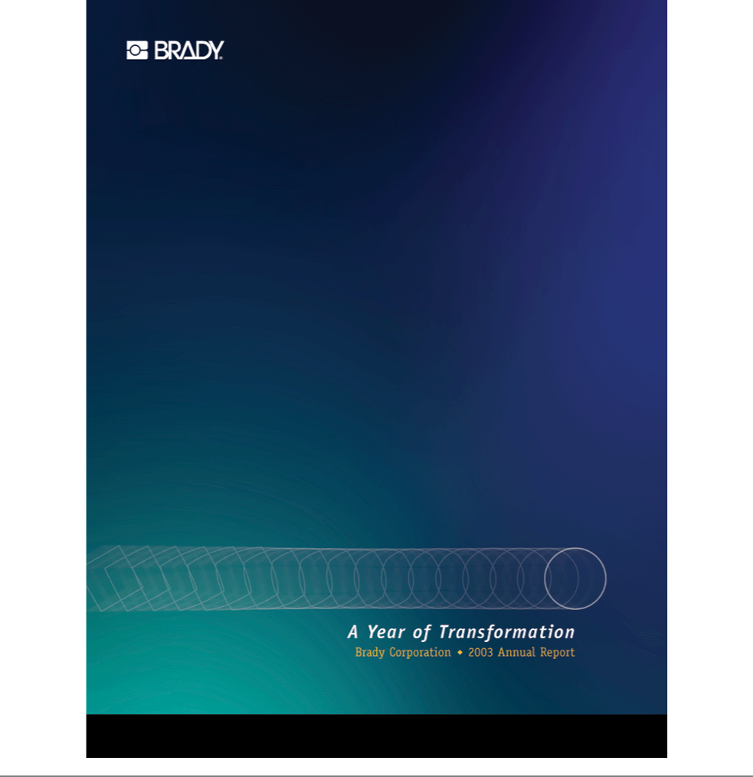

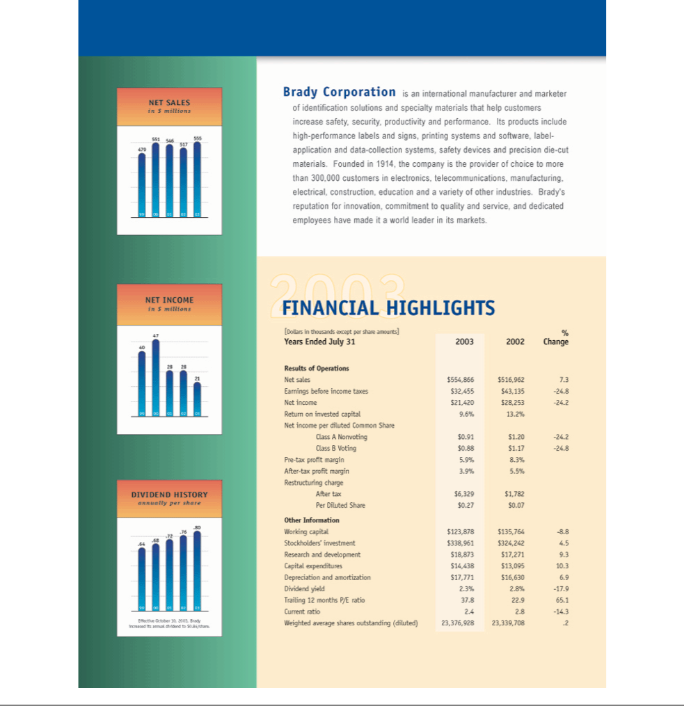

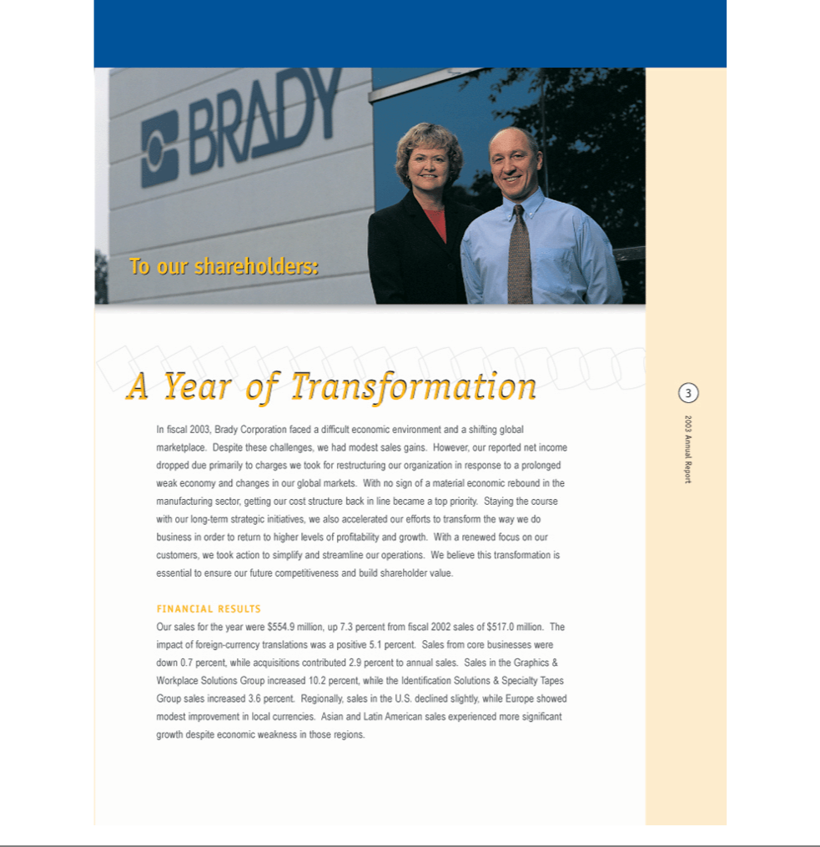

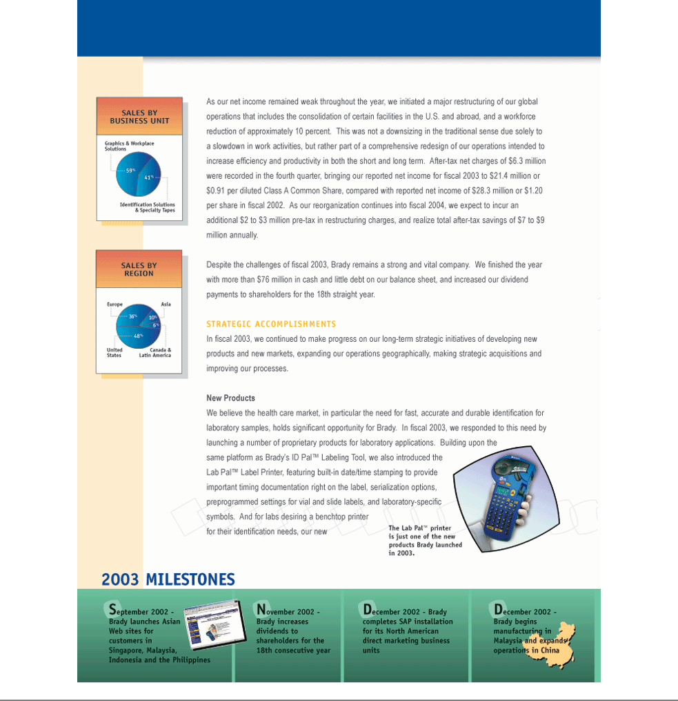

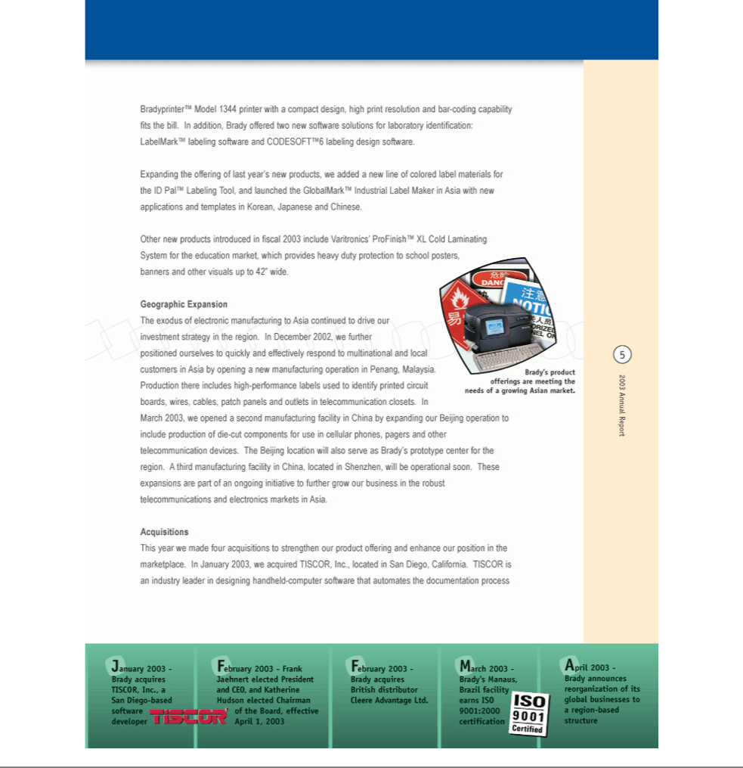

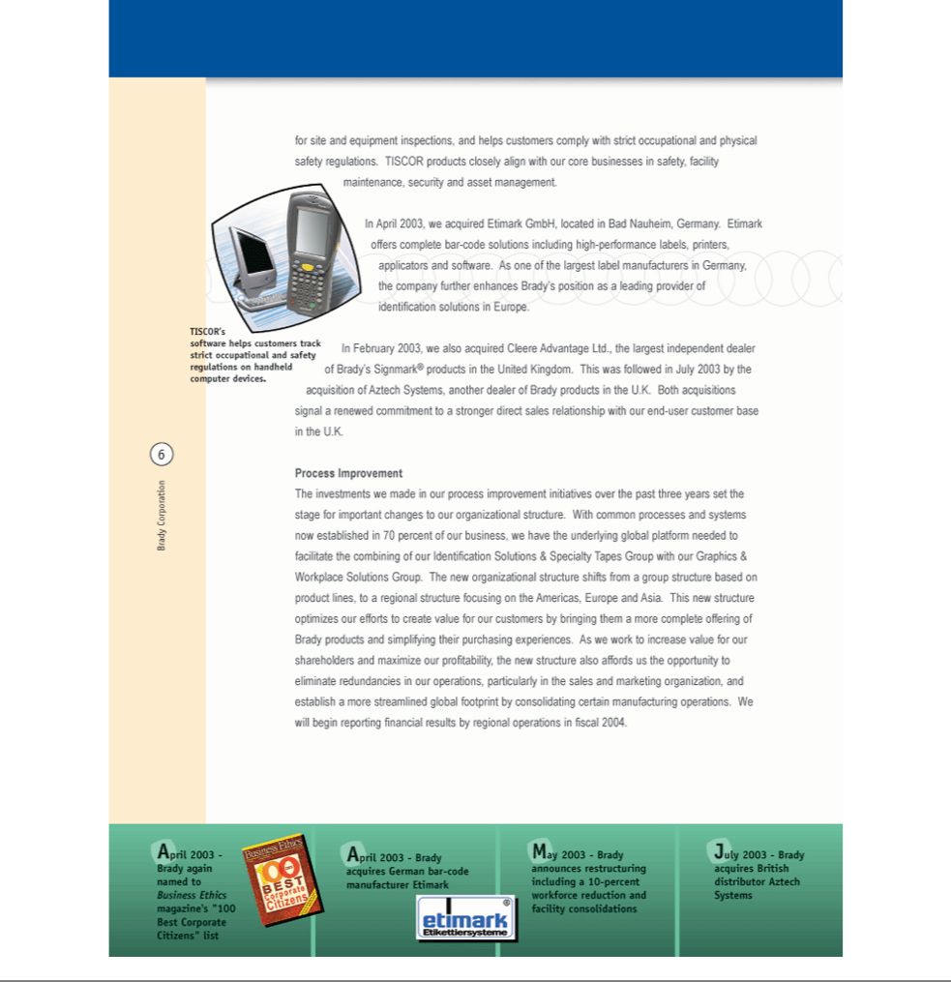

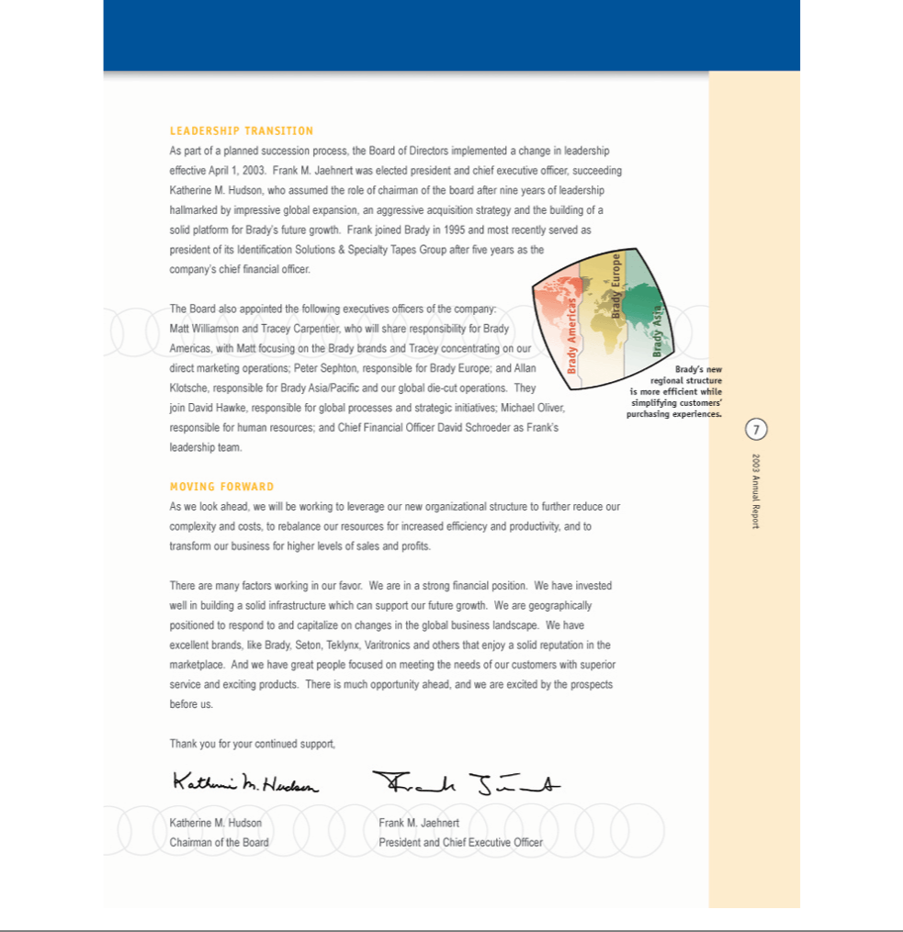

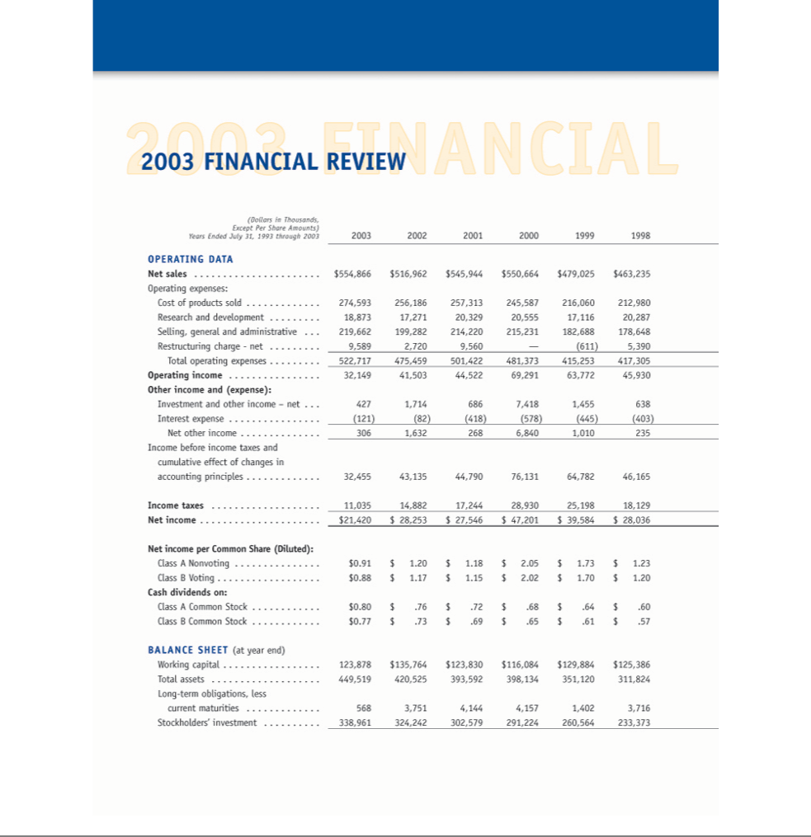

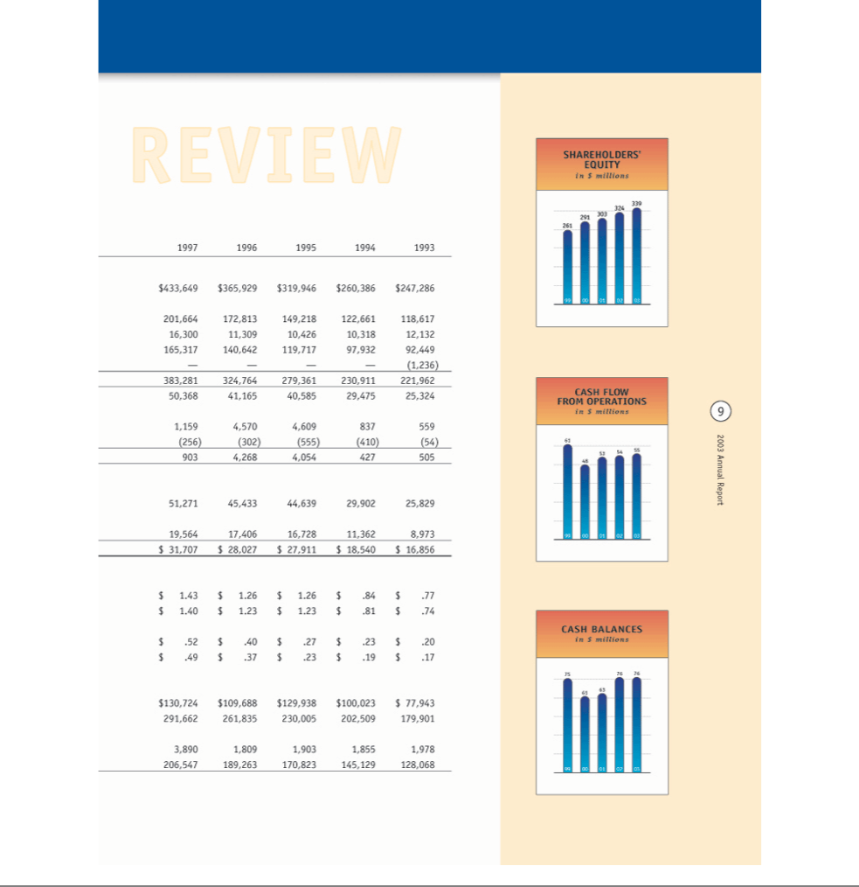

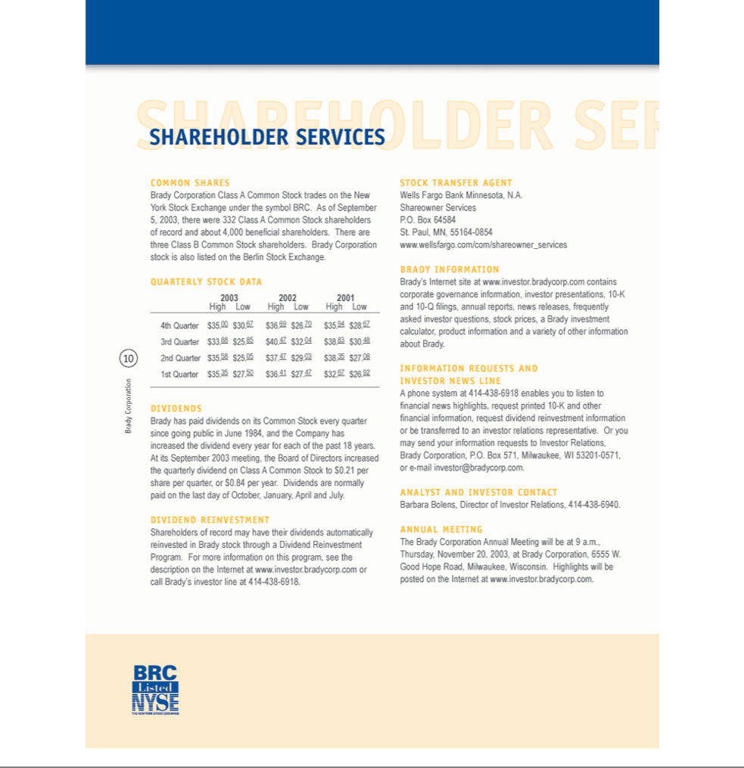

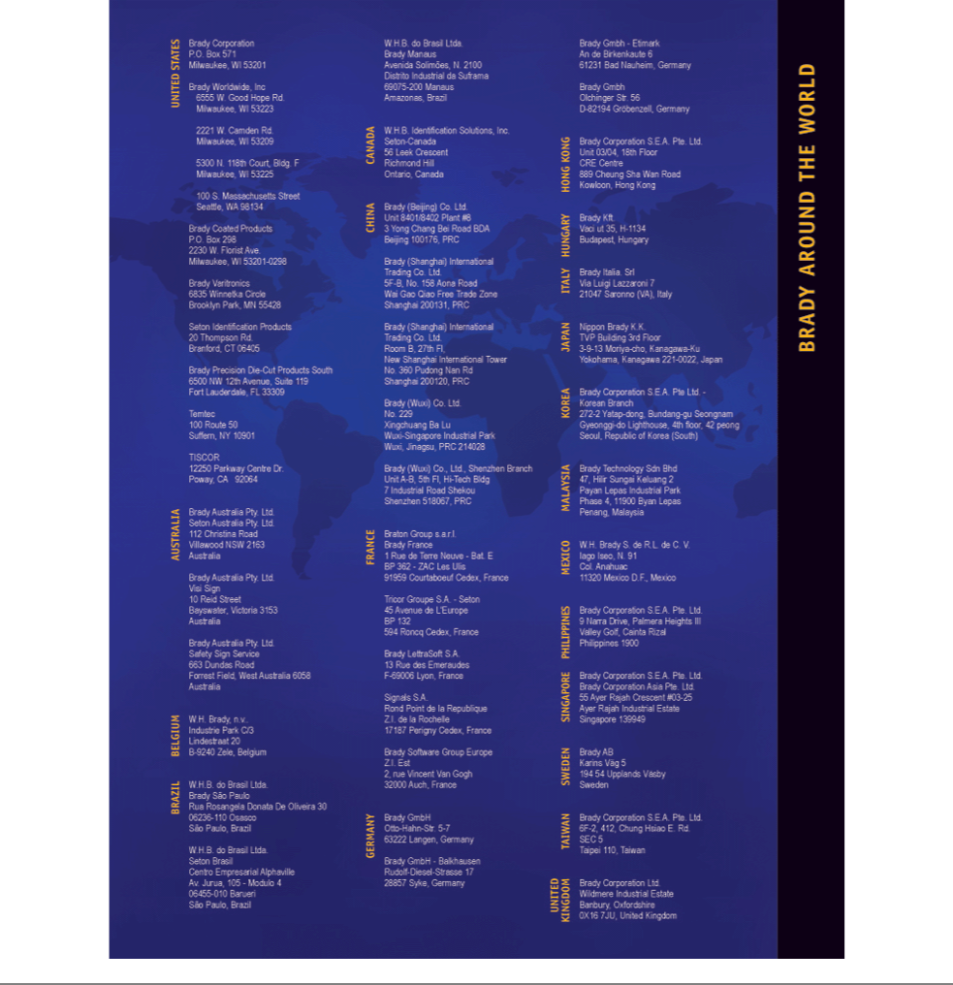

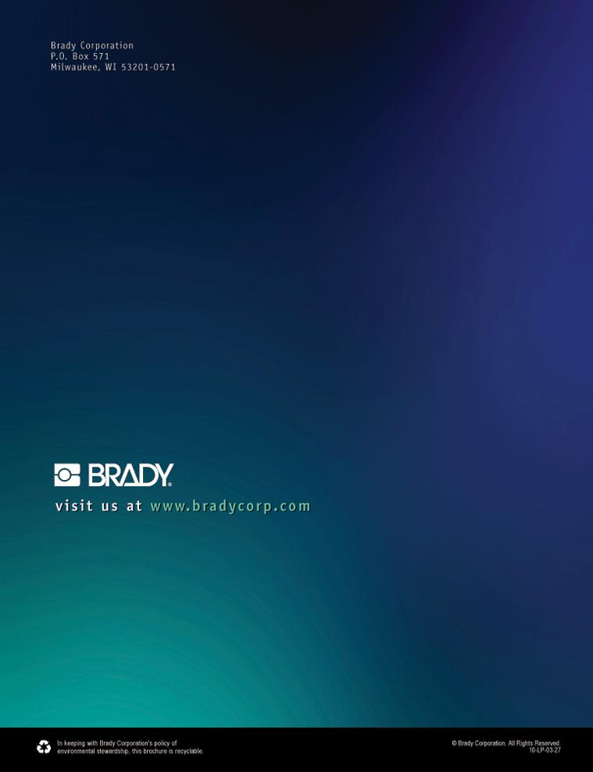

.

.

.

Exhibit 21

SCHEDULE OF SUBSIDIARIES OF BRADY CORPORATION

Percentage

of Voting

State (Country) Securities

Name of Company of Incorporation Owned

- ---------------------------------------------------------------------------------------------------------------------------

Brady Corporation | Wisconsin | Parent
Tricor Direct Inc.- | Delaware | 100%
Doing Business As:
Seton
Seton Name Plate Company
D&G Sign and Label Co.
Seton Identification Products
The Hirol Company
Worldmark of Wisconsin Inc. | Delaware | 100%
Brady Investment Co. | Nevada | 100%
Brady International Sales, Inc. | U.S. Virgin Islands | 100%
Brady International Co. | Wisconsin | 100%
Brady Worldwide, Inc. | Wisconsin | 100%
Also Doing Business As:
Varitronic Systems
Teklynx International
Barcodes West
Temtec
TISCOR, Inc. | California | 100%
Brady Australia Pty. Ltd. | Australia | 100%
Also Doing Business As:
Visi Sign Pty.
Seton Australia Pty. Ltd. | Australia | 100%
W.H. Brady, N.V. | Belgium | 100%
W.H.B. do Brasil Ltda. | Brazil | 100%
W.H.B. Identification Solutions, Inc.- | Canada | 100%
Doing Business As:
Brady
GrafTek
Revere-Seton
Seton
1167232 Ontario, Inc. | Canada | 100%
BRC Financial | Canada | 100%

Percentage

of Voting

State (Country) Securities

Name of Company of Incorporation Owned

- -----------------------------------------------------------------------------------------------------------------------------

Brady Shanghai International Trading Co., Ltd. | China | 100%
Brady (Wuxi) Co. Ltd. | China | 100%
Brady (Beijing) Co. Ltd. | China | 100%
B.I. U.K. Limited | England | 100%
B.I. Financial Limited | England | 100%
Seton Limited | England | 100%
W.H. Brady Co. Ltd. | England | 100%
Brady Corporation Limited | England | 100%
Brady LettraSoft S.A. | France | 100%
Braton Europe Eurl | France | 100%
Braton Groupe S.A.R.L. - | France | 100%
Doing Business As:
Brady
Techniques Avancees
Holman
Periprint
Tricor Group, S.A. - | France | 100%
Doing Business As:
Seton
Signals
Brady Holding GmbH | Germany | 100%
Brady GmbH | Germany | 100%
Doing Business As:
Seton
Balkhausen
Brady ISST
Soft
Brady KFT | Hungary | 100%
Brady Italia, SRL | Italy | 100%
Nippon Brady K.K. | Japan | 100%
Brady Technology SDN, BHD. | Malaysia | 100%
W. H. Brady S. de R.L. de C.V. | Mexico | 100%
Brady Corporation S.E.A. Pte. Ltd. | Singapore | 100%
Brady Corporation Asia Pte. Ltd. | Singapore | 100%
Brady Lettrasoft S.L. | Spain | 100%
Brady AB | Sweden | 100%
Seton Scandinavia AB | Sweden | 100%

EXHIBIT 23

INDEPENDENT AUDITORS' CONSENT

We consent to the incorporation by reference in Registration Statements Nos. 333-99615, 333-38857, 333-38859, 333-44505 and 333-92417 of Brady Corporation on Form S-8 of our report dated September 8, 2003 (which report expresses an unqualified opinion and includes an explanatory paragraph as to the adoption of Statement of Financial Accounting Standards No. 142, "Goodwill and Other Intangible Assets"), appearing in this Annual Report on Form 10-K of Brady Corporation for the year ended July 31, 2003.

/s/ Deloitte & Touche LLP

Milwaukee, Wisconsin

October 23, 2003

EXHIBIT 31.1

RULE 13a-14(a)/15d-14(a) CERTIFICATION

I, Frank M. Jaehnert, certify that:

- I have reviewed this annual report on Form 10-K of Brady Corporation;

- Based on my knowledge, this report does not contain any untrue statement of a material fact or omit to state a material fact necessary to make the statements made, in light of the circumstances under which such statements were made, not misleading with respect to the period covered by this report;

- Based on my knowledge, the financial statements, and other financial information included in this report, fairly present in all material respects the financial condition, results of operations and cash flows of the registrant as of, and for, the periods presented in this report;

- The registrant's other certifying officer and I are responsible for establishing and maintaining disclosure controls and procedures (as defined in Exchange Act Rules 13a-15(e) and 15d-15(e)) for the registrant and have:

  - Designed such disclosure controls and procedures, or caused such disclosure controls and procedures to be designed under our supervision, to ensure that material information relating to the registrant, including its consolidated subsidiaries, is made known to us by others within those entities, particularly during the period in which this report is being prepared;

  - Evaluated the effectiveness of the registrant's disclosure controls and procedures and presented in this report our conclusions about the effectiveness of the disclosure controls and procedures, as of the end of the period covered by this report based on such evaluation; and

  - Disclosed in this report any change in the registrant's internal control over financial reporting that occurred during the registrant's most recent fiscal quarter (the registrant's fourth fiscal quarter in the case of an annual report) that has materially affected, or is reasonably likely to materially affect, the registrant's internal control over financial reporting; and

- The registrant's other certifying officer and I have disclosed, based on our most recent evaluation of internal control over financial reporting, to the registrant's auditors and the audit committee of the registrant's board of directors (or persons performing the equivalent functions):

  - All significant deficiencies and material weaknesses in the design or operation of internal control over financial reporting which are reasonably likely to adversely affect the registrant's ability to record, process, summarize and report financial information; and

  - Any fraud, whether or not material, that involves management or other employees who have a significant role in the registrant's internal control over financial reporting.

Date: October 23, 2002

/s/ FRANK M. JAEHNERT

- ---------------------------------------------------------

(Frank M. Jaehnert)

President and Chief Executive Officer

EXHIBIT 31.2

RULE 13a-14(a)/15d-14(a) CERTIFICATION

I, David W. Schroeder, certify that:

- I have reviewed this annual report on Form 10-K of Brady Corporation;

- Based on my knowledge, this report does not contain any untrue statement of a material fact or omit to state a material fact necessary to make the statements made, in light of the circumstances under which such statements were made, not misleading with respect to the period covered by this report;

- Based on my knowledge, the financial statements, and other financial information included in this report, fairly present in all material respects the financial condition, results of operations and cash flows of the registrant as of, and for, the periods presented in this report;

- The registrant's other certifying officer and I are responsible for establishing and maintaining disclosure controls and procedures (as defined in Exchange Act Rules 13a-15(e) and 15d-15(e)) for the registrant and have:

  - Designed such disclosure controls and procedures, or caused such disclosure controls and procedures to be designed under our supervision, to ensure that material information relating to the registrant, including its consolidated subsidiaries, is made known to us by others within those entities, particularly during the period in which this report is being prepared;

  - Evaluated the effectiveness of the registrant's disclosure controls and procedures and presented in this report our conclusions about the effectiveness of the disclosure controls and procedures, as of the end of the period covered by this report based on such evaluation; and

  - Disclosed in this report any change in the registrant's internal control over financial reporting that occurred during the registrant's most recent fiscal quarter (the registrant's fourth fiscal quarter in the case of an annual report) that has materially affected, or is reasonably likely to materially affect, the registrant's internal control over financial reporting; and

- The registrant's other certifying officer and I have disclosed, based on our most recent evaluation of internal control over financial reporting, to the registrant's auditors and the audit committee of the registrant's board of directors (or persons performing the equivalent functions):

  - All significant deficiencies and material weaknesses in the design or operation of internal control over financial reporting which are reasonably likely to adversely affect the registrant's ability to record, process, summarize and report financial information; and

  - Any fraud, whether or not material, that involves management or other employees who have a significant role in the registrant's internal control over financial reporting.

Date: October 23, 2003

/s/ DAVID W. SCHROEDER

- ---------------------------------------------------------

(David W. Schroeder)

Senior Vice President and Chief Financial Officer

EXHIBIT 32.1

SECTION 1350 CERTIFICATION

Pursuant to 18 U.S.C. Section 1350, as adopted pursuant to Section 906 of the Sarbanes-Oxley Act of 2002, the undersigned officer of Brady Corporation (the "Company") certifies to his knowledge that:

- The Annual Report on Form 10-K of the Company for the year ended July 31, 2003 fully complies with the requirements of Section 13(a) or 15(d) of the Securities Exchange Act of 1934; and

- The information contained in that Form 10-K fairly presents, in all material respects, the financial conditions and results of operations of the Company.

Date: October 23, 2003

/s/ FRANK M. JAEHNERT

- ---------------------------------------------------------

(Frank M. Jaehnert)

President and Chief Executive Officer

A signed original of this written statement required by Section 906, or other document authenticating, acknowledging, or otherwise adopting the signature that appears in typed form within the electronic version of this written statement required by Section 906, has been provided to the Company and will be retained by the Company and furnished to the Securities and Exchange Commission or its staff upon request.

EXHIBIT 32.2

SECTION 1350 CERTIFICATION

Pursuant to 18 U.S.C. Section 1350, as adopted pursuant to Section 906 of the Sarbanes-Oxley Act of 2002, the undersigned officer of Brady Corporation (the "Company") certifies to his knowledge that:

- The Annual Report on Form 10-K of the Company for the year ended July 31, 2003 fully complies with the requirements of Section 13(a) or 15(d) of the Securities Exchange Act of 1934; and

- The information contained in that Form 10-K fairly presents, in all material respects, the financial conditions and results of operations of the Company.

Date: October 23, 2003

/s/ DAVID W. SCHROEDER

- ---------------------------------------------------------

(David W. Schroeder)

Senior Vice President and Chief Financial Officer

A signed original of this written statement required by Section 906, or other document authenticating, acknowledging, or otherwise adopting the signature that appears in typed form within the electronic version of this written statement required by Section 906, has been provided to the Company and will be retained by the Company and furnished to the Securities and Exchange Commission or its staff upon request.

